# Sites that were included

NSABHC0005 Test Set: (Timestamp('2002-12-03 00:00:00'), Timestamp('2005-08-06 00:00:00')), Period: 159  
  
NSABHC0006 Test Set: (Timestamp('2008-02-19 00:00:00'), Timestamp('2010-09-20 00:00:00')), Period: 91  
  
NSABHC0013 Test Set: (Timestamp('2006-03-17 00:00:00'), Timestamp('2009-02-21 00:00:00')), Period: 85  
  
NSABHC0014 Test Set: (Timestamp('2020-02-12 00:00:00'), Timestamp('2022-12-26 00:00:00')), Period: 85  
  
NSABHC0015 Test Set: (Timestamp('2020-01-19 00:00:00'), Timestamp('2022-12-26 00:00:00')), Period: 84  
  
NSABHC0017 Test Set: (Timestamp('1993-04-21 00:00:00'), Timestamp('1998-11-30 00:00:00')), Period: 84  
  
NSABHC0018 Test Set: (Timestamp('2002-09-30 00:00:00'), Timestamp('2005-08-14 00:00:00')), Period: 155  
  
NSABHC0019 Test Set: (Timestamp('1993-03-04 00:00:00'), Timestamp('1998-05-06 00:00:00')), Period: 84  
  
NSABHC0020 Test Set: (Timestamp('1987-09-12 00:00:00'), Timestamp('1993-03-04 00:00:00')), Period: 82  
  
NSABHC0021 Test Set: (Timestamp('1992-10-11 00:00:00'), Timestamp('1998-03-11 00:00:00')), Period: 159  
  
NSABHC0025 Test Set: (Timestamp('2015-02-22 00:00:00'), Timestamp('2017-10-25 00:00:00')), Period: 82  
  
NTABRT0005 Test Set: (Timestamp('2015-07-17 00:00:00'), Timestamp('2018-04-13 00:00:00')), Period: 147  
  
NTABRT0007 Test Set: (Timestamp('2020-08-08 00:00:00'), Timestamp('2022-12-20 00:00:00')), Period: 148  
  
NTAFIN0001 Test Set: (Timestamp('2019-05-09 00:00:00'), Timestamp('2021-01-31 00:00:00')), Period: 85  
  
NTAFIN0002 Test Set: (Timestamp('2008-04-01 00:00:00'), Timestamp('2010-10-23 00:00:00')), Period: 108  
  
NTAFIN0005 Test Set: (Timestamp('1994-06-22 00:00:00'), Timestamp('2000-05-29 00:00:00')), Period: 129  
  
NTAFIN0006 Test Set: (Timestamp('2004-12-26 00:00:00'), Timestamp('2008-02-20 00:00:00')), Period: 127  
  
NTAFIN0007 Test Set: (Timestamp('1999-09-24 00:00:00'), Timestamp('2004-12-10 00:00:00')), Period: 116  
  
NTAFIN0008 Test Set: (Timestamp('2020-10-27 00:00:00'), Timestamp('2022-12-19 00:00:00')), Period: 126  
  
NTAFIN0012 Test Set: (Timestamp('2013-03-14 00:00:00'), Timestamp('2015-11-15 00:00:00')), Period: 154  
  
NTAFIN0016 Test Set: (Timestamp('2010-09-05 00:00:00'), Timestamp('2014-06-13 00:00:00')), Period: 132  
  
NTAFIN0017 Test Set: (Timestamp('1998-09-12 00:00:00'), Timestamp('2003-07-01 00:00:00')), Period: 87  
  
NTAFIN0019 Test Set: (Timestamp('2006-05-13 00:00:00'), Timestamp('2008-12-12 00:00:00')), Period: 82  
  
NTAFIN0020 Test Set: (Timestamp('2004-10-23 00:00:00'), Timestamp('2007-05-09 00:00:00')), Period: 82  
  
NTAFIN0021 Test Set: (Timestamp('2013-08-05 00:00:00'), Timestamp('2015-12-01 00:00:00')), Period: 82  
  
NTAFIN0025 Test Set: (Timestamp('1993-03-15 00:00:00'), Timestamp('2000-08-01 00:00:00')), Period: 87  
  
NTAFIN0026 Test Set: (Timestamp('2006-10-29 00:00:00'), Timestamp('2009-03-19 00:00:00')), Period: 78  
  
NTAFIN0027 Test Set: (Timestamp('1987-09-23 00:00:00'), Timestamp('1993-02-11 00:00:00')), Period: 79  
  
NTAFIN0029 Test Set: (Timestamp('2020-07-07 00:00:00'), Timestamp('2022-12-28 00:00:00')), Period: 86  
  
NTAFIN0033 Test Set: (Timestamp('2000-02-07 00:00:00'), Timestamp('2004-07-03 00:00:00')), Period: 80  
  
NTAMAC0001 Test Set: (Timestamp('1987-09-14 00:00:00'), Timestamp('1992-04-04 00:00:00')), Period: 134  
  
NTAMAC0003 Test Set: (Timestamp('1993-06-19 00:00:00'), Timestamp('1998-11-08 00:00:00')), Period: 125  
  
NTASSD0006 Test Set: (Timestamp('2015-07-20 00:00:00'), Timestamp('2017-12-24 00:00:00')), Period: 95  
  
NTASSD0008 Test Set: (Timestamp('1999-09-10 00:00:00'), Timestamp('2004-01-19 00:00:00')), Period: 95  
  
NTASSD0009 Test Set: (Timestamp('1993-05-20 00:00:00'), Timestamp('1999-08-25 00:00:00')), Period: 167  
  
NTASSD0011 Test Set: (Timestamp('2009-02-16 00:00:00'), Timestamp('2012-05-23 00:00:00')), Period: 93  
  
NTASSD0012 Test Set: (Timestamp('2012-07-26 00:00:00'), Timestamp('2015-06-01 00:00:00')), Period: 94  
  
NTASSD0018 Test Set: (Timestamp('2012-09-12 00:00:00'), Timestamp('2015-07-11 00:00:00')), Period: 92  
  
QDACHC0004 Test Set: (Timestamp('1997-11-02 00:00:00'), Timestamp('2002-12-01 00:00:00')), Period: 175  
  
QDACHC0005 Test Set: (Timestamp('2005-11-15 00:00:00'), Timestamp('2008-09-13 00:00:00')), Period: 177  
  
QDACHC0006 Test Set: (Timestamp('2017-12-11 00:00:00'), Timestamp('2020-05-24 00:00:00')), Period: 171  
  
QDACHC0007 Test Set: (Timestamp('1987-09-03 00:00:00'), Timestamp('1992-11-10 00:00:00')), Period: 174  
  
QDAMGD0001 Test Set: (Timestamp('2017-11-19 00:00:00'), Timestamp('2020-03-31 00:00:00')), Period: 172  
  
QDAMGD0002 Test Set: (Timestamp('1987-09-05 00:00:00'), Timestamp('1992-09-25 00:00:00')), Period: 171  
  
QDAMGD0003 Test Set: (Timestamp('2015-04-27 00:00:00'), Timestamp('2017-10-25 00:00:00')), Period: 167  
  
QDAMGD0004 Test Set: (Timestamp('2015-11-22 00:00:00'), Timestamp('2018-04-12 00:00:00')), Period: 154  
  
QDAMGD0005 Test Set: (Timestamp('1994-04-08 00:00:00'), Timestamp('1999-07-20 00:00:00')), Period: 161  
  
QDAMGD0006 Test Set: (Timestamp('1987-09-12 00:00:00'), Timestamp('1992-12-14 00:00:00')), Period: 174  
  
QDAMGD0007 Test Set: (Timestamp('2015-03-11 00:00:00'), Timestamp('2017-11-03 00:00:00')), Period: 172  
  
QDAMGD0008 Test Set: (Timestamp('2005-07-28 00:00:00'), Timestamp('2008-08-22 00:00:00')), Period: 170  
  
QDAMGD0011 Test Set: (Timestamp('2020-05-09 00:00:00'), Timestamp('2022-12-10 00:00:00')), Period: 94  
  
QDAMGD0013 Test Set: (Timestamp('2018-08-17 00:00:00'), Timestamp('2020-08-13 00:00:00')), Period: 144  
  
QDAMGD0014 Test Set: (Timestamp('1987-09-03 00:00:00'), Timestamp('1994-02-19 00:00:00')), Period: 159  
  
QDAMGD0017 Test Set: (Timestamp('1998-08-10 00:00:00'), Timestamp('2003-07-31 00:00:00')), Period: 92  
  
QDAMGD0018 Test Set: (Timestamp('2017-11-18 00:00:00'), Timestamp('2020-04-07 00:00:00')), Period: 91  
  
QDAMGD0019 Test Set: (Timestamp('2009-08-07 00:00:00'), Timestamp('2013-04-20 00:00:00')), Period: 93  
  
QDAMGD0021 Test Set: (Timestamp('2020-06-02 00:00:00'), Timestamp('2022-12-17 00:00:00')), Period: 174  
  
QDAMGD0022 Test Set: (Timestamp('2008-12-10 00:00:00'), Timestamp('2012-06-19 00:00:00')), Period: 172  
  
QDAMGD0023 Test Set: (Timestamp('2011-09-22 00:00:00'), Timestamp('2015-05-03 00:00:00')), Period: 176  
  
QDAMGD0024 Test Set: (Timestamp('2005-08-27 00:00:00'), Timestamp('2008-07-10 00:00:00')), Period: 174  
  
QDASSD0003 Test Set: (Timestamp('2009-04-15 00:00:00'), Timestamp('2012-12-03 00:00:00')), Period: 95  
  
QDASSD0006 Test Set: (Timestamp('2005-07-24 00:00:00'), Timestamp('2008-10-13 00:00:00')), Period: 145  
  
QDASSD0007 Test Set: (Timestamp('2008-08-02 00:00:00'), Timestamp('2011-04-21 00:00:00')), Period: 145  
  
QDASSD0009 Test Set: (Timestamp('1999-11-06 00:00:00'), Timestamp('2004-06-20 00:00:00')), Period: 96  
  
QDASSD0010 Test Set: (Timestamp('2009-03-13 00:00:00'), Timestamp('2012-08-29 00:00:00')), Period: 173  
  
QDASSD0013 Test Set: (Timestamp('2018-09-23 00:00:00'), Timestamp('2020-08-27 00:00:00')), Period: 152  
  
QDASSD0014 Test Set: (Timestamp('2003-09-22 00:00:00'), Timestamp('2006-05-09 00:00:00')), Period: 174  
  
QDASSD0015 Test Set: (Timestamp('2003-09-21 00:00:00'), Timestamp('2006-04-22 00:00:00')), Period: 170  
  
SAAFLB0030 Test Set: (Timestamp('2008-12-16 00:00:00'), Timestamp('2012-06-03 00:00:00')), Period: 166  
  
SAAGVD0002 Test Set: (Timestamp('2003-09-17 00:00:00'), Timestamp('2006-02-13 00:00:00')), Period: 149  
  
SAAGVD0003 Test Set: (Timestamp('1987-09-14 00:00:00'), Timestamp('1992-10-20 00:00:00')), Period: 147  
  
SAANUL0003 Test Set: (Timestamp('2013-06-09 00:00:00'), Timestamp('2015-11-14 00:00:00')), Period: 124  
  
SAASTP0002 Test Set: (Timestamp('2012-09-12 00:00:00'), Timestamp('2015-07-11 00:00:00')), Period: 92  
  
SAASTP0011 Test Set: (Timestamp('2012-04-05 00:00:00'), Timestamp('2015-04-06 00:00:00')), Period: 89  
  
SAASTP0012 Test Set: (Timestamp('2008-11-28 00:00:00'), Timestamp('2012-05-23 00:00:00')), Period: 89  
  
SAASTP0013 Test Set: (Timestamp('2015-07-11 00:00:00'), Timestamp('2017-10-04 00:00:00')), Period: 89  
  
SAASTP0015 Test Set: (Timestamp('1993-04-02 00:00:00'), Timestamp('1999-04-19 00:00:00')), Period: 92  
  
SAASTP0018 Test Set: (Timestamp('2012-07-03 00:00:00'), Timestamp('2015-06-18 00:00:00')), Period: 88  
  
SAASTP0020 Test Set: (Timestamp('2012-06-17 00:00:00'), Timestamp('2015-07-20 00:00:00')), Period: 89  
  
SAASTP0030 Test Set: (Timestamp('1987-09-11 00:00:00'), Timestamp('1993-05-22 00:00:00')), Period: 91  
  
SAASTP0031 Test Set: (Timestamp('2017-10-15 00:00:00'), Timestamp('2020-02-26 00:00:00')), Period: 91  
  
SAASTP0032 Test Set: (Timestamp('1993-07-09 00:00:00'), Timestamp('1999-08-27 00:00:00')), Period: 91  
  
SASMDD0003 Test Set: (Timestamp('2006-05-12 00:00:00'), Timestamp('2009-02-21 00:00:00')), Period: 73  
  
SATSTP0001 Test Set: (Timestamp('2003-05-26 00:00:00'), Timestamp('2006-02-19 00:00:00')), Period: 164  
  
SATSTP0003 Test Set: (Timestamp('2004-01-13 00:00:00'), Timestamp('2006-06-27 00:00:00')), Period: 91  
  
SATSTP0008 Test Set: (Timestamp('2017-12-02 00:00:00'), Timestamp('2020-04-30 00:00:00')), Period: 91  
  
WAACOO0010 Test Set: (Timestamp('2020-06-05 00:00:00'), Timestamp('2022-12-28 00:00:00')), Period: 81  
  
WAAGAS0002 Test Set: (Timestamp('2017-11-11 00:00:00'), Timestamp('2020-04-09 00:00:00')), Period: 95  
  
WAAHAM0003 Test Set: (Timestamp('2015-07-07 00:00:00'), Timestamp('2017-10-24 00:00:00')), Period: 115  
  
WAALSD0001 Test Set: (Timestamp('1998-09-20 00:00:00'), Timestamp('2003-04-12 00:00:00')), Period: 171  
  
WAAMUR0005 Test Set: (Timestamp('2020-05-17 00:00:00'), Timestamp('2022-12-25 00:00:00')), Period: 94  
  
WAAPIL0001 Test Set: (Timestamp('1999-12-03 00:00:00'), Timestamp('2004-05-13 00:00:00')), Period: 155  
  
WAAPIL0004 Test Set: (Timestamp('2005-10-07 00:00:00'), Timestamp('2008-09-13 00:00:00')), Period: 92  
  
WAAPIL0007 Test Set: (Timestamp('1987-09-04 00:00:00'), Timestamp('1993-12-25 00:00:00')), Period: 144  
  
WAAPIL0008 Test Set: (Timestamp('2015-06-21 00:00:00'), Timestamp('2018-01-04 00:00:00')), Period: 94  
  
WAAPIL0009 Test Set: (Timestamp('1987-09-04 00:00:00'), Timestamp('1992-07-15 00:00:00')), Period: 94  
  
WAAPIL0015 Test Set: (Timestamp('2020-02-27 00:00:00'), Timestamp('2022-12-25 00:00:00')), Period: 97  
  
WAAPIL0018 Test Set: (Timestamp('2015-03-18 00:00:00'), Timestamp('2017-10-01 00:00:00')), Period: 93  
  
WAAPIL0019 Test Set: (Timestamp('2017-11-18 00:00:00'), Timestamp('2020-03-31 00:00:00')), Period: 94  
  
WAAPIL0030 Test Set: (Timestamp('2009-01-21 00:00:00'), Timestamp('2012-08-08 00:00:00')), Period: 169  
  
WAAPIL0033 Test Set: (Timestamp('1998-11-30 00:00:00'), Timestamp('2003-08-24 00:00:00')), Period: 90

# Table: MSE of the Random Forest on each output

|  |  |  |  |  |
| --- | --- | --- | --- | --- |
|  | pv_filter | npv_filter | bs_filter | loss_mean |
| Train | 1.149 | 1.572 | 1.713 | 1.478 |
| Test | 24.931 | 48.655 | 58.02 | 43.869 |

# Permutation Importance

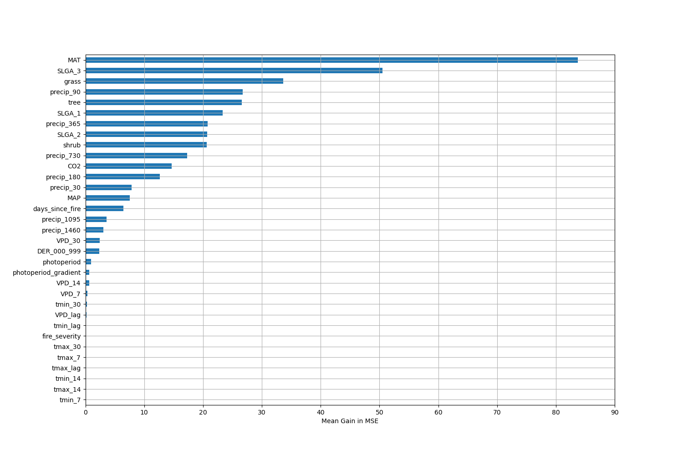

# Permutation Importance by Precip

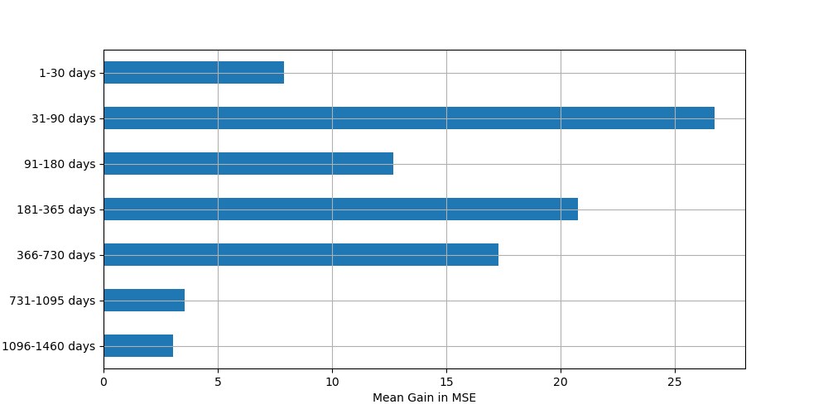

# ALE Importance

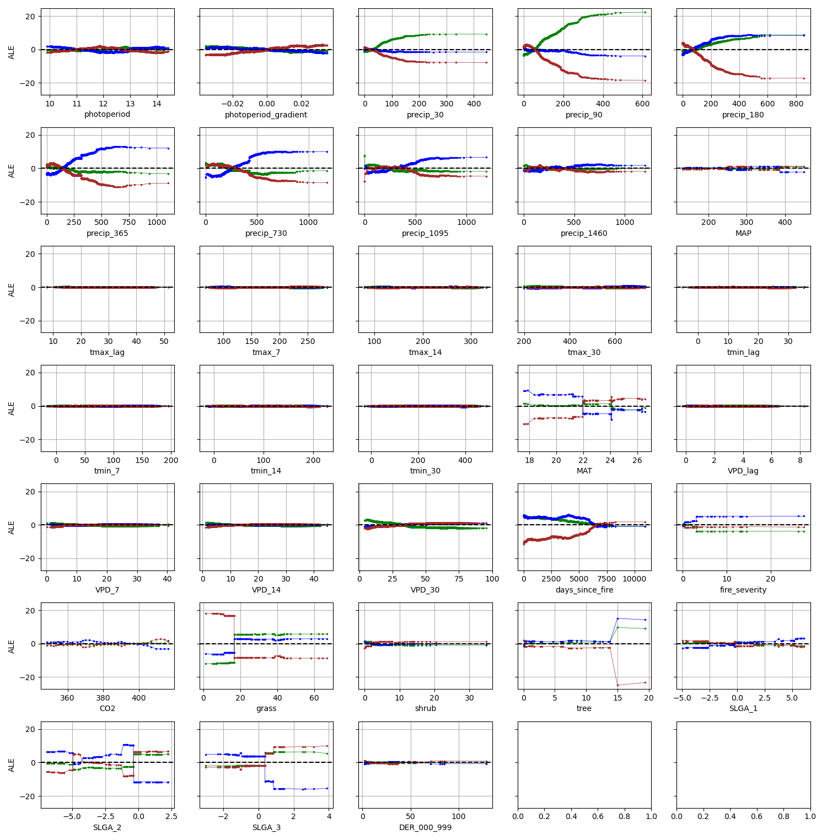

# NSABHC0005

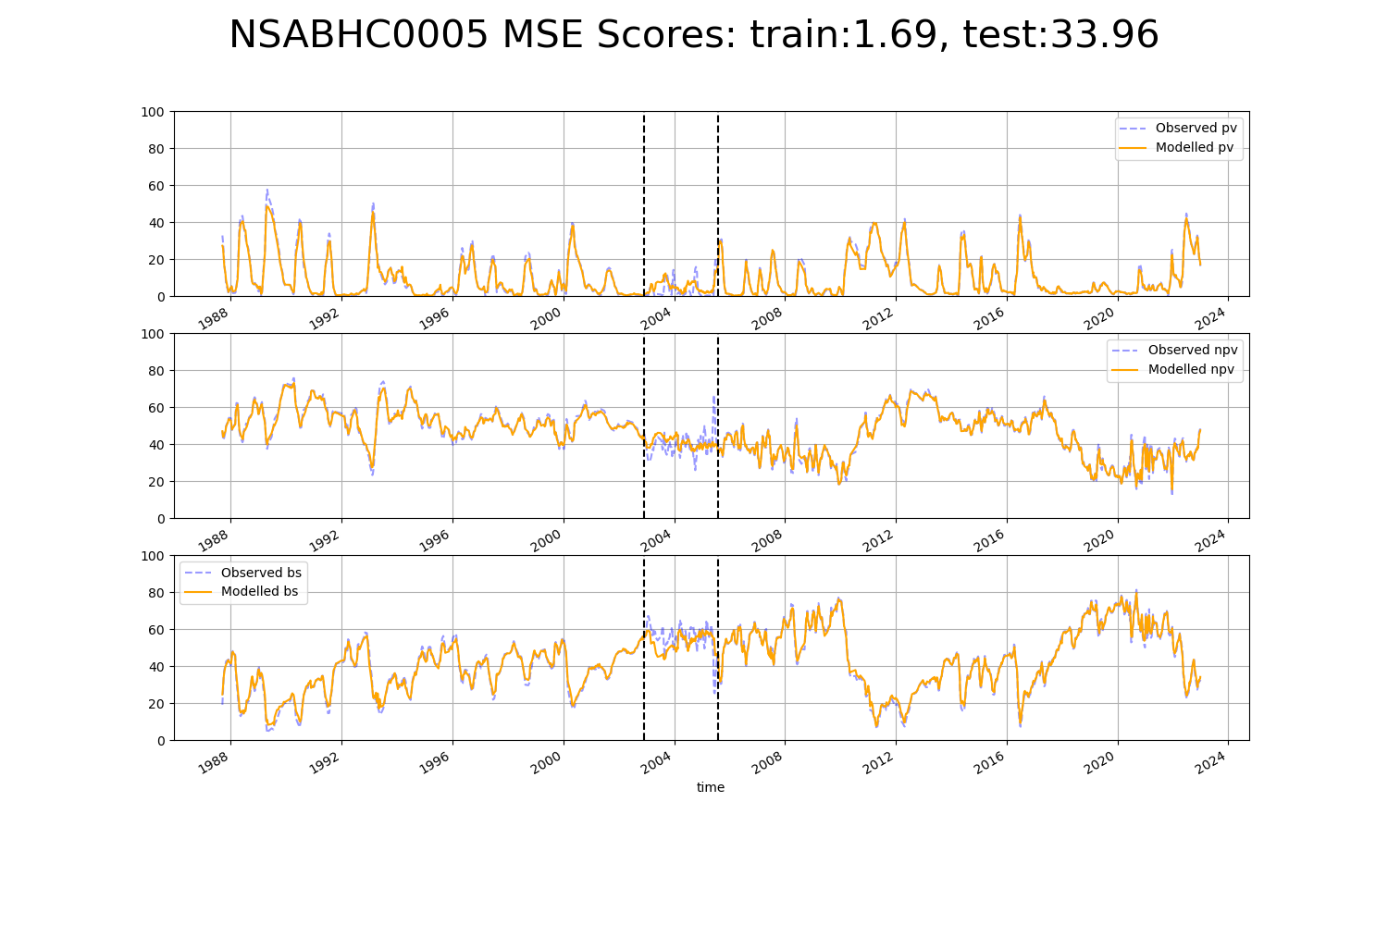

# NSABHC0006

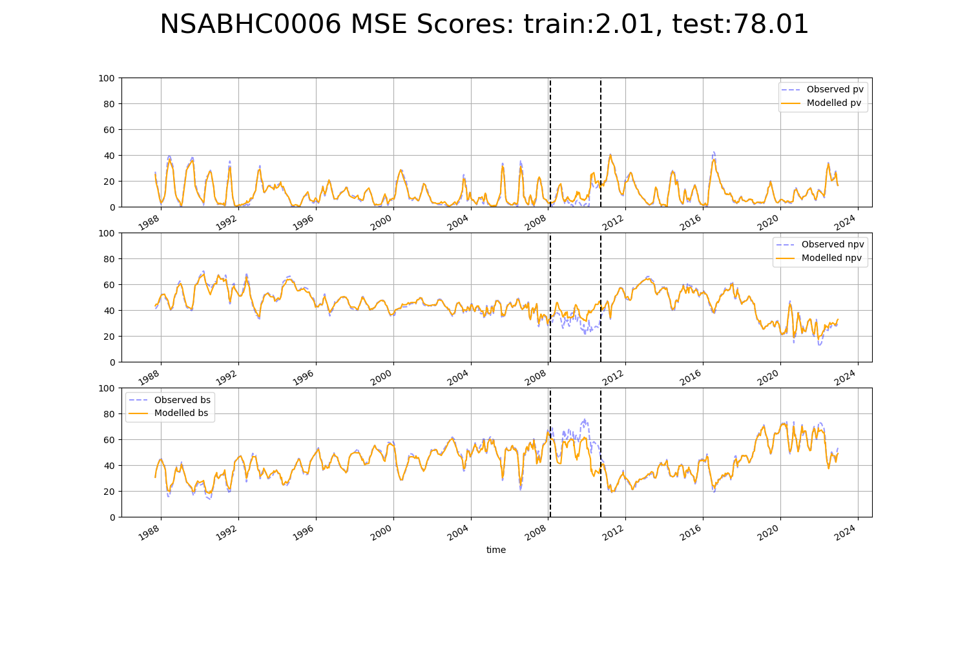

# NSABHC0013

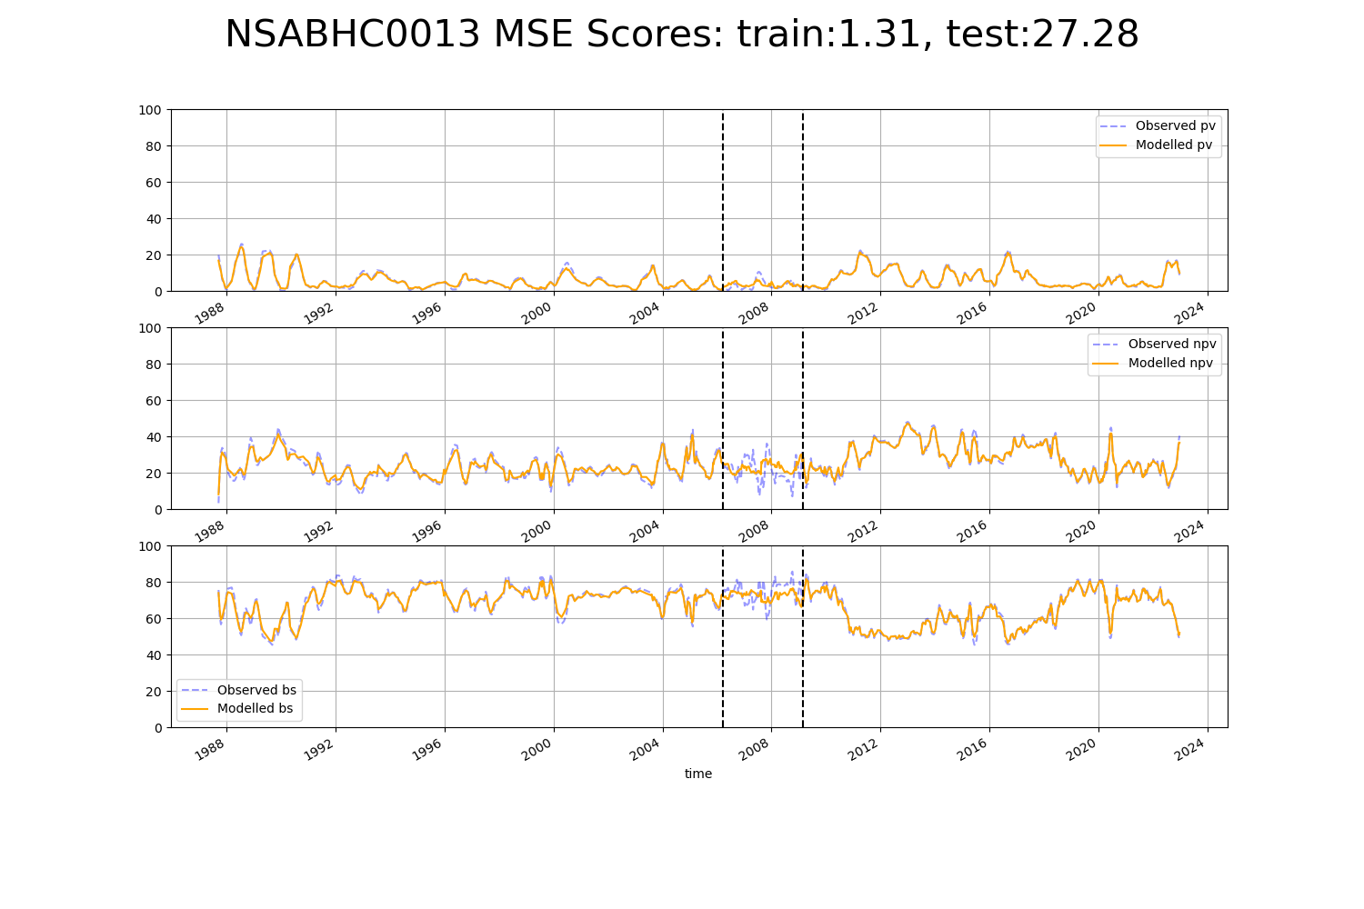

# NSABHC0014

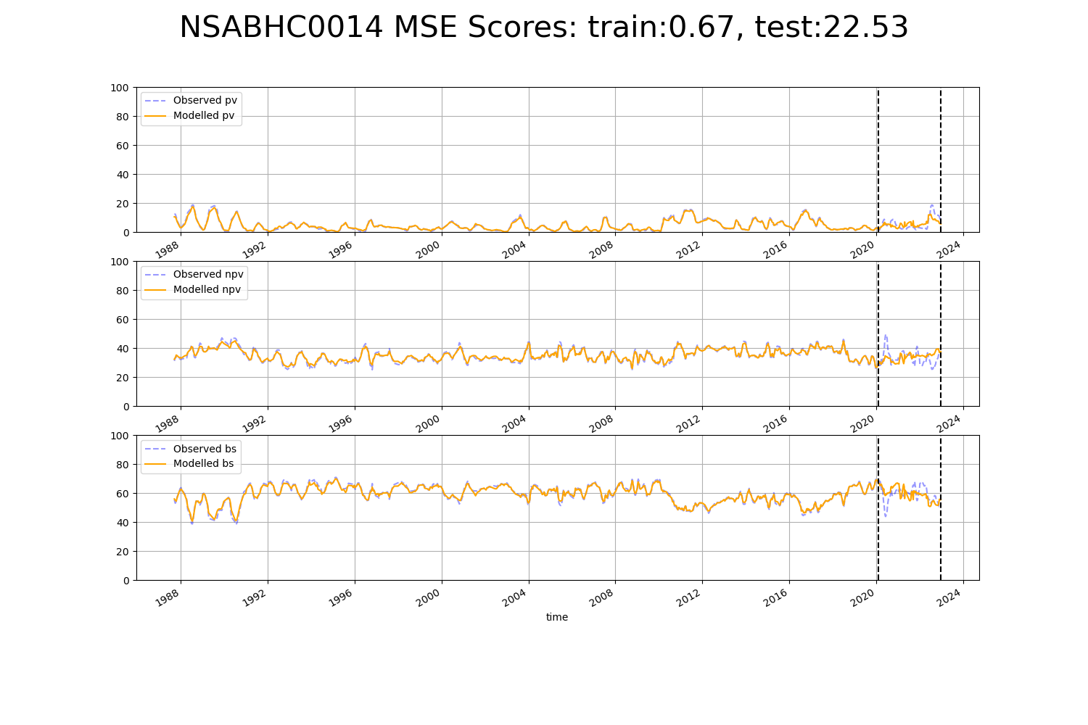

# NSABHC0015

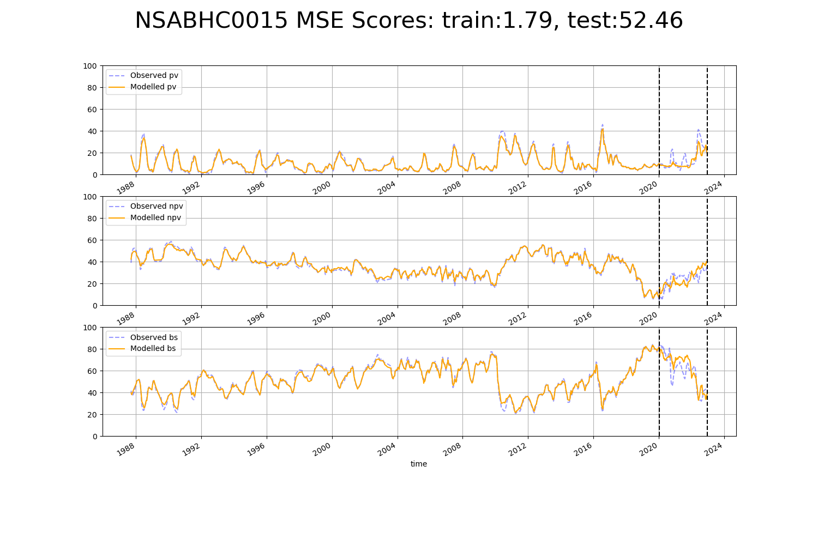

# NSABHC0017

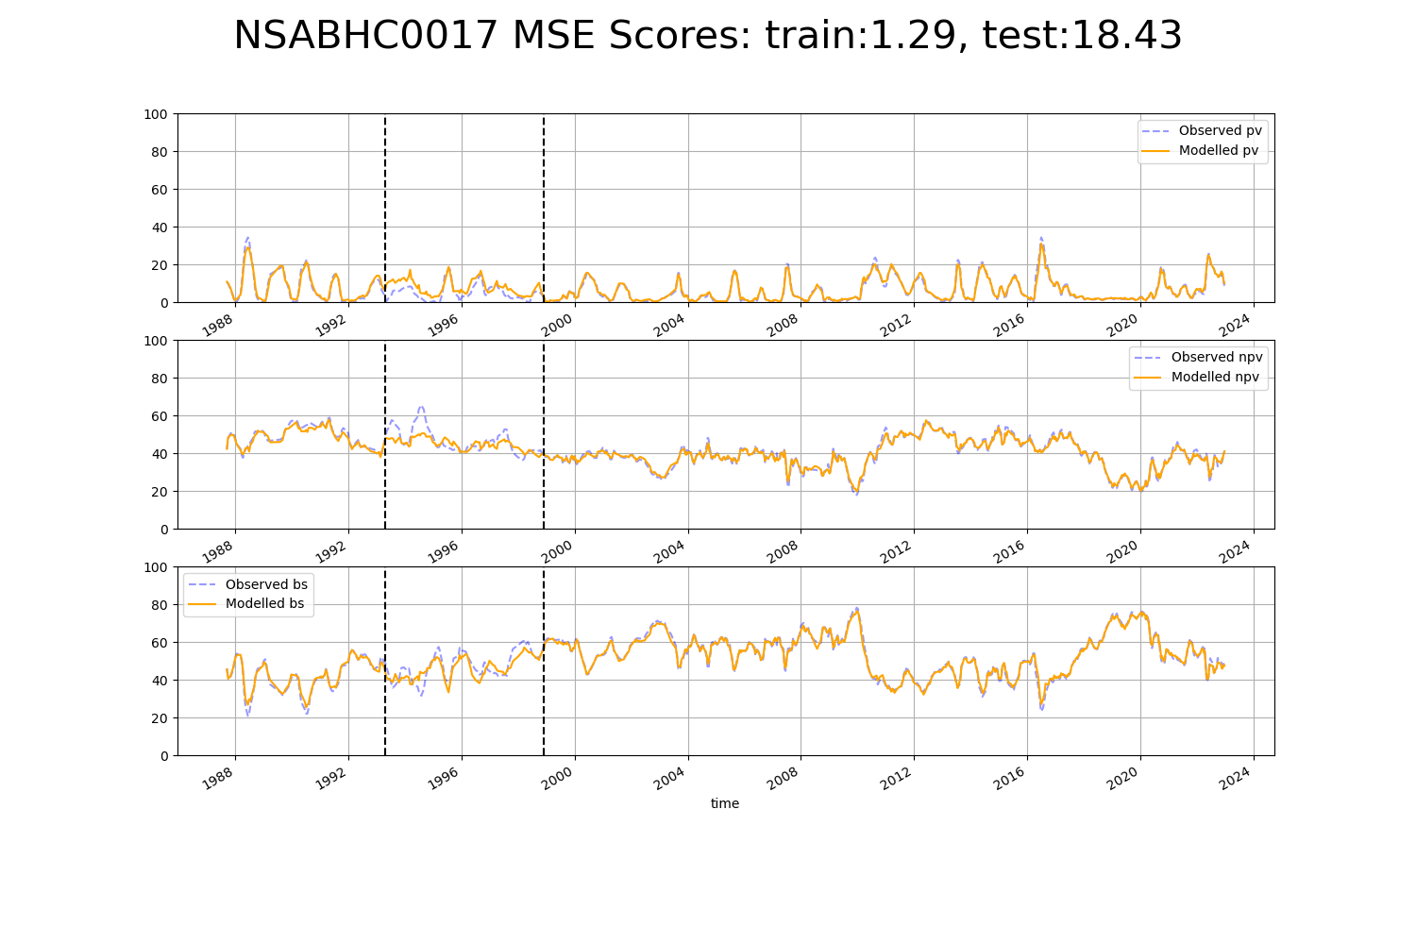

# NSABHC0018

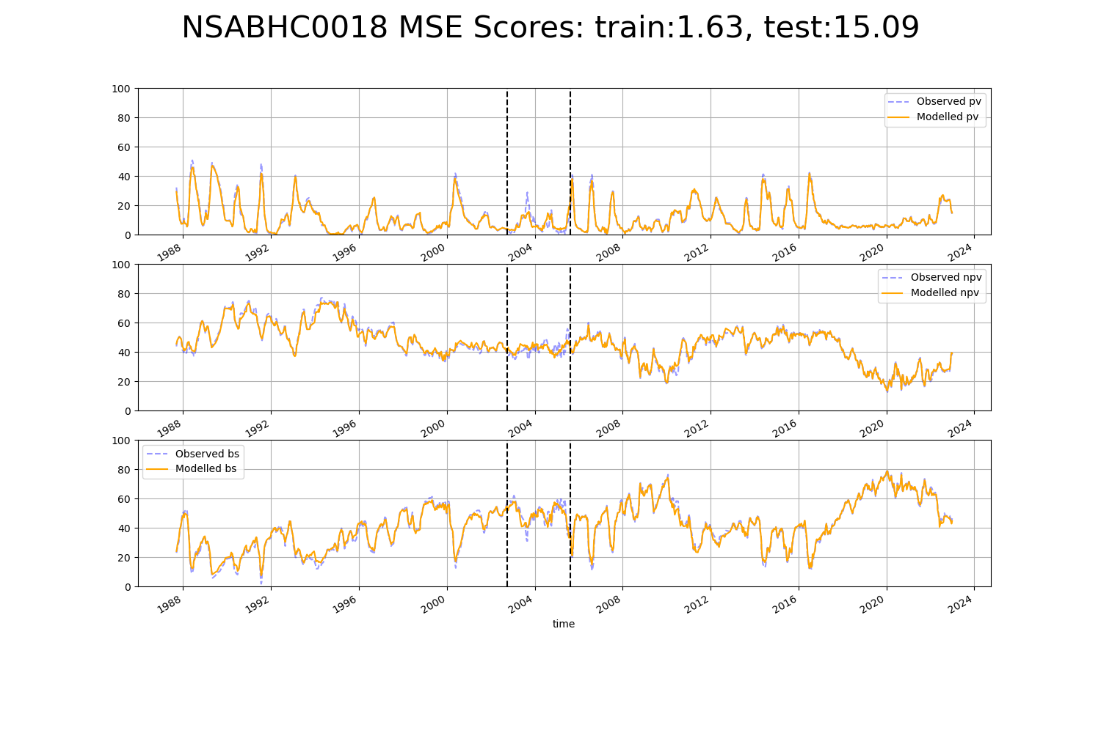

# NSABHC0019

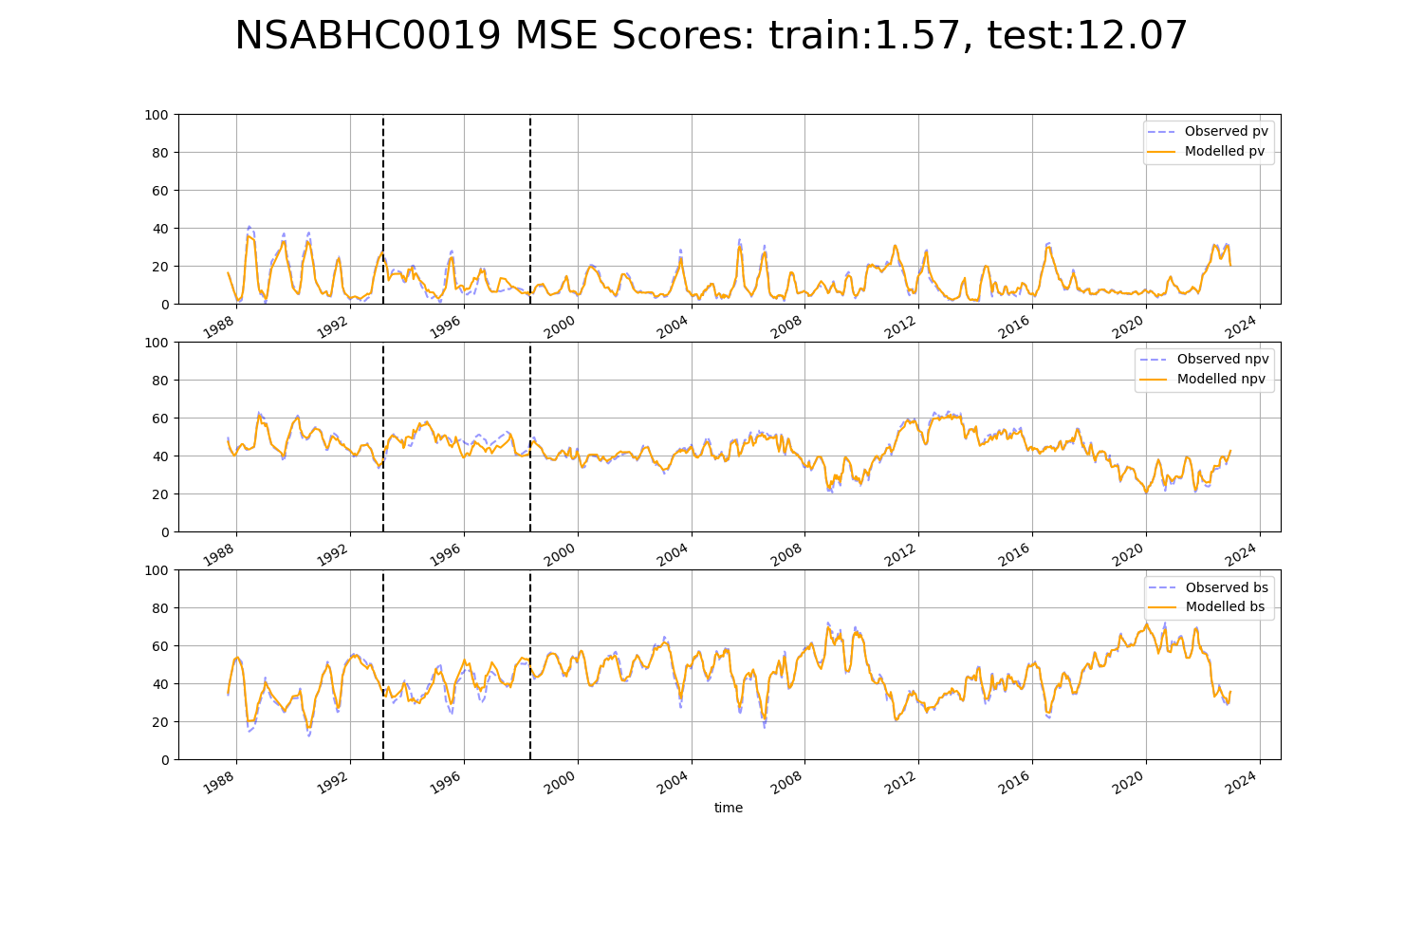

# NSABHC0020

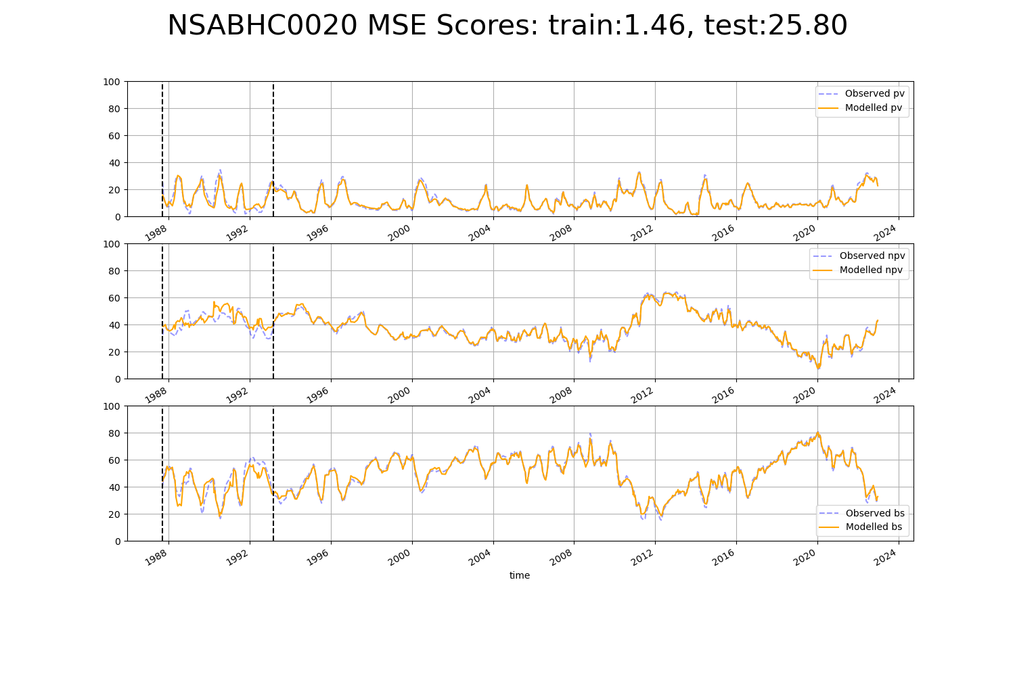

# NSABHC0021

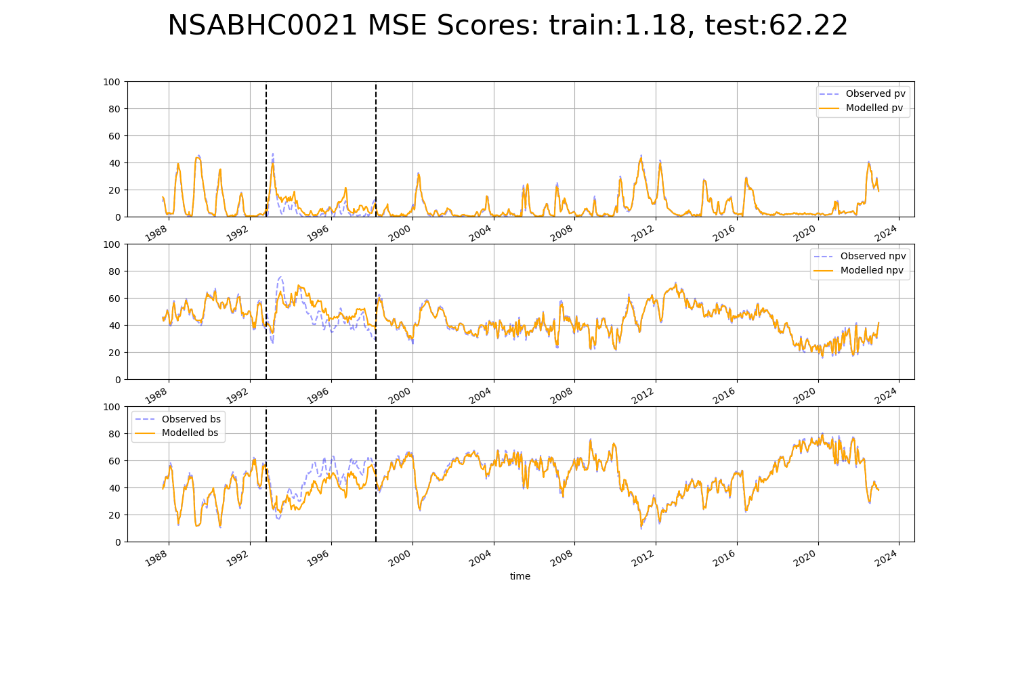

# NSABHC0025

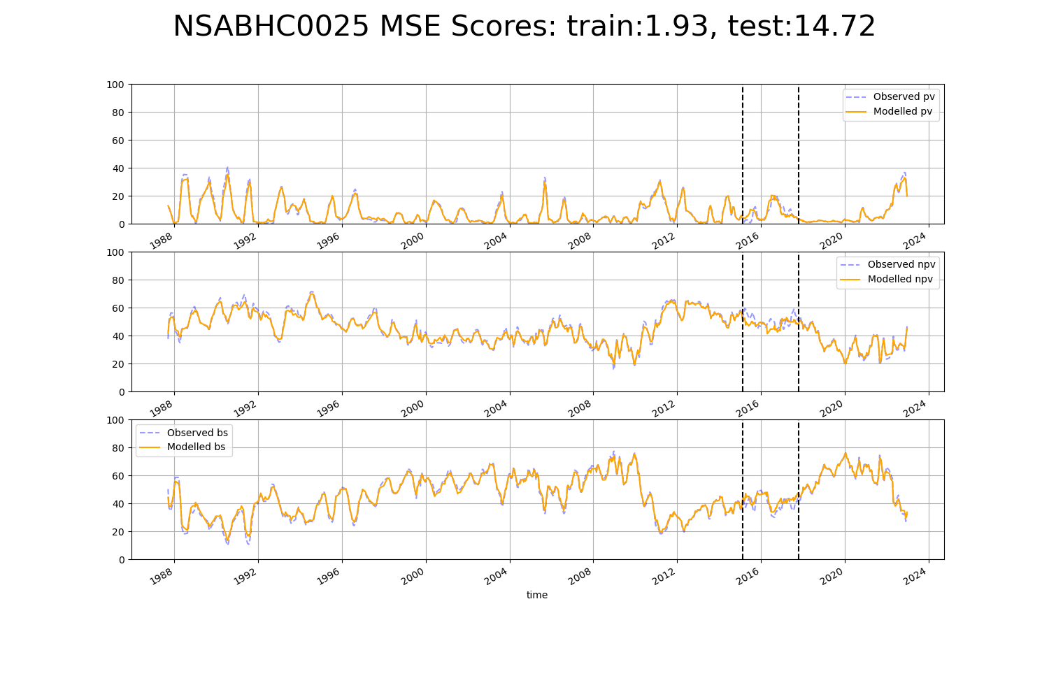

# NTABRT0005

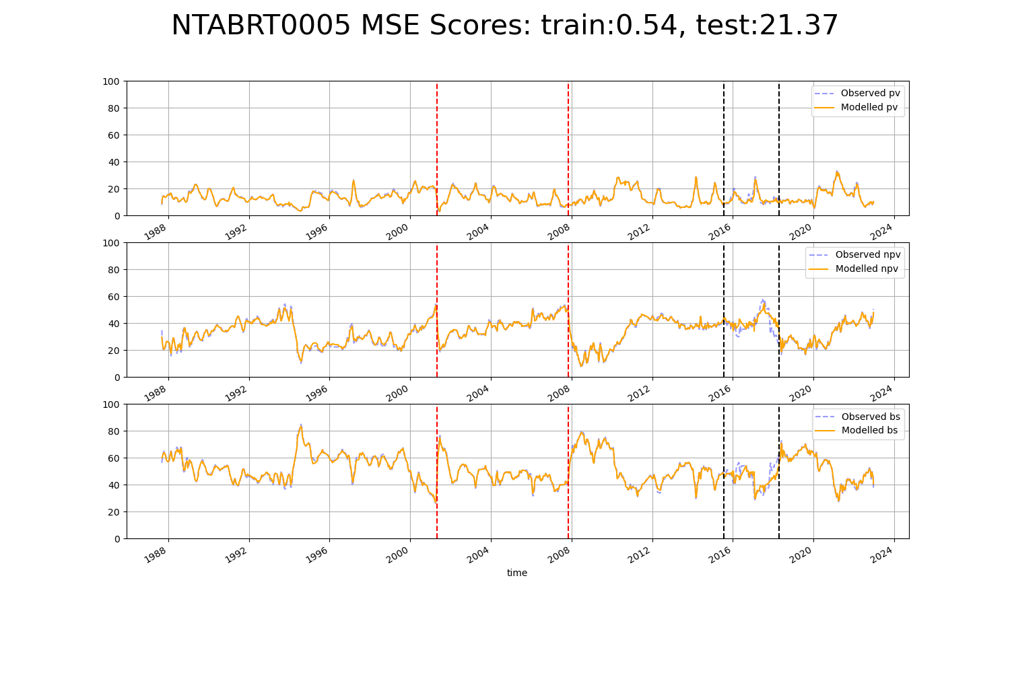

# NTABRT0007

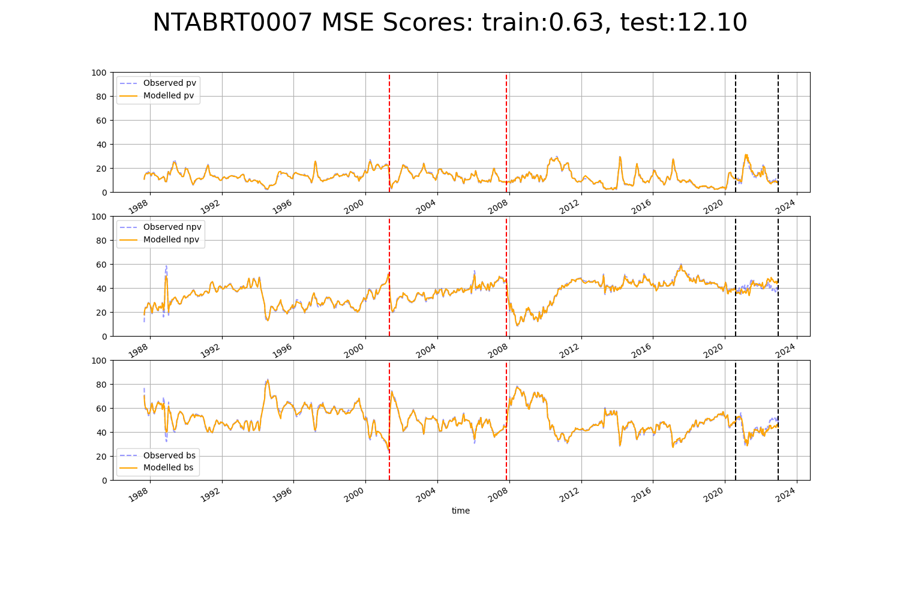

# NTAFIN0001

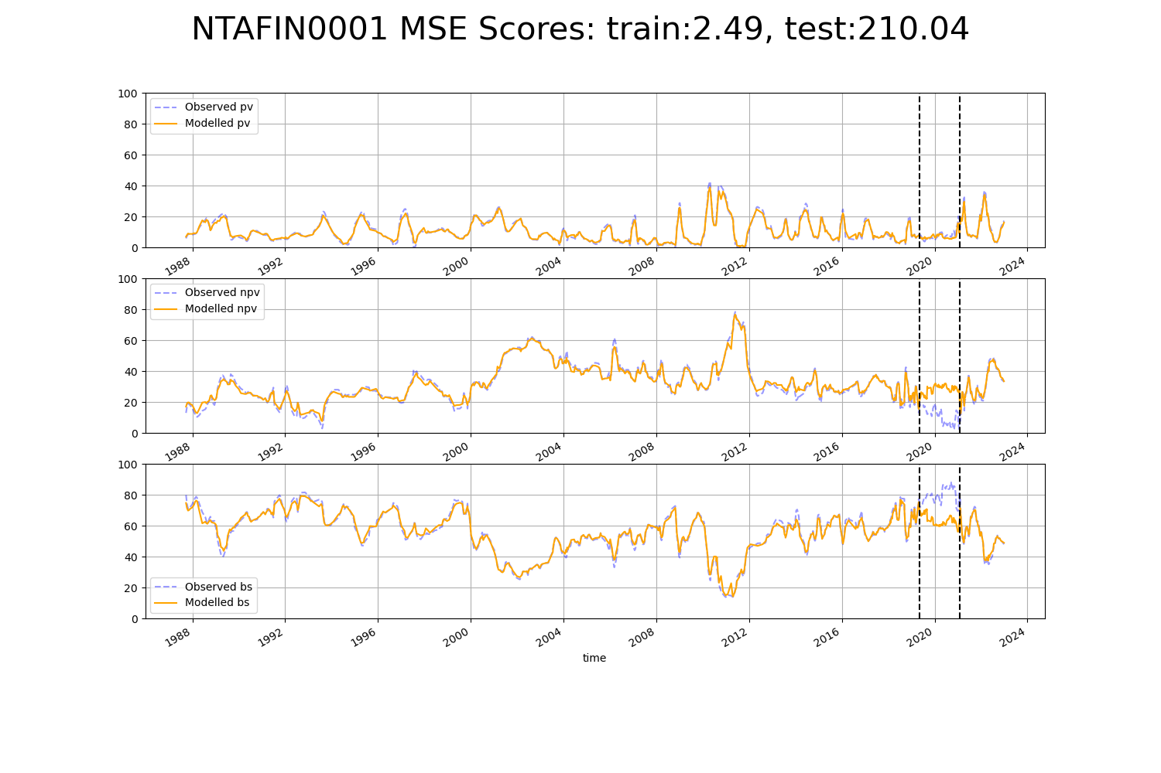

# NTAFIN0002

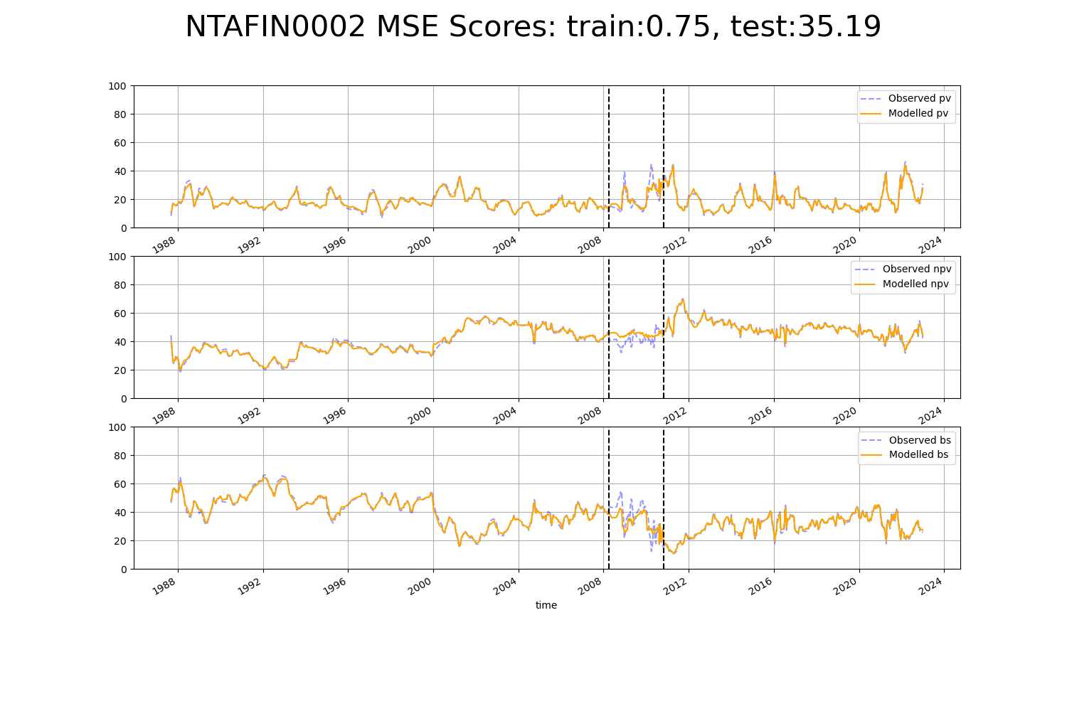

# NTAFIN0005

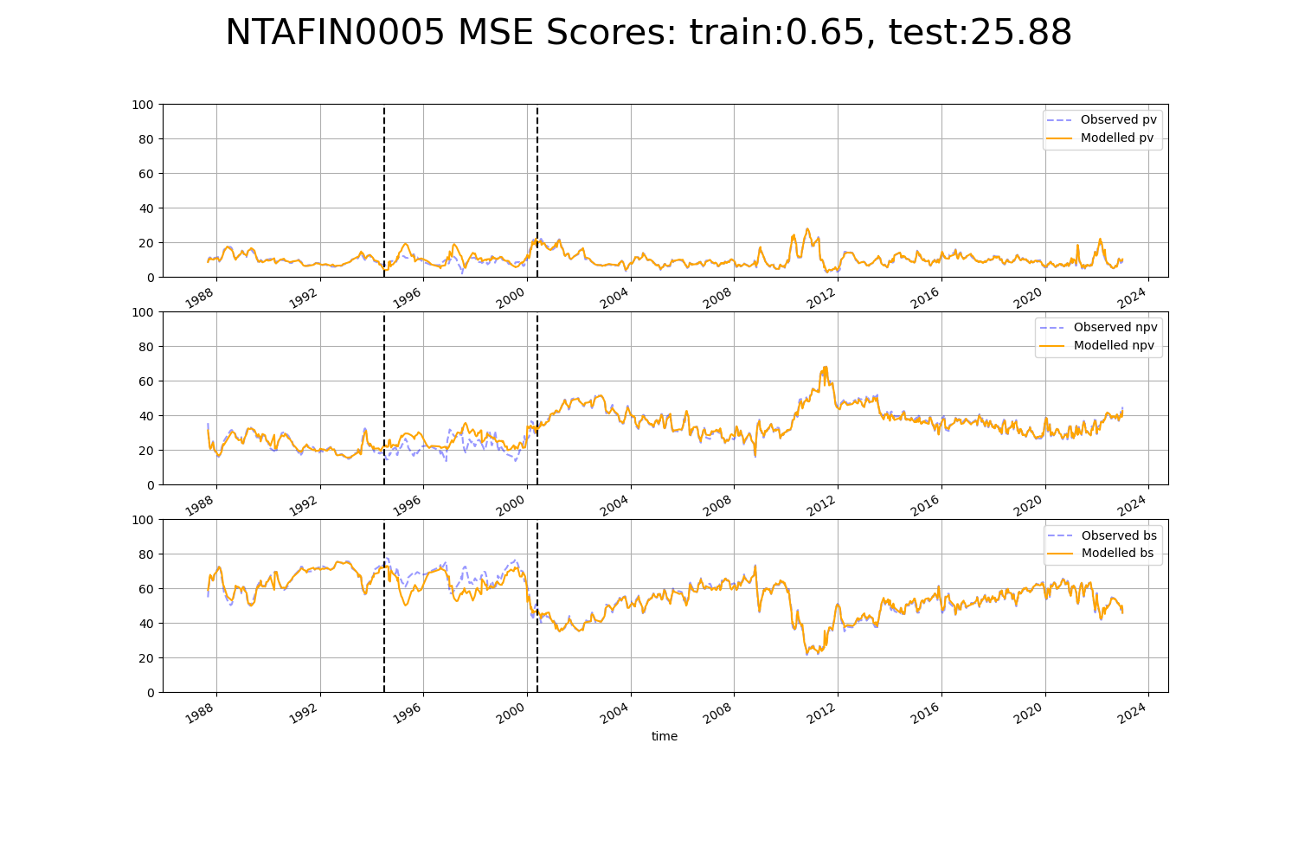

# NTAFIN0006

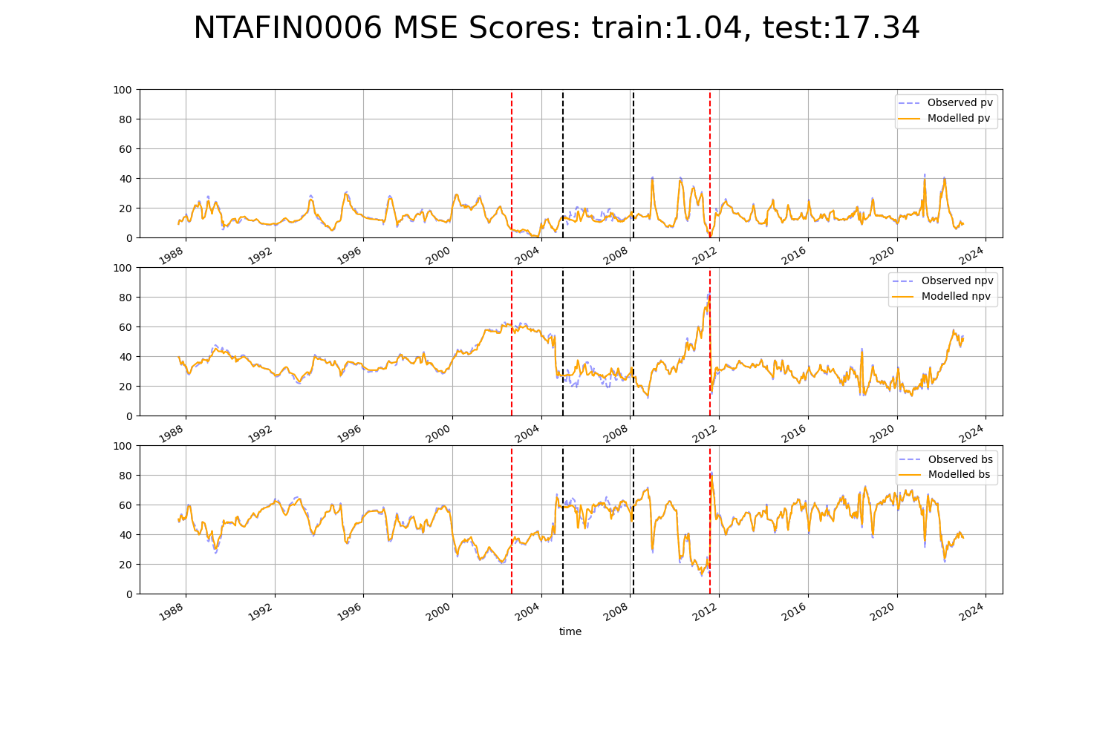

# NTAFIN0007

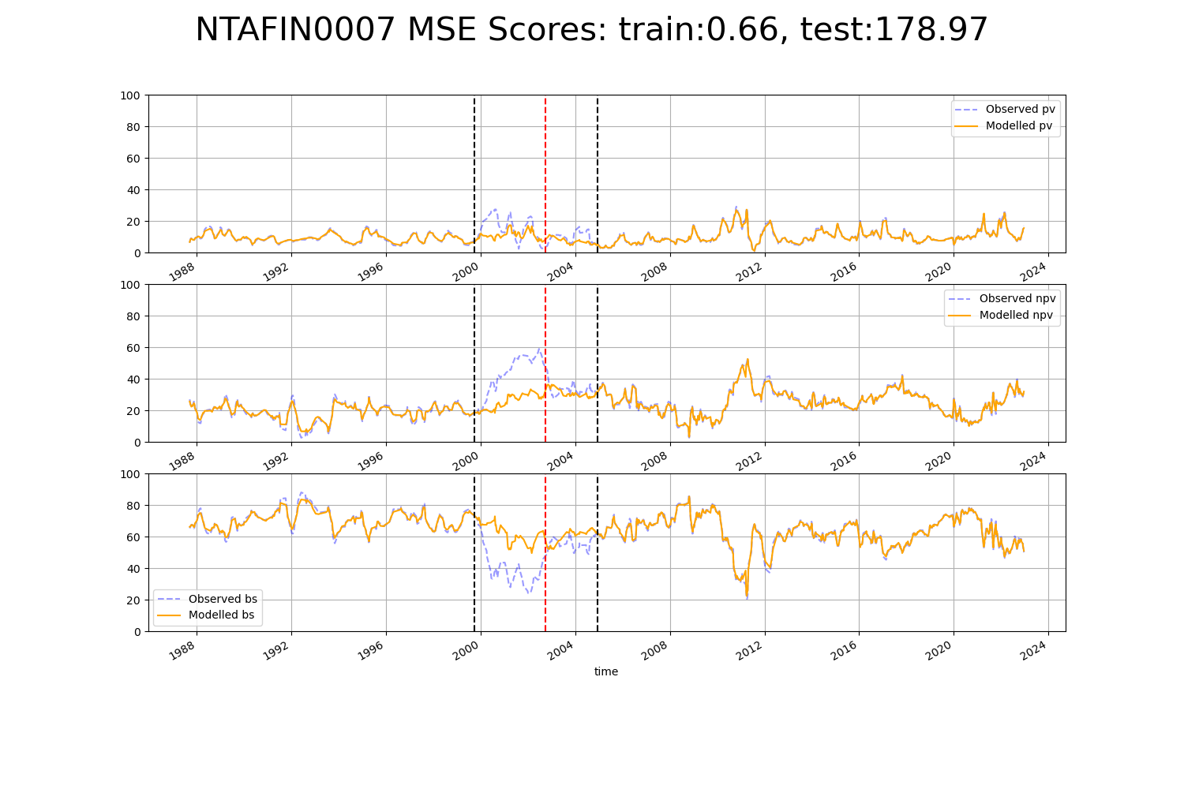

# NTAFIN0008

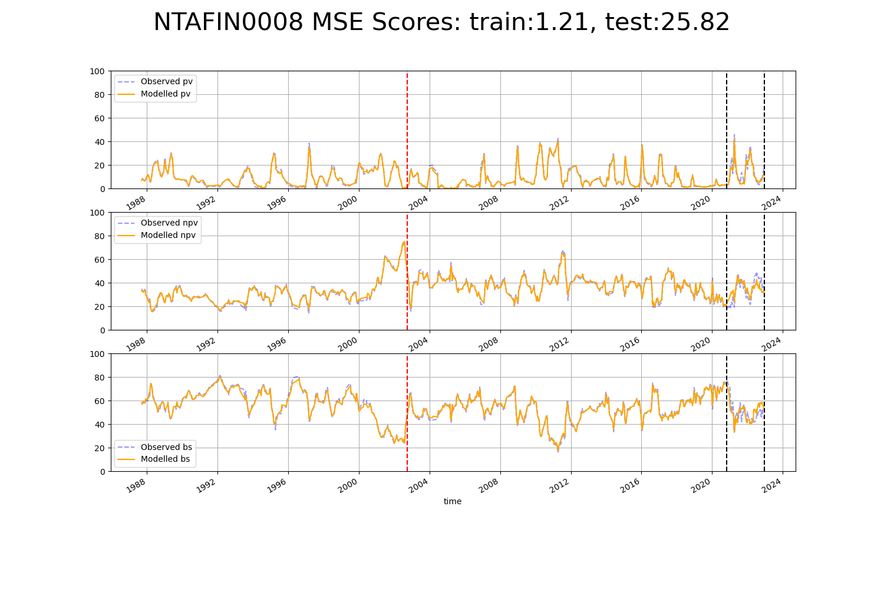

# NTAFIN0012

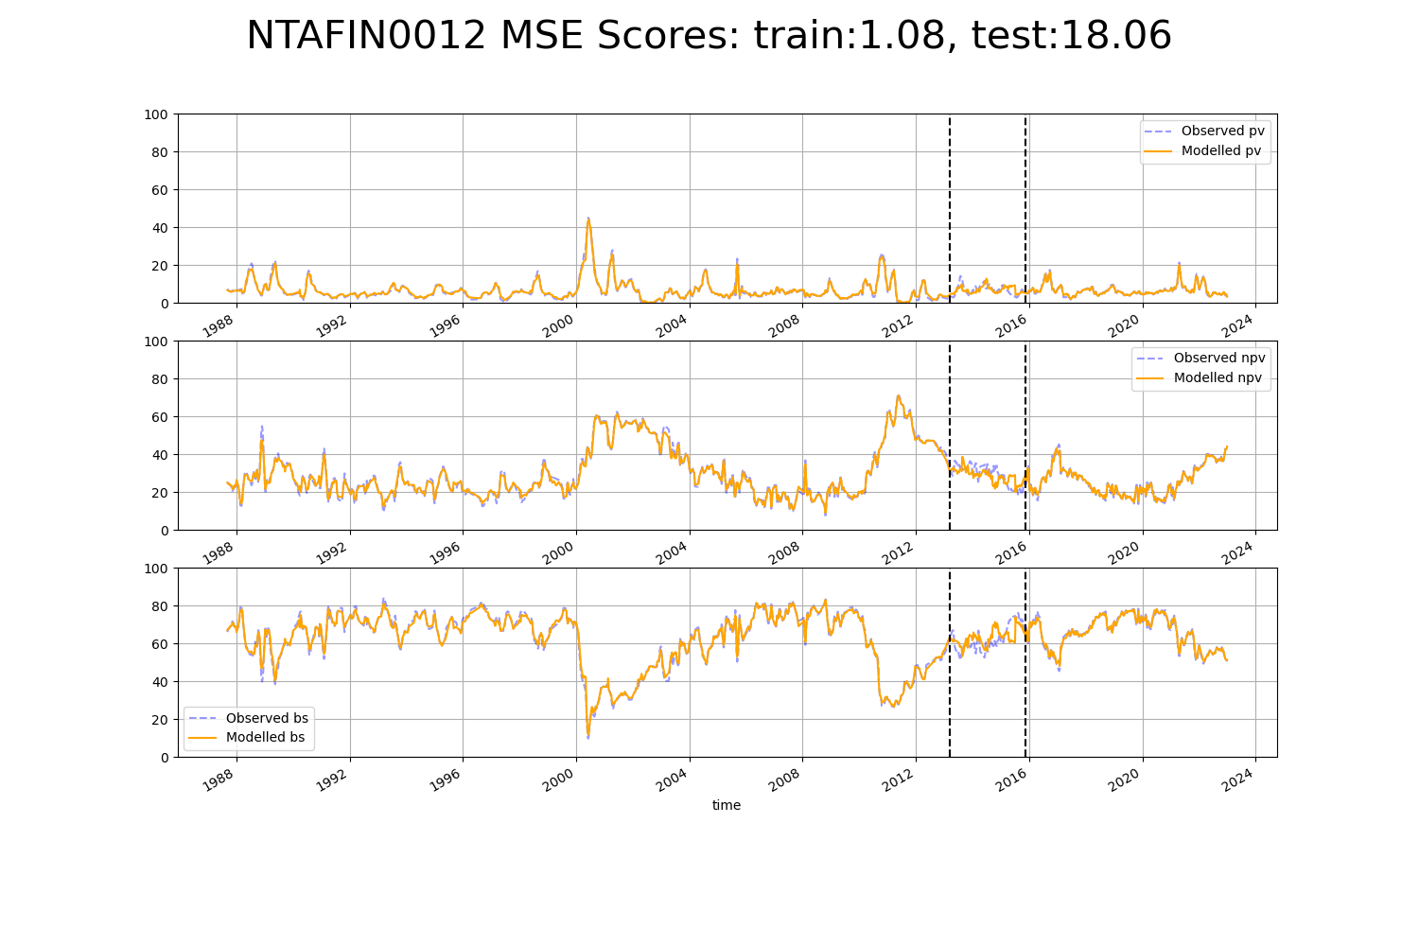

# NTAFIN0016

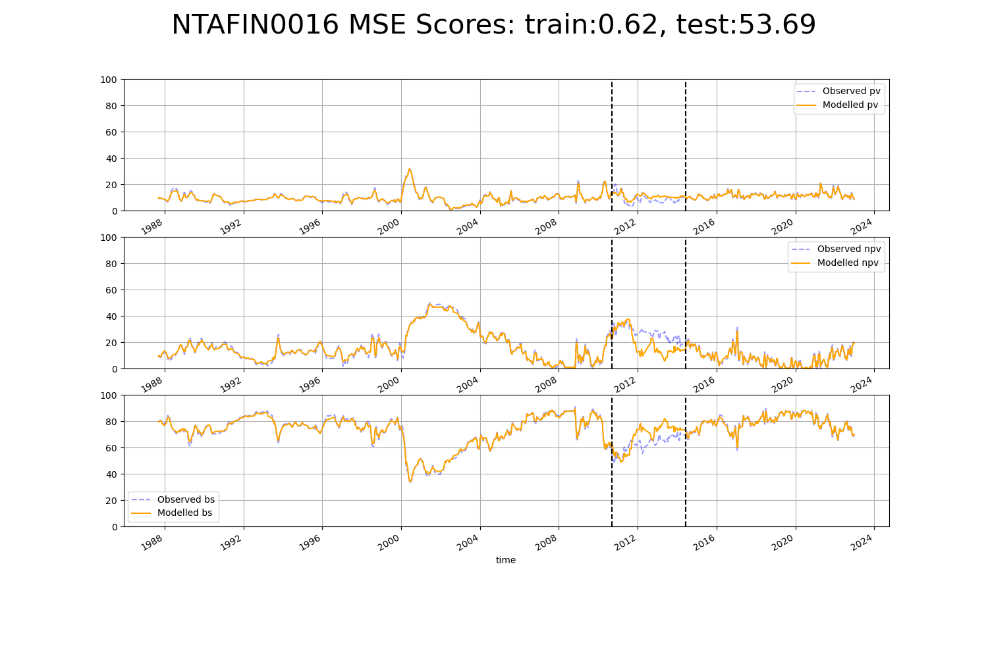

# NTAFIN0017

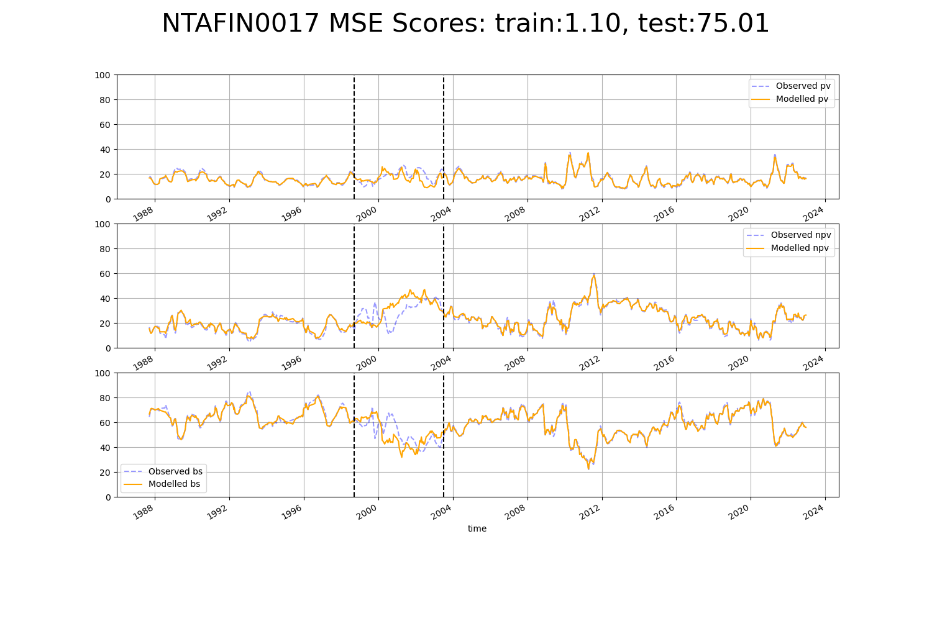

# NTAFIN0019

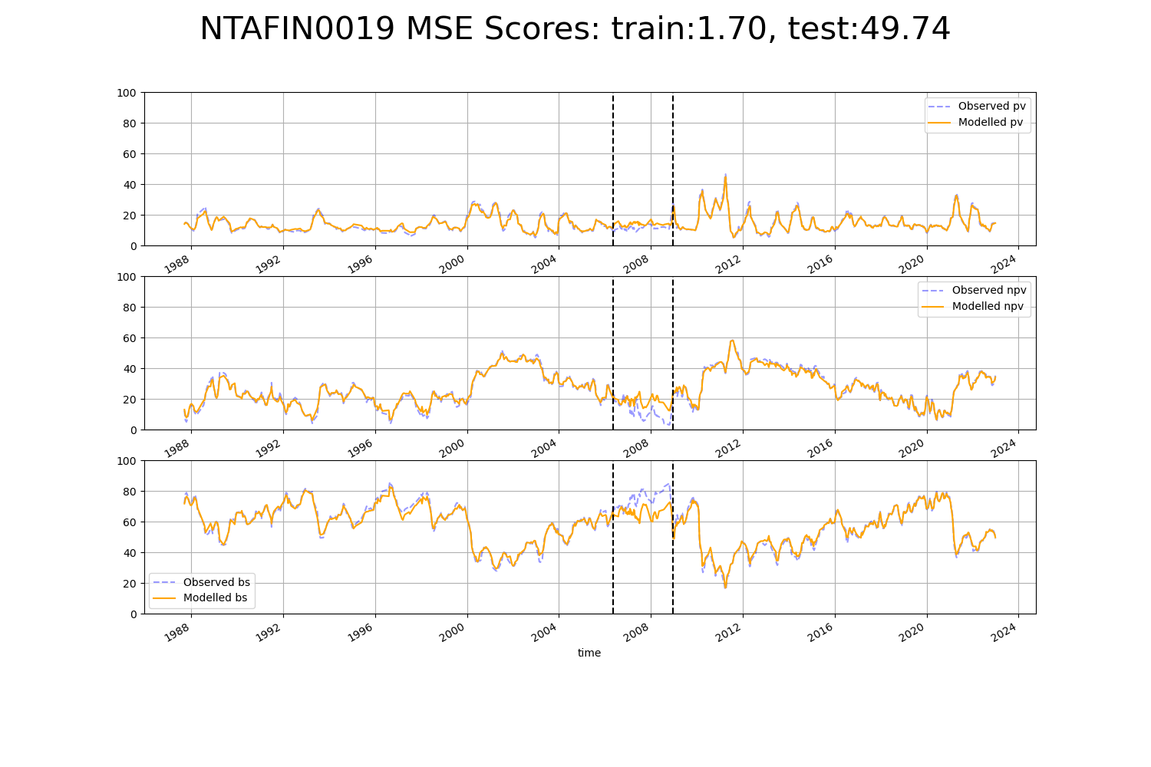

# NTAFIN0020

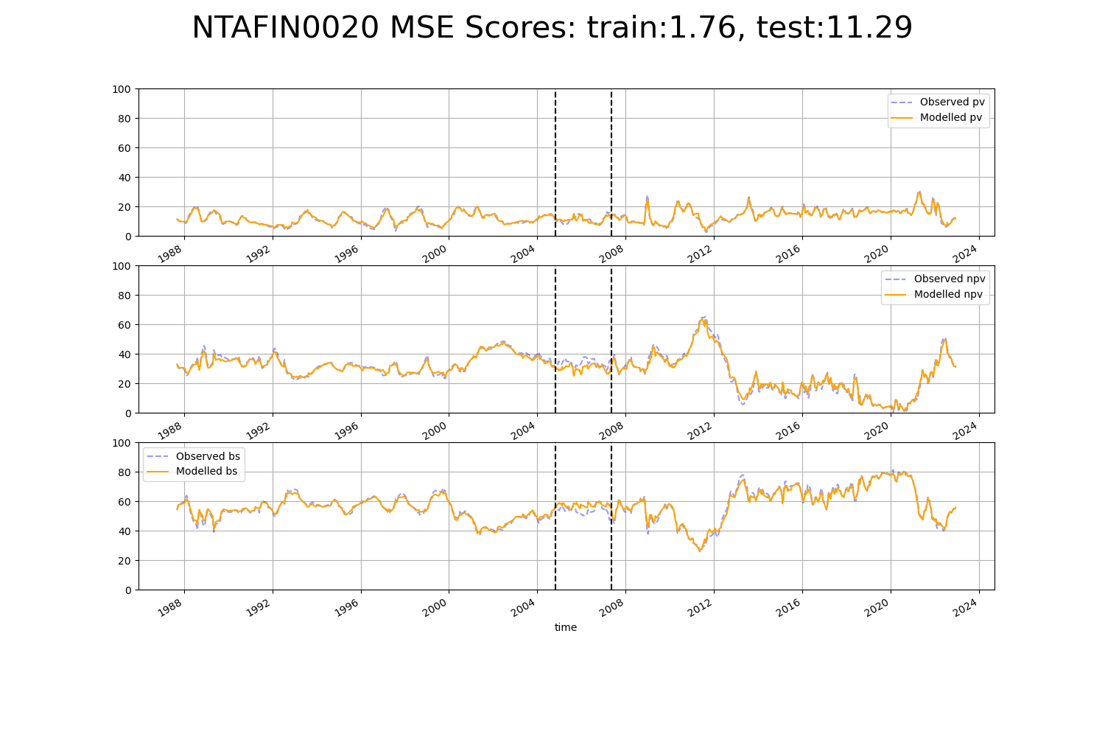

# NTAFIN0021

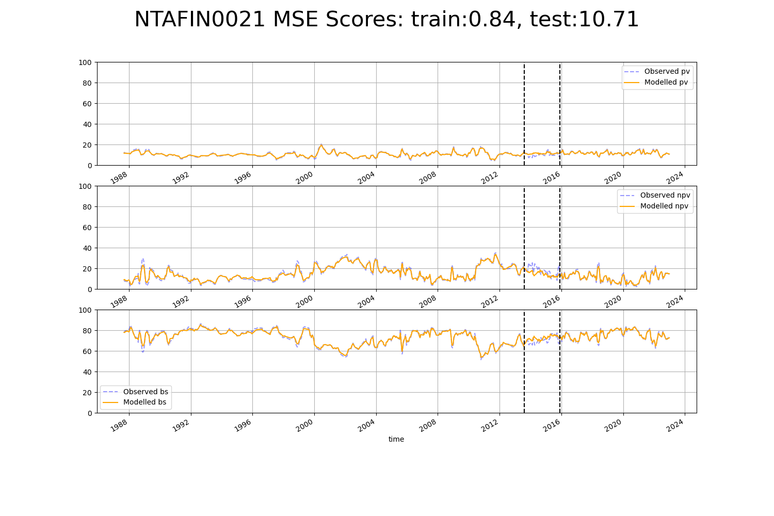

# NTAFIN0025

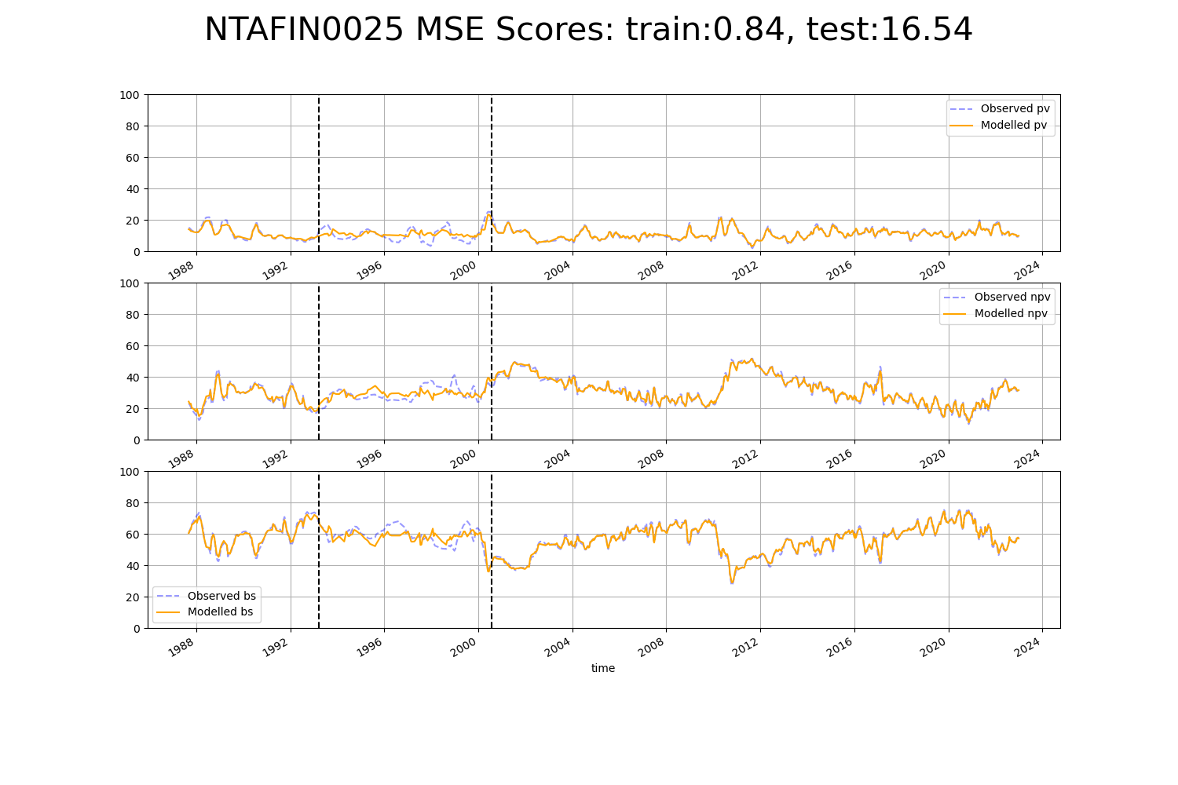

# NTAFIN0026

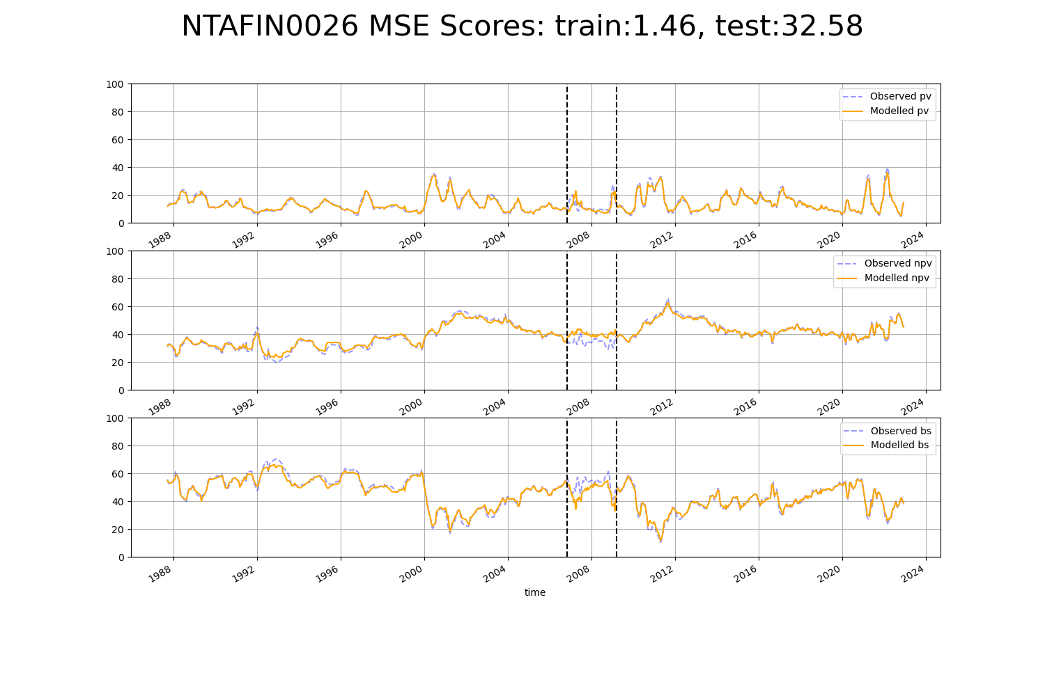

# NTAFIN0027

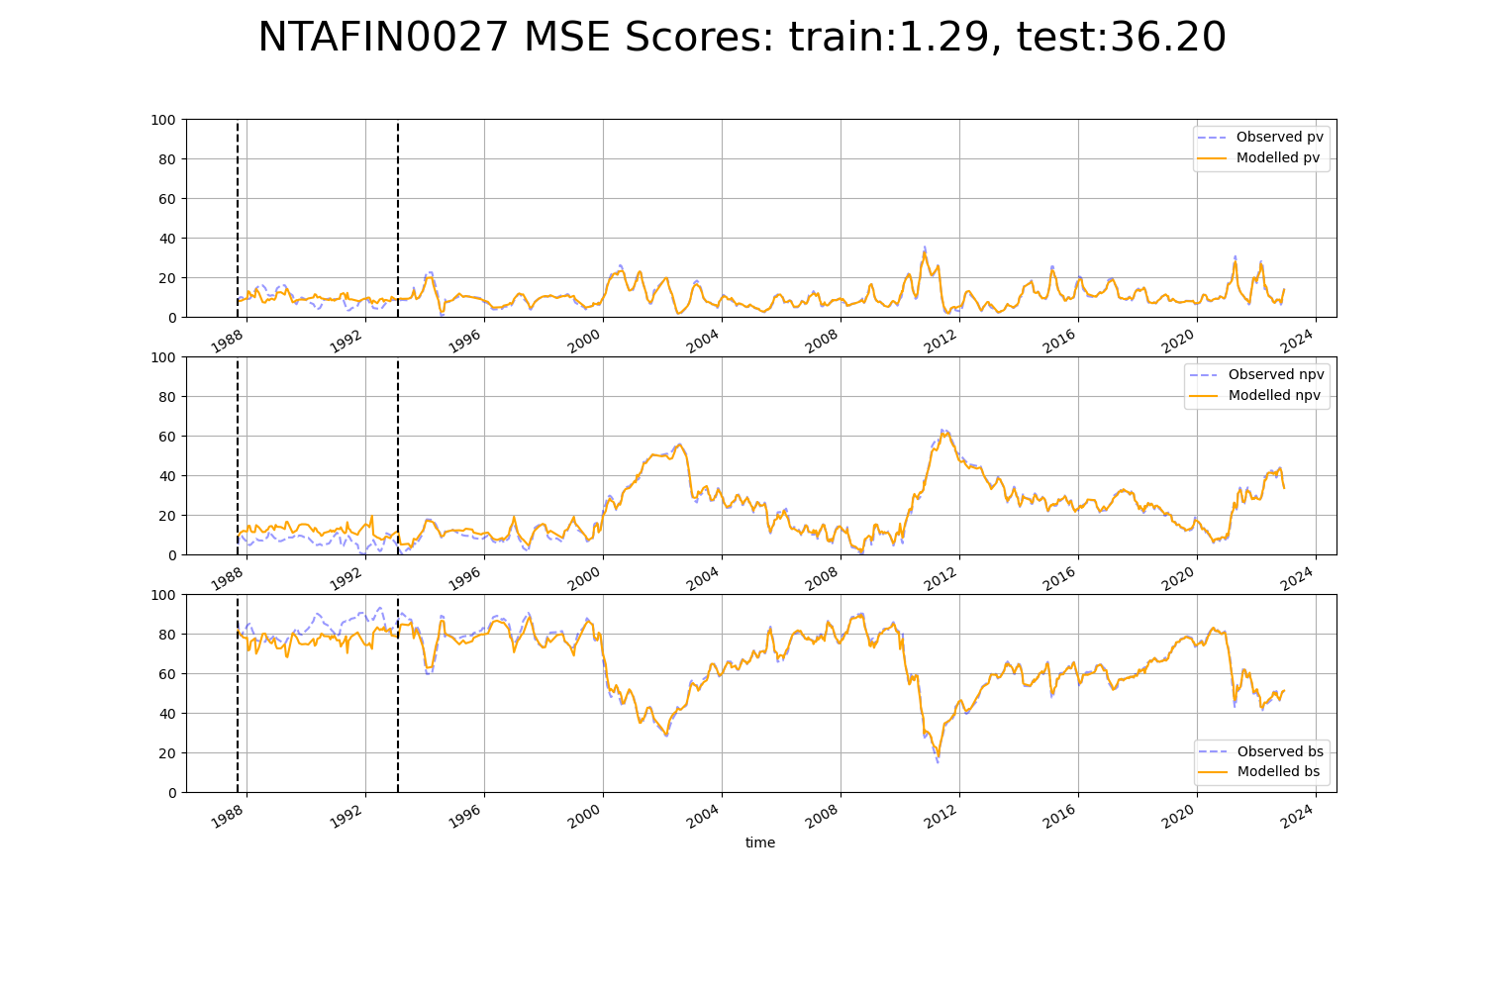

# NTAFIN0029

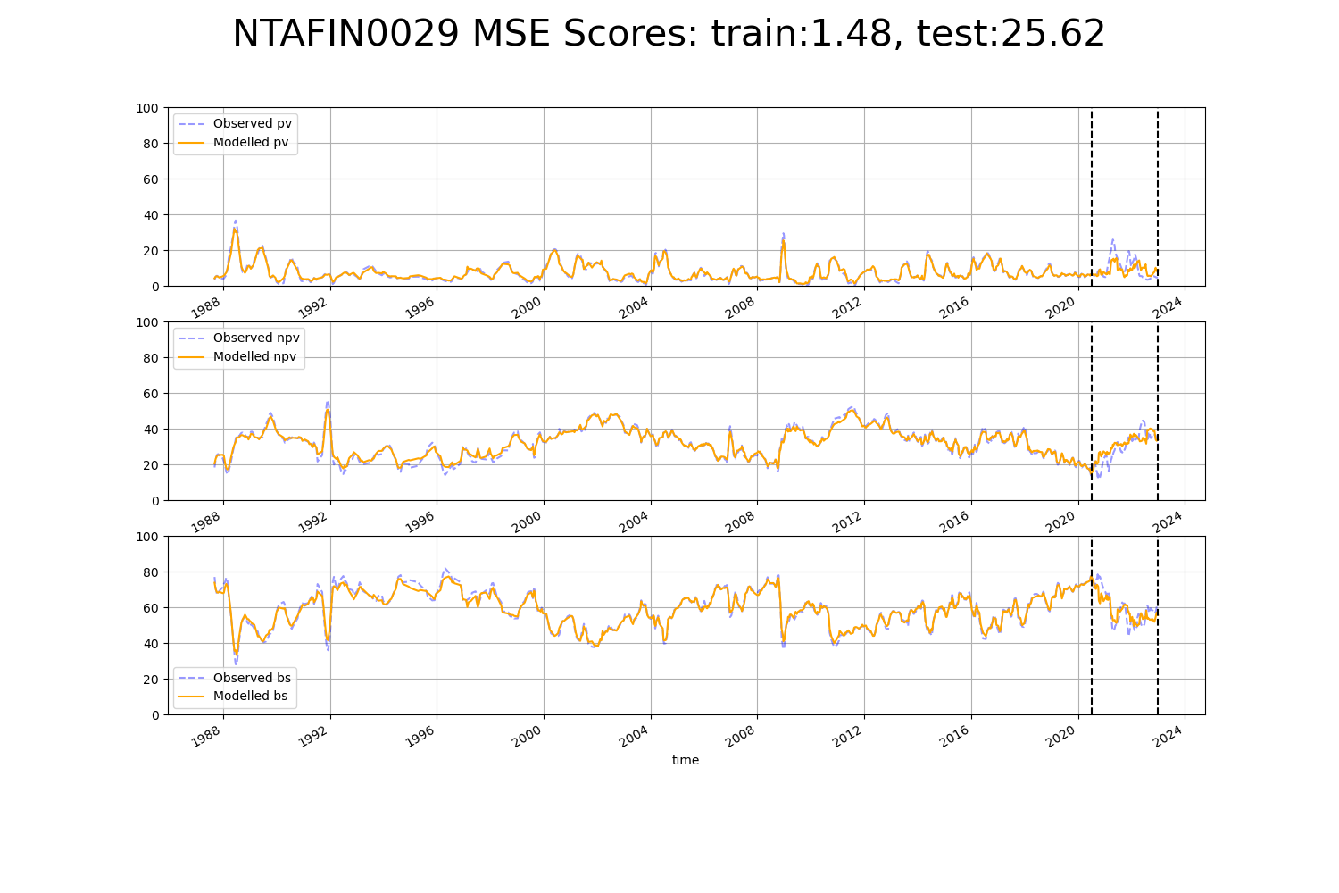

# NTAFIN0033

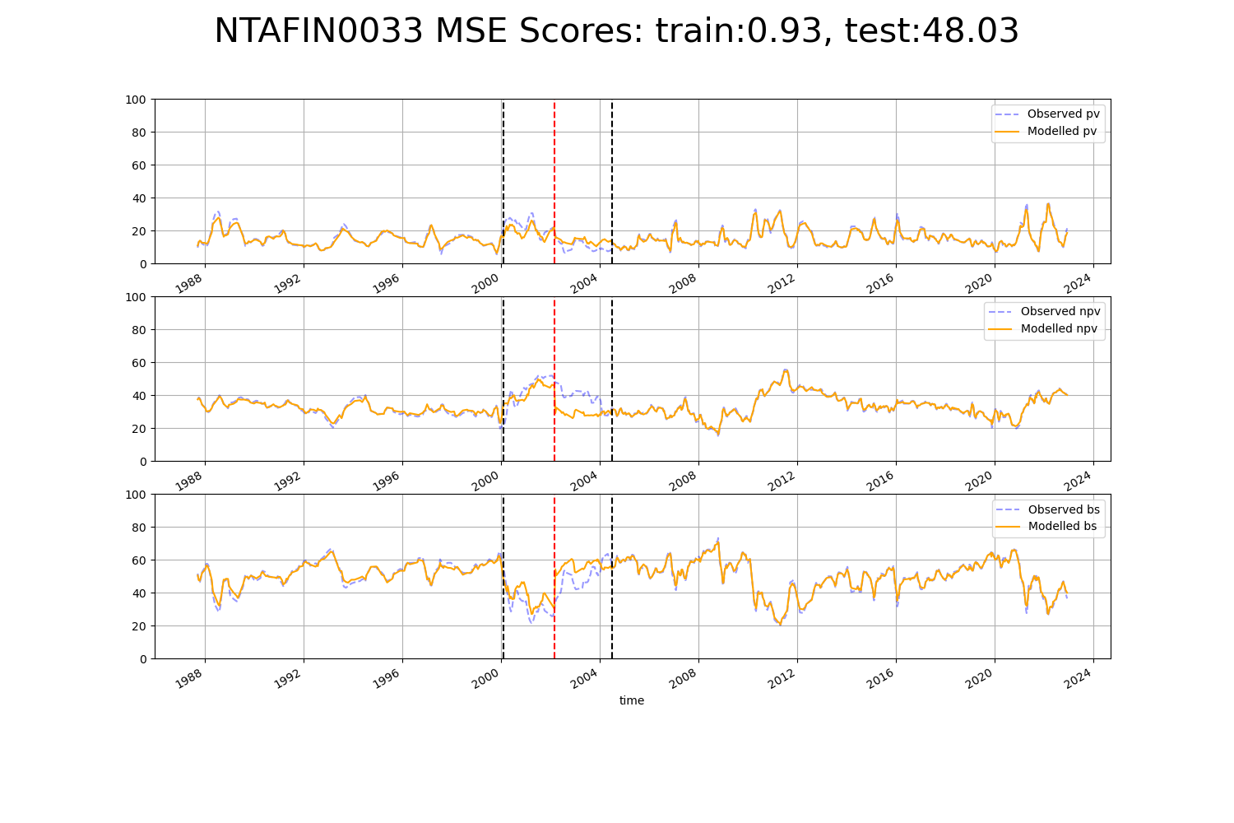

# NTAMAC0001

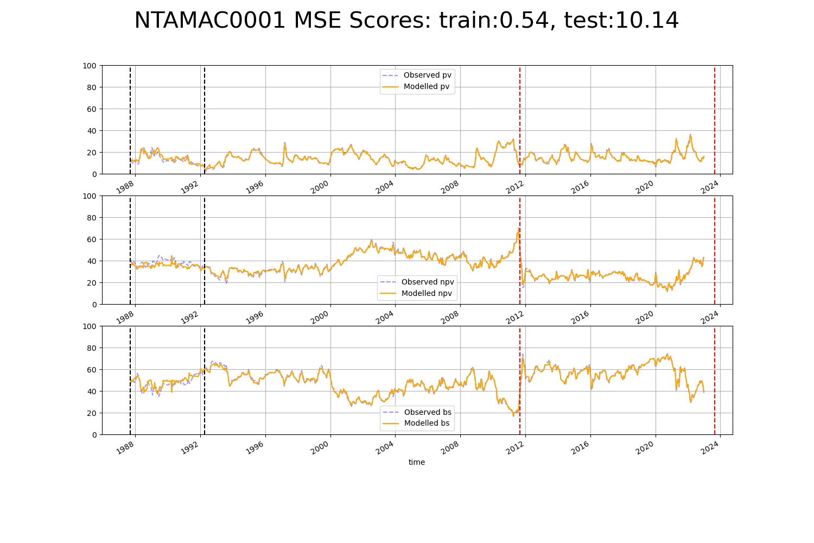

# NTAMAC0003

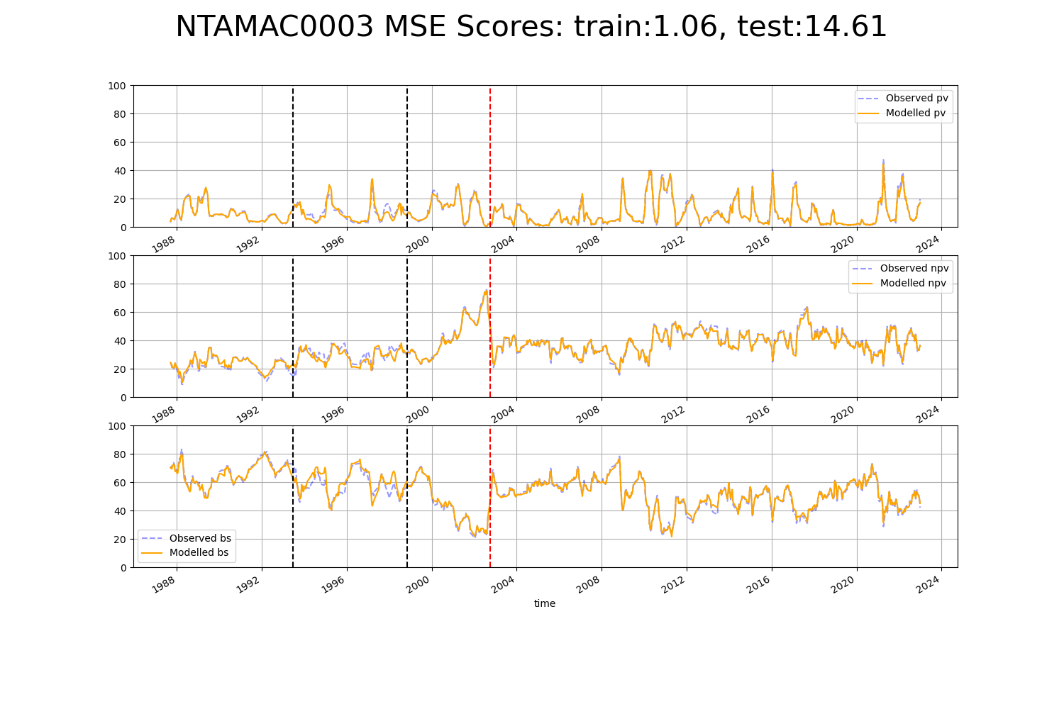

# NTASSD0006

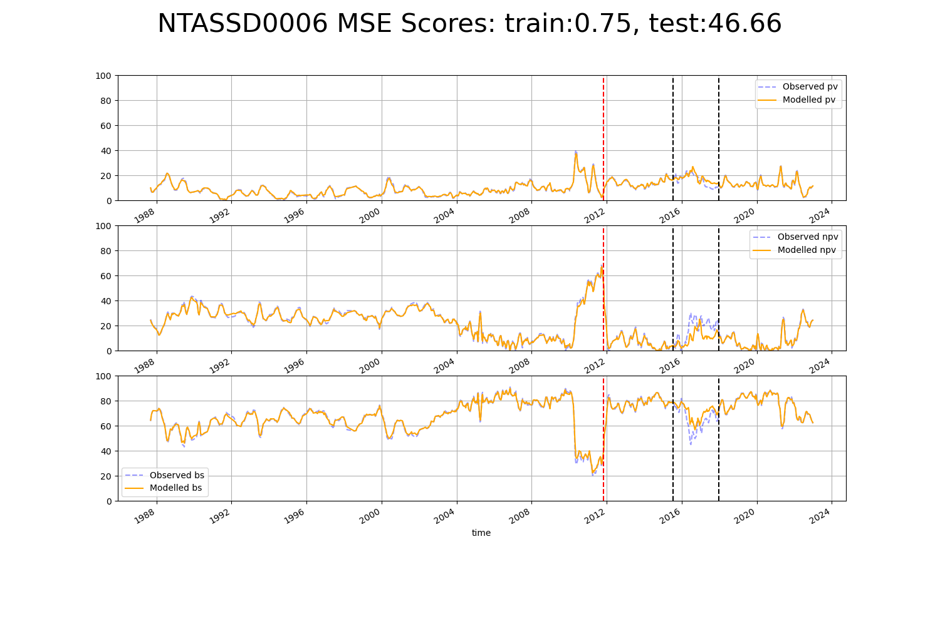

# NTASSD0008

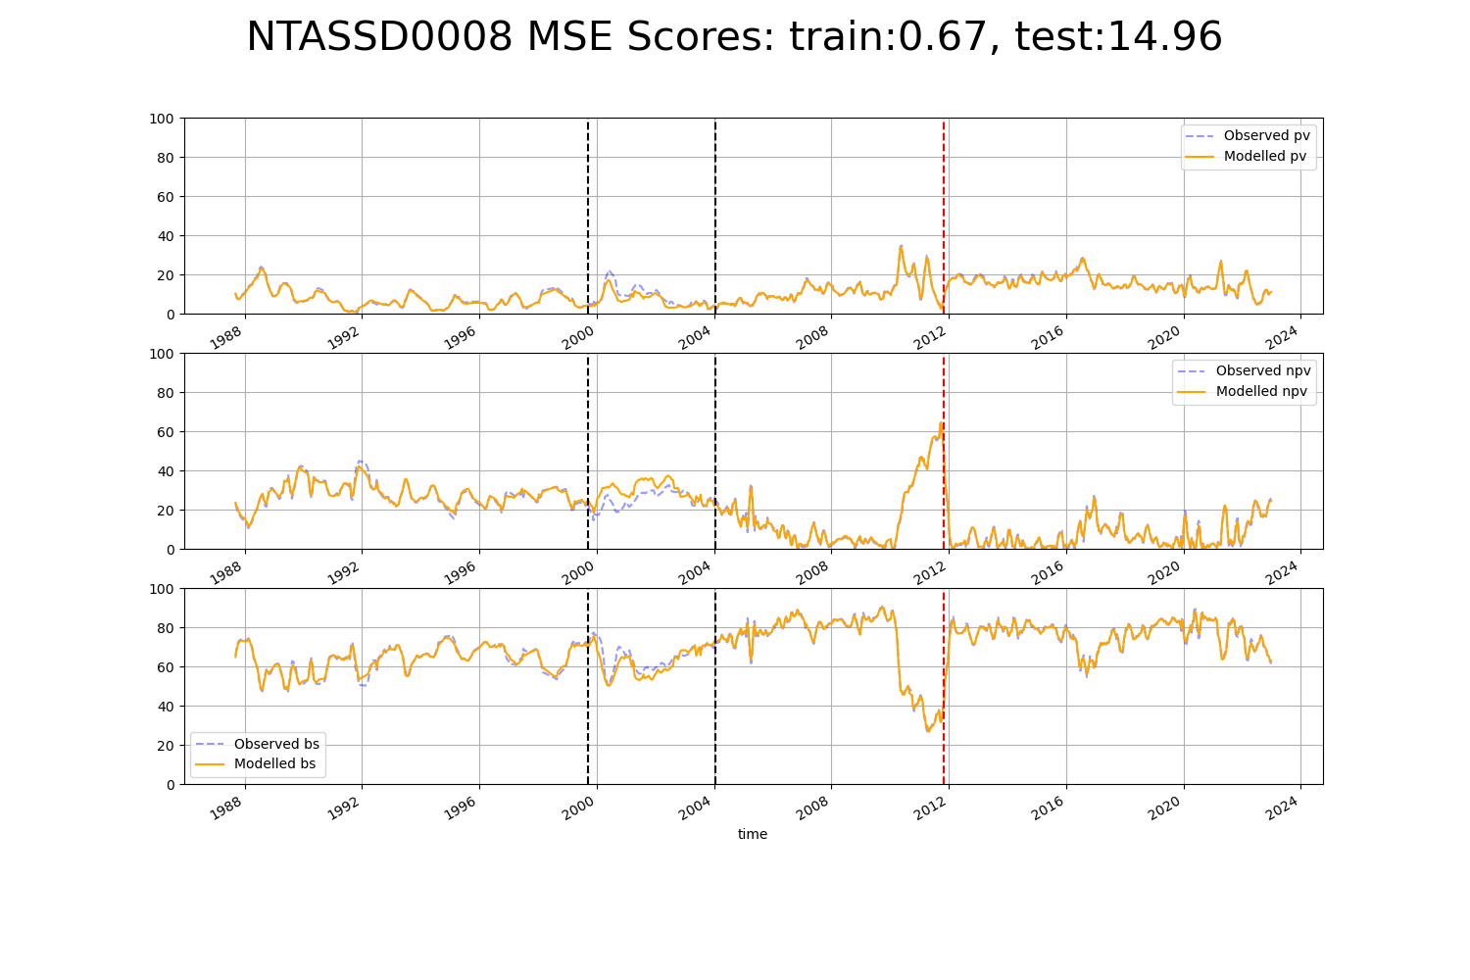

# NTASSD0009

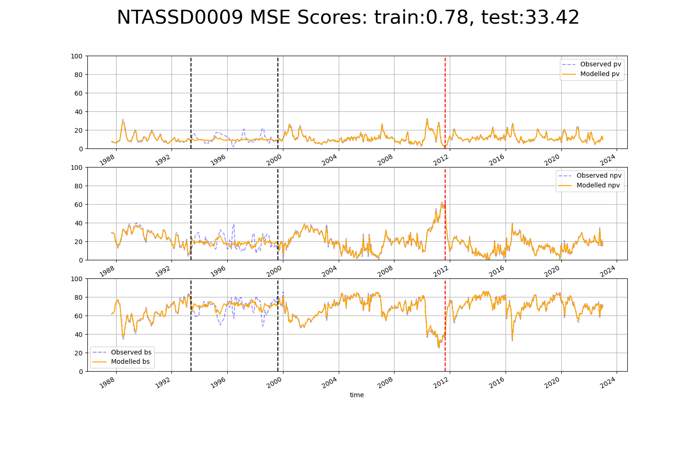

# NTASSD0011

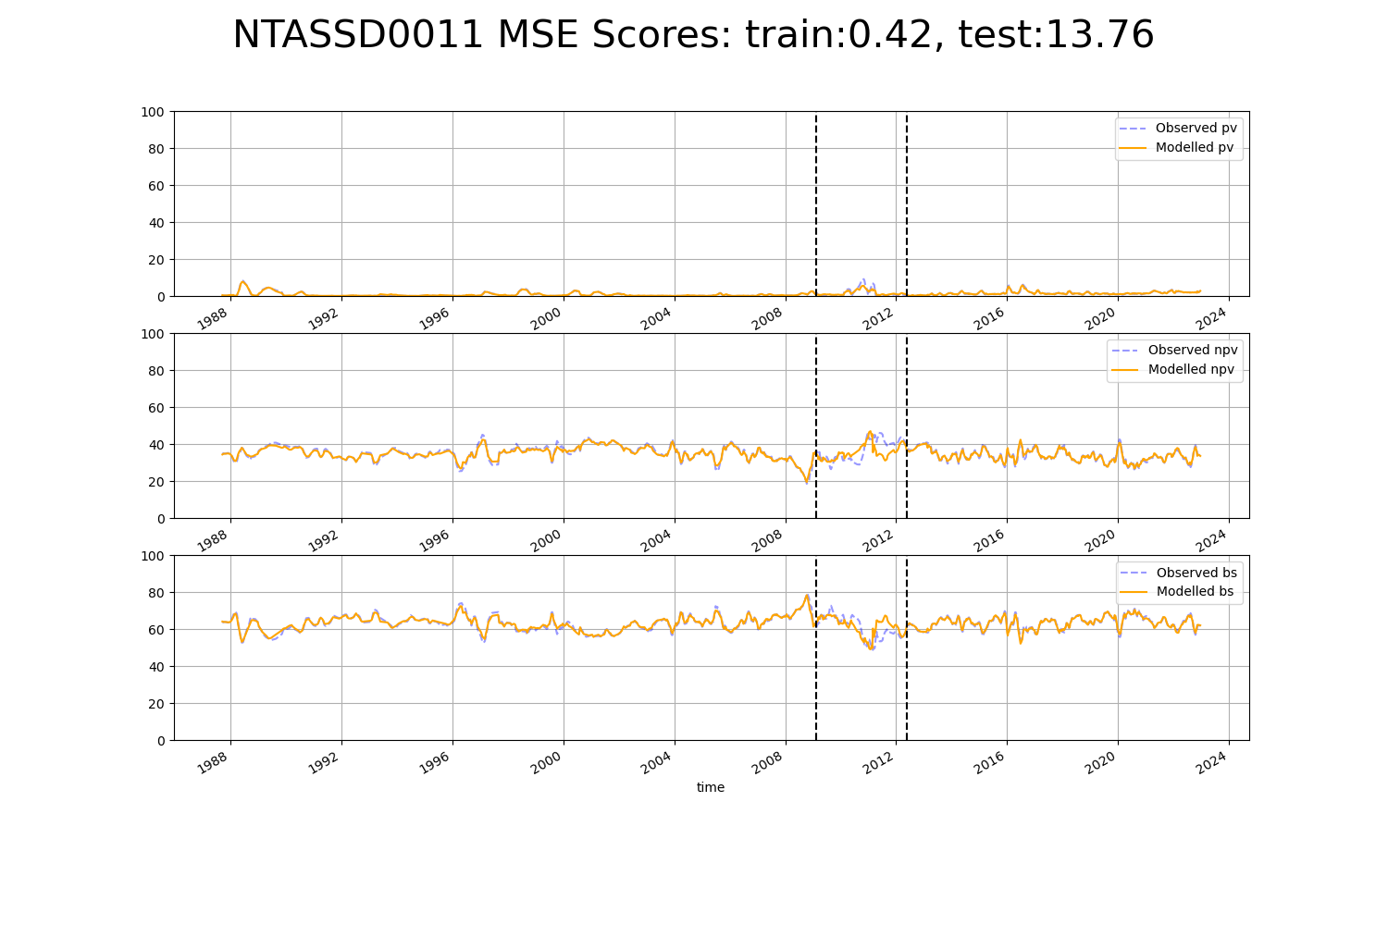

# NTASSD0012

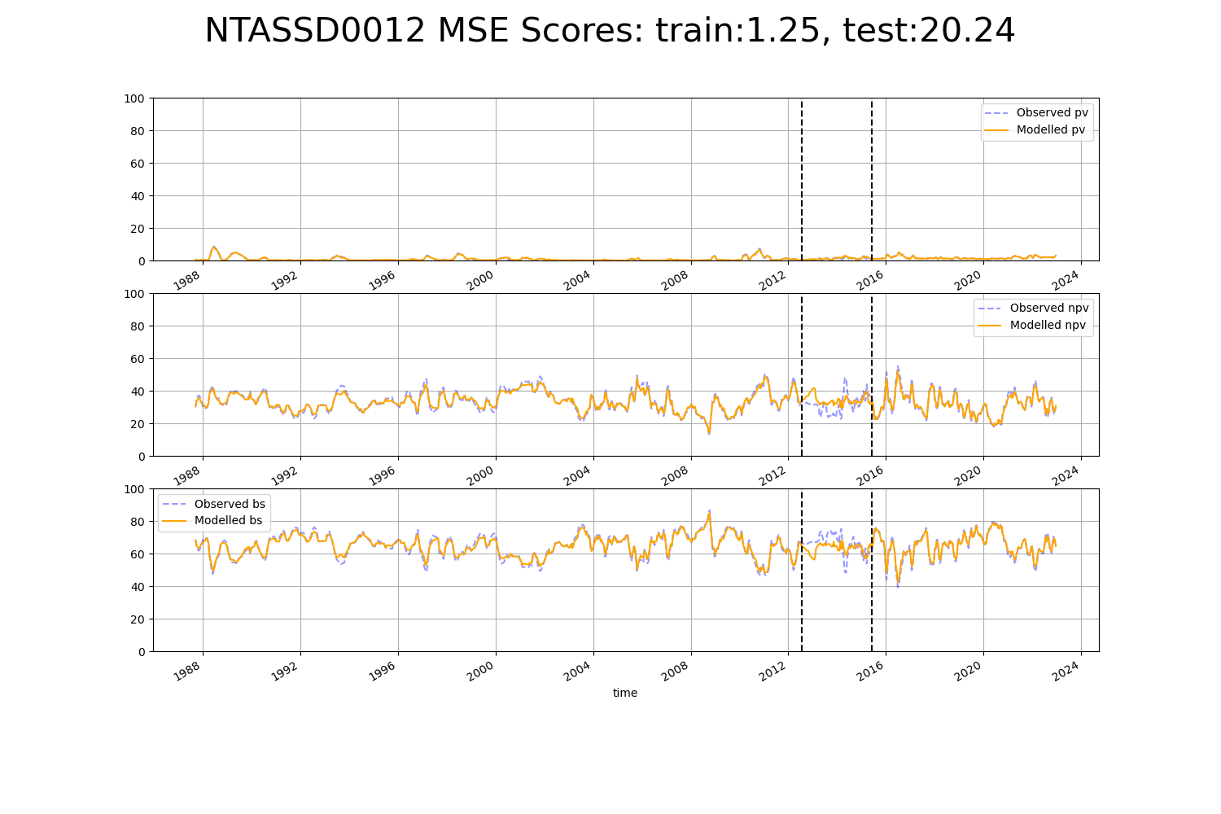

# NTASSD0018

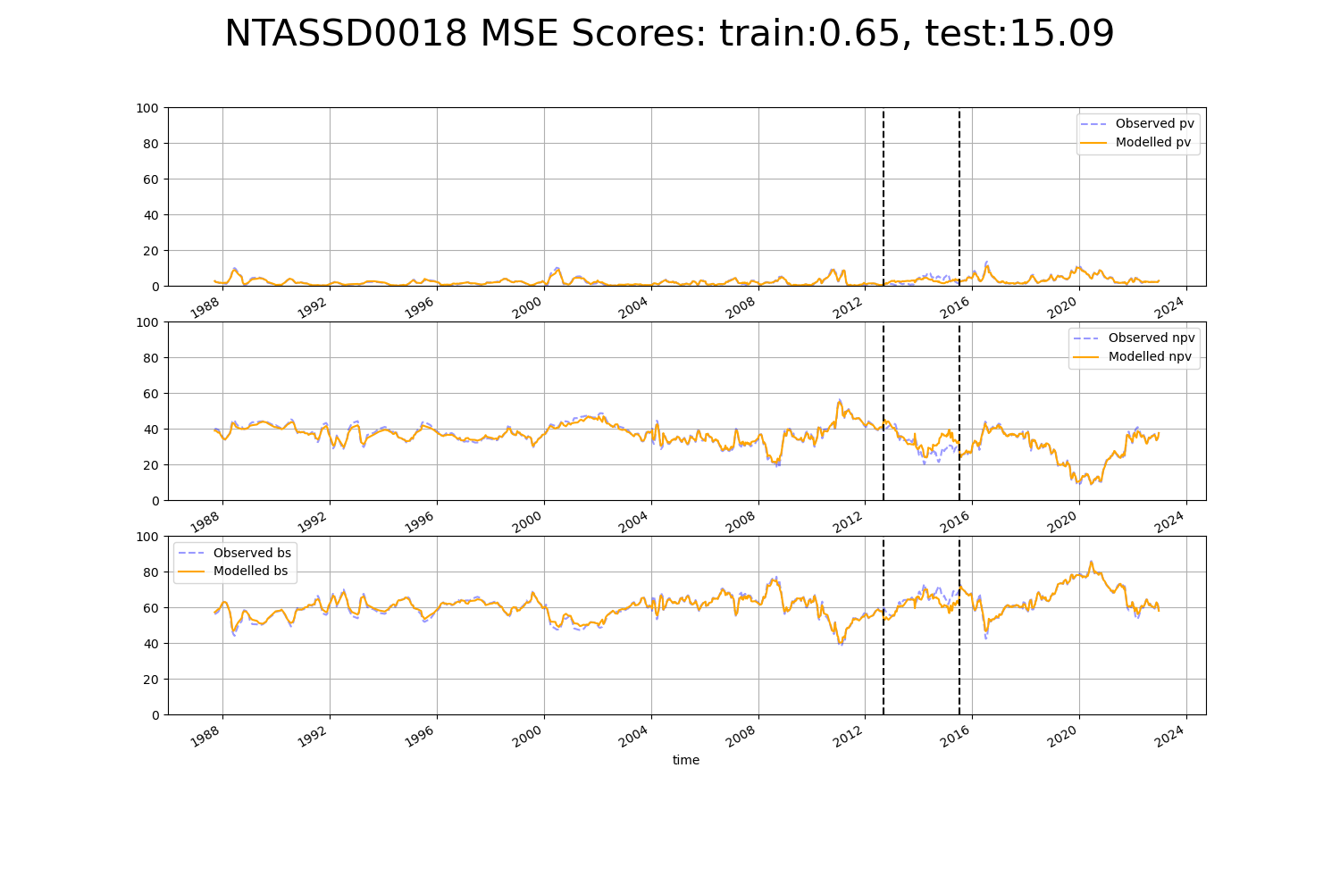

# QDACHC0004

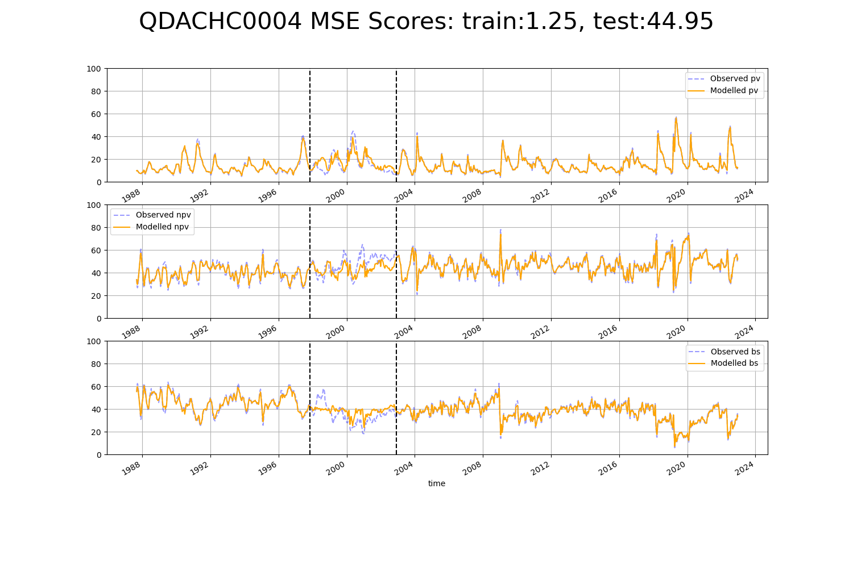

# QDACHC0005

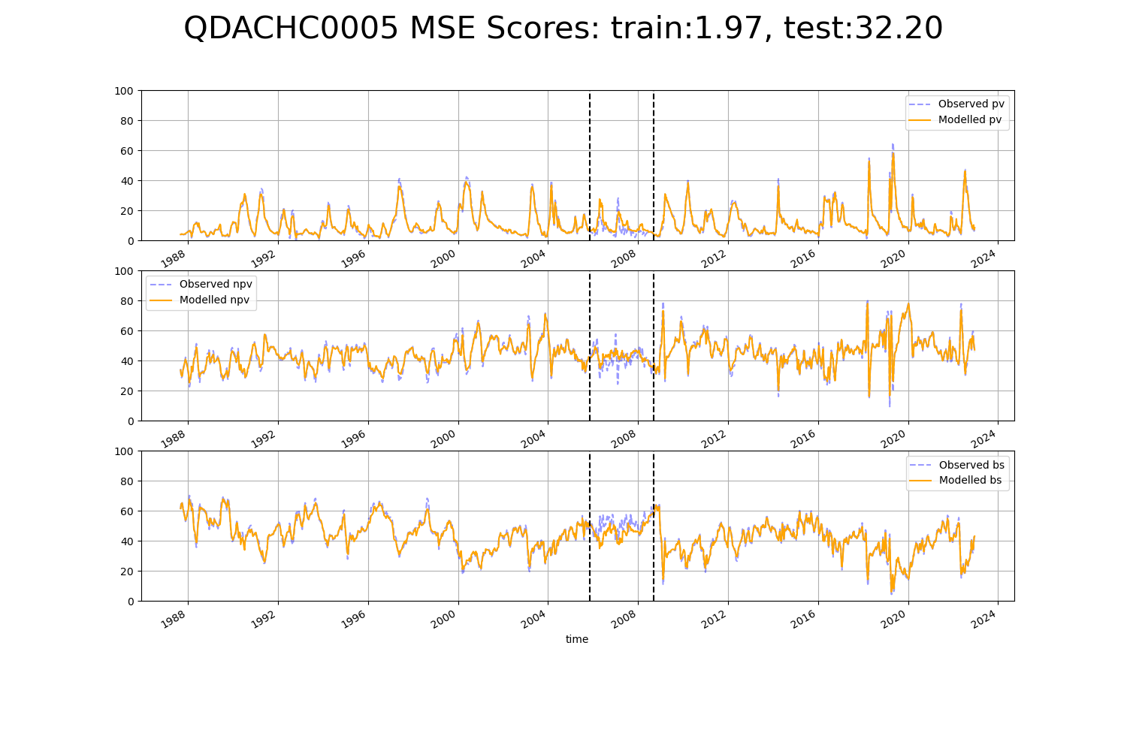

# QDACHC0006

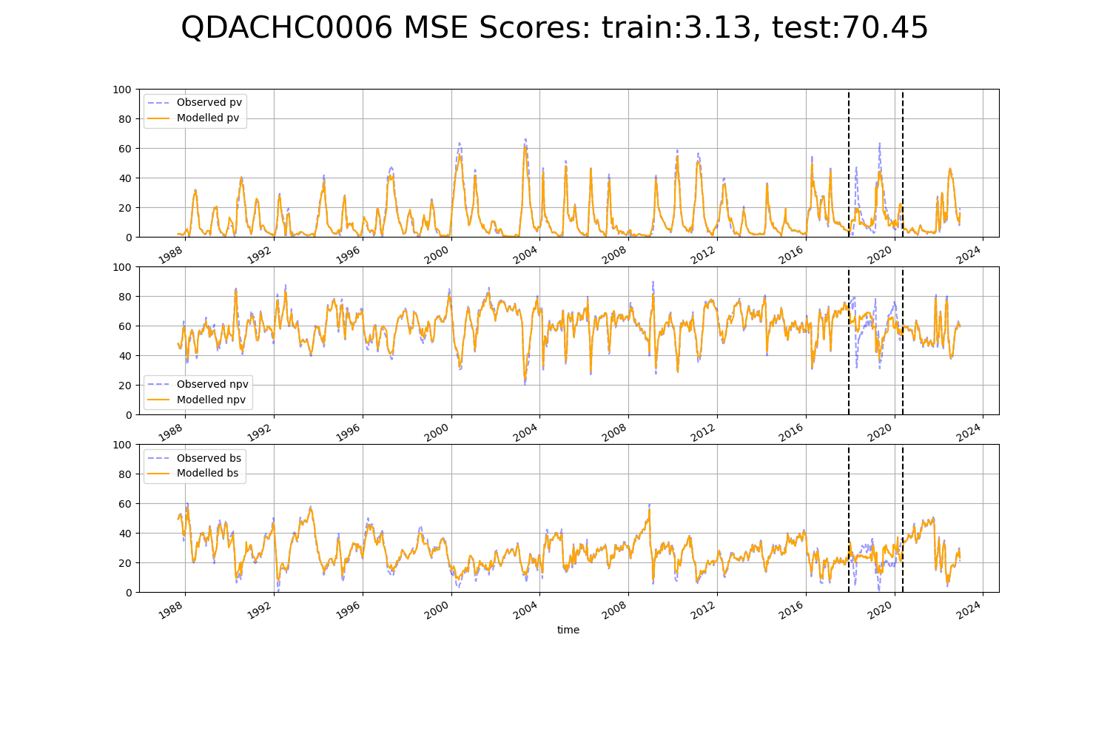

# QDACHC0007

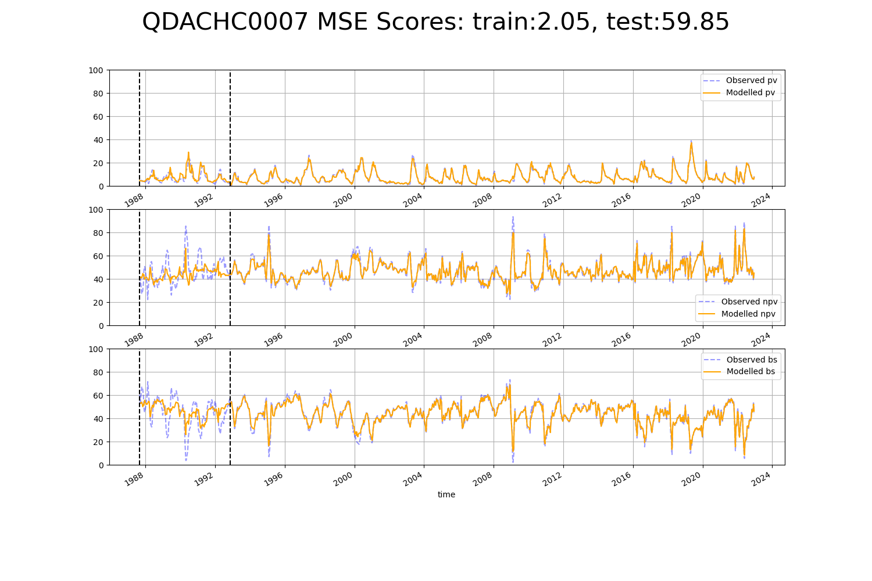

# QDAMGD0001

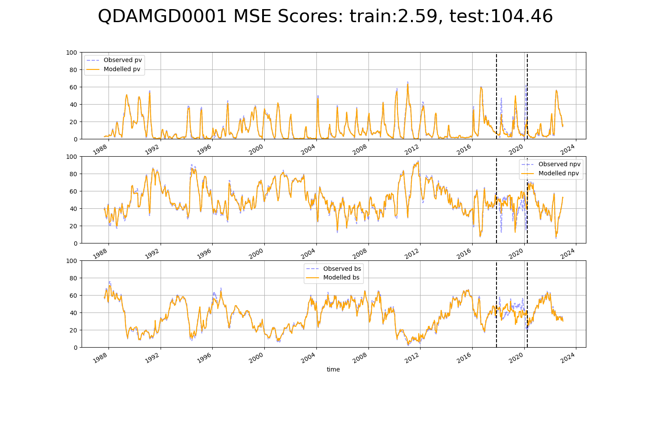

# QDAMGD0002

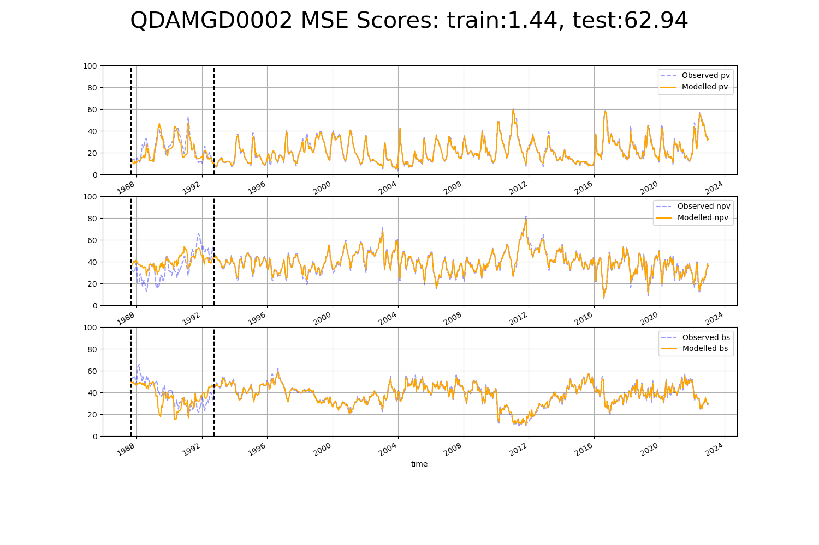

# QDAMGD0003

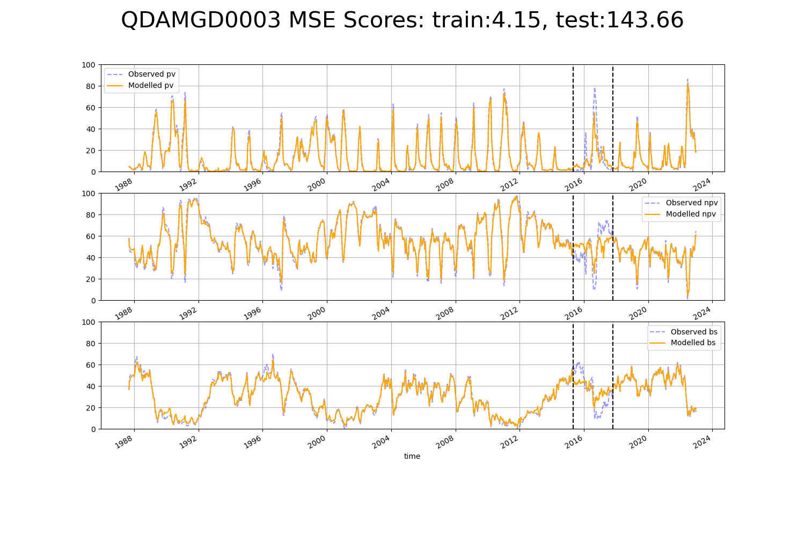

# QDAMGD0004

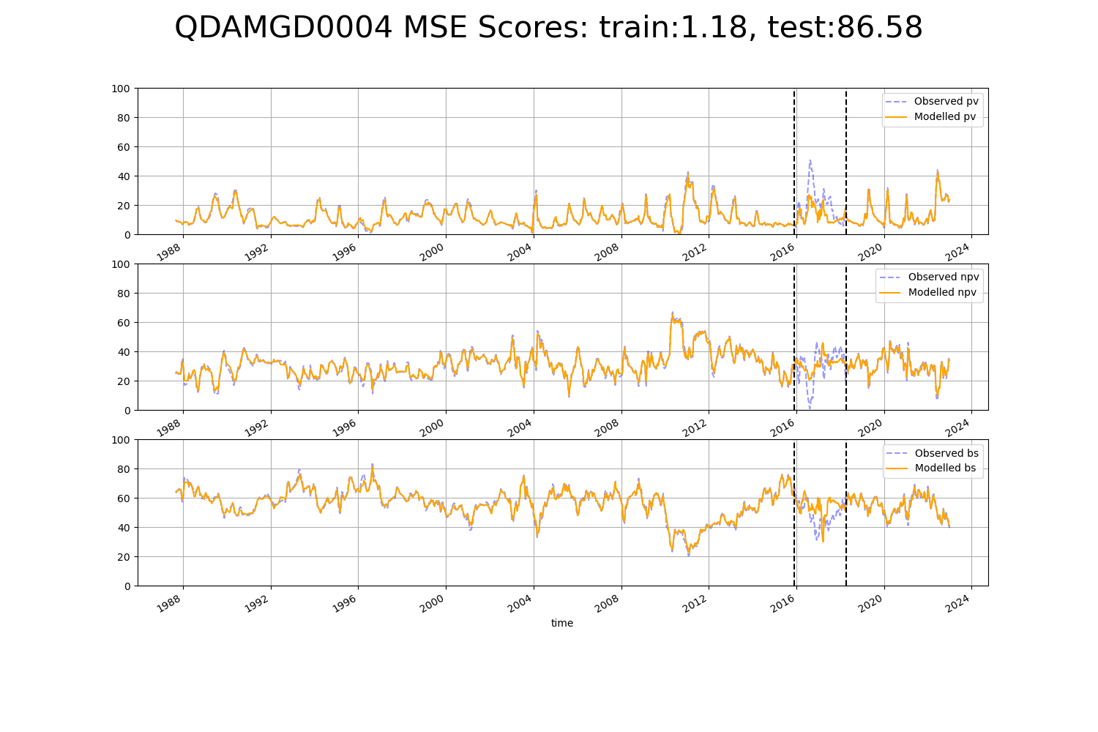

# QDAMGD0005

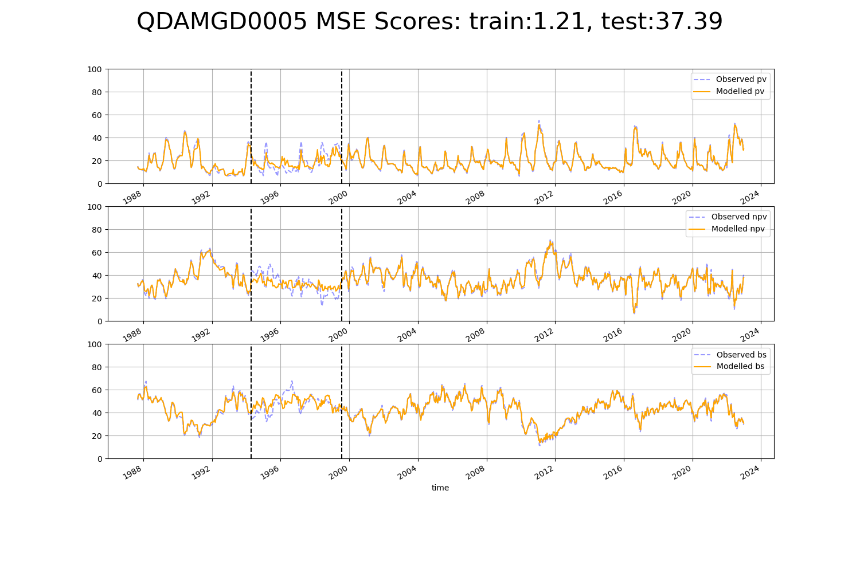

# QDAMGD0006

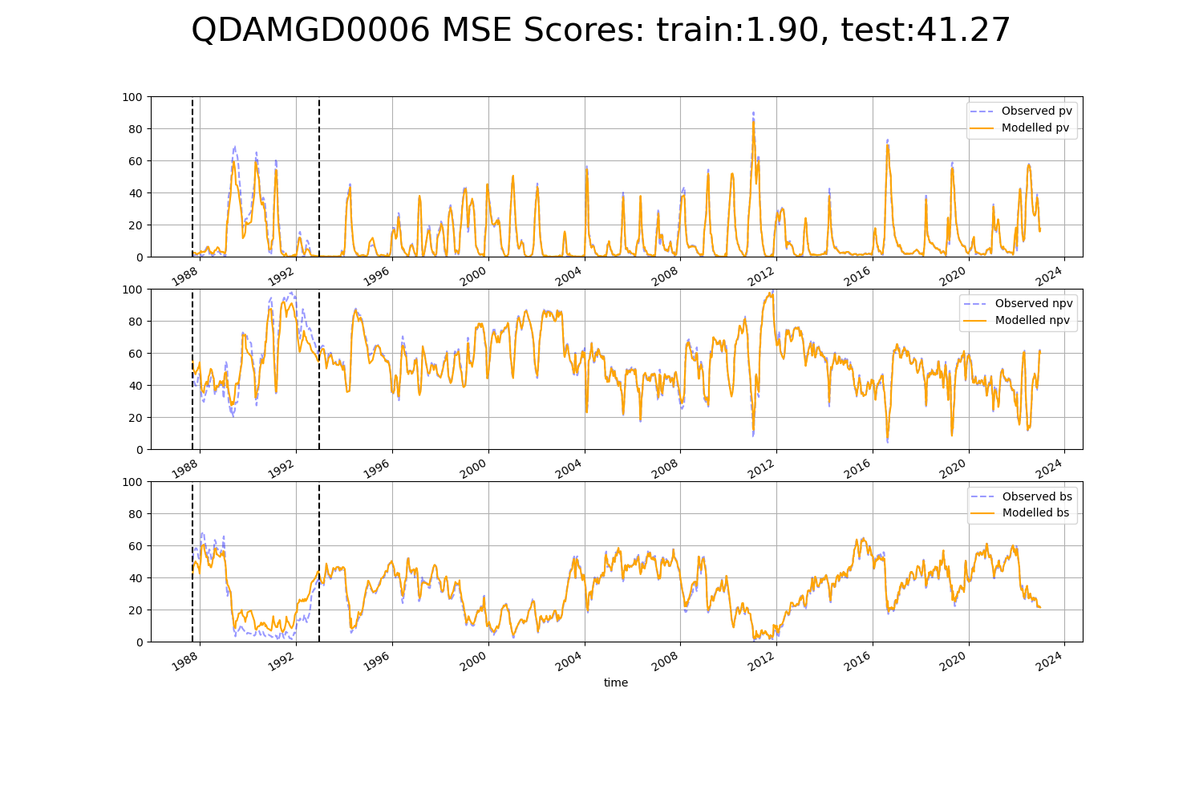

# QDAMGD0007

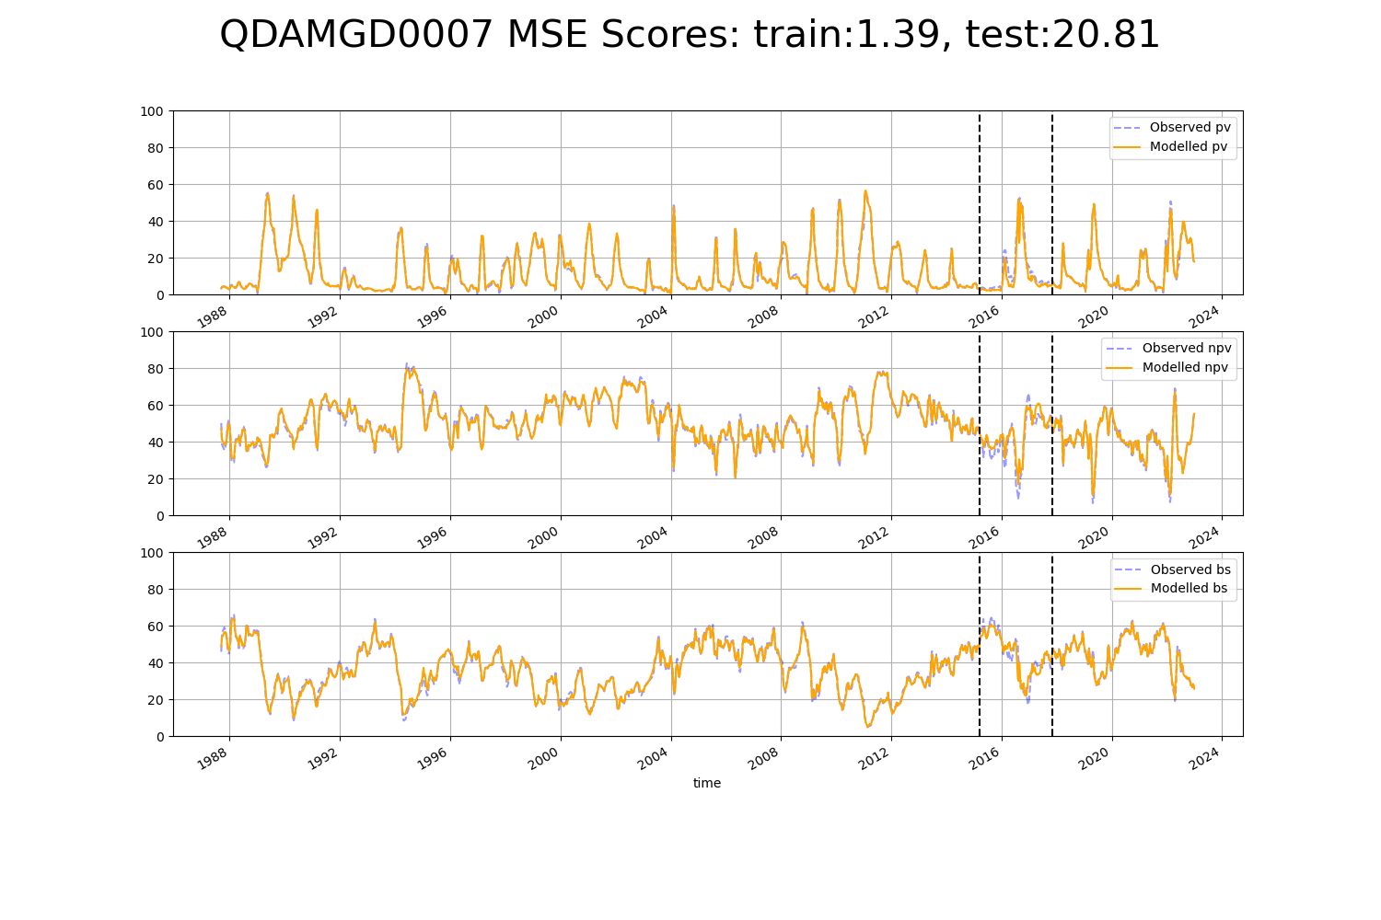

# QDAMGD0008

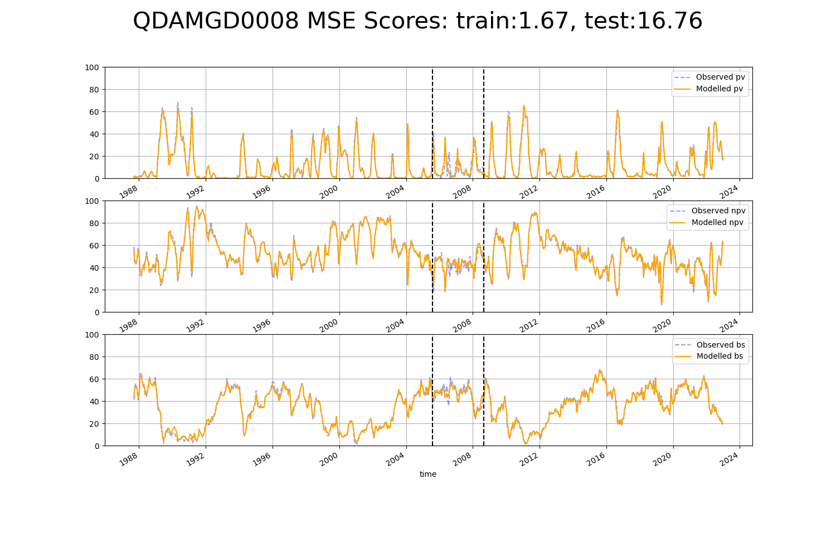

# QDAMGD0011

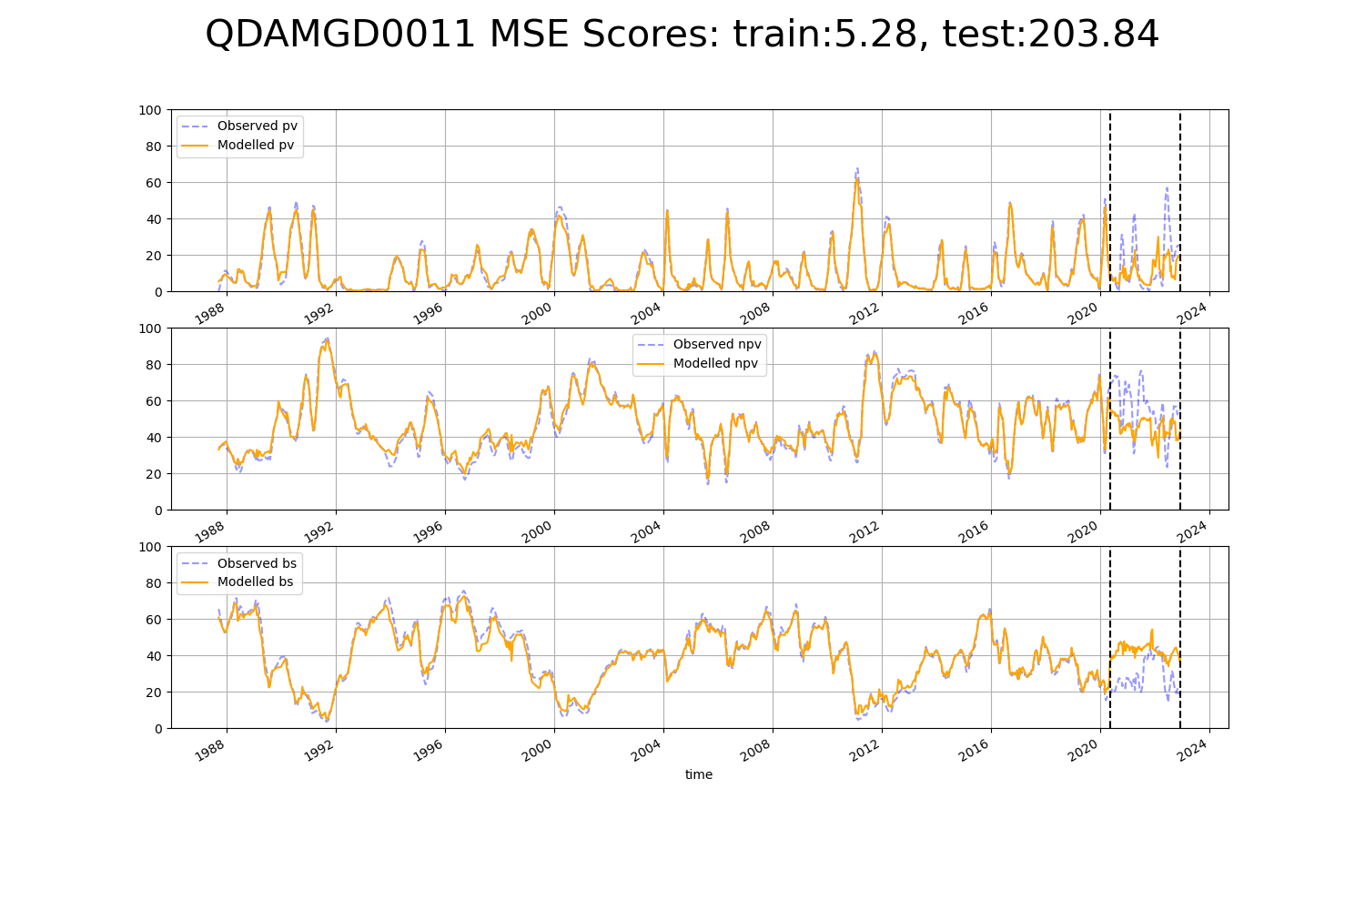

# QDAMGD0013

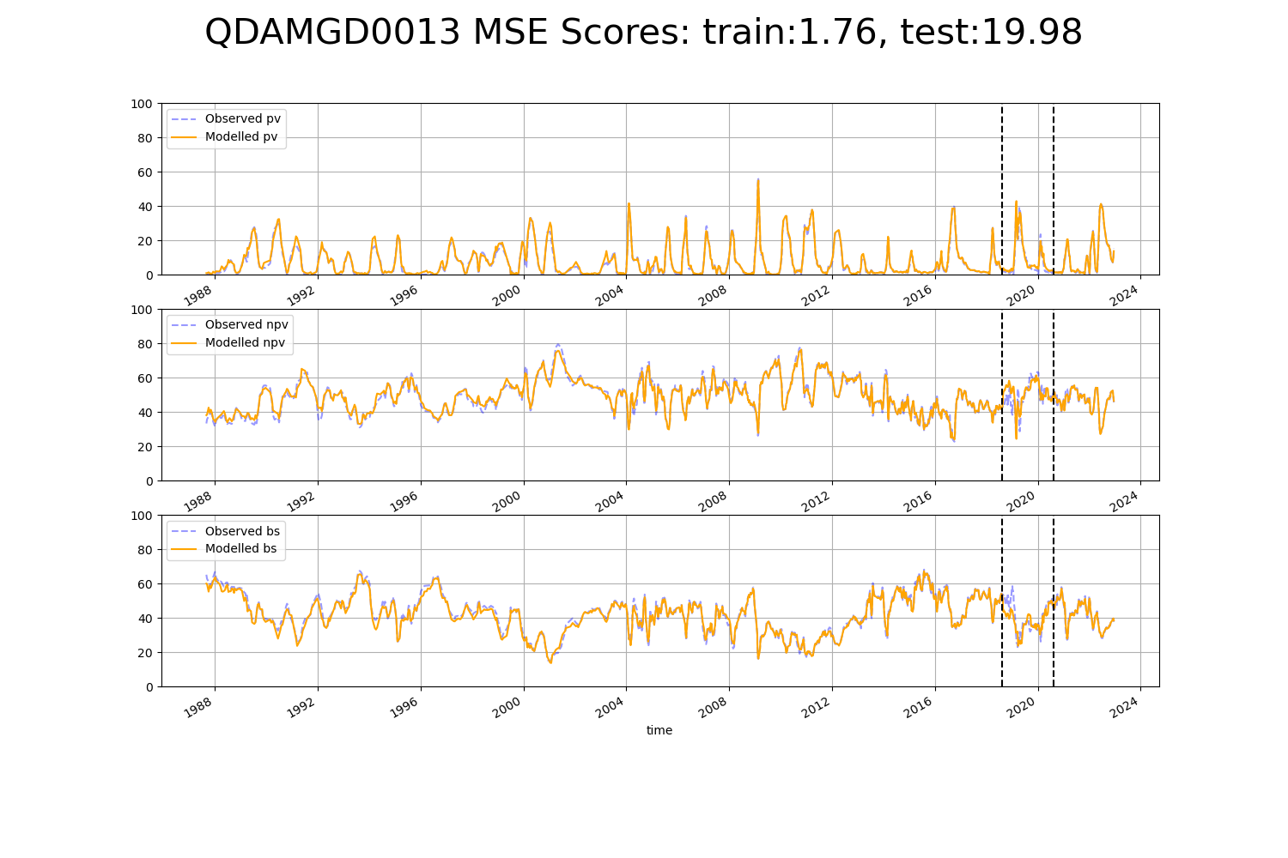

# QDAMGD0014

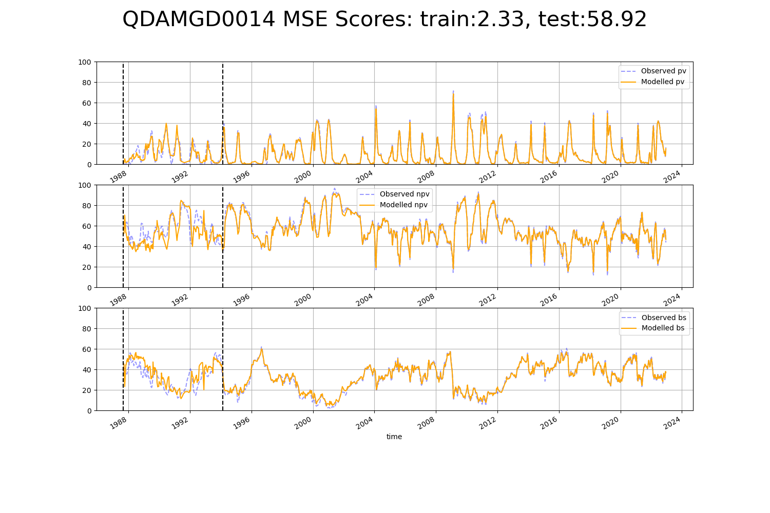

# QDAMGD0017

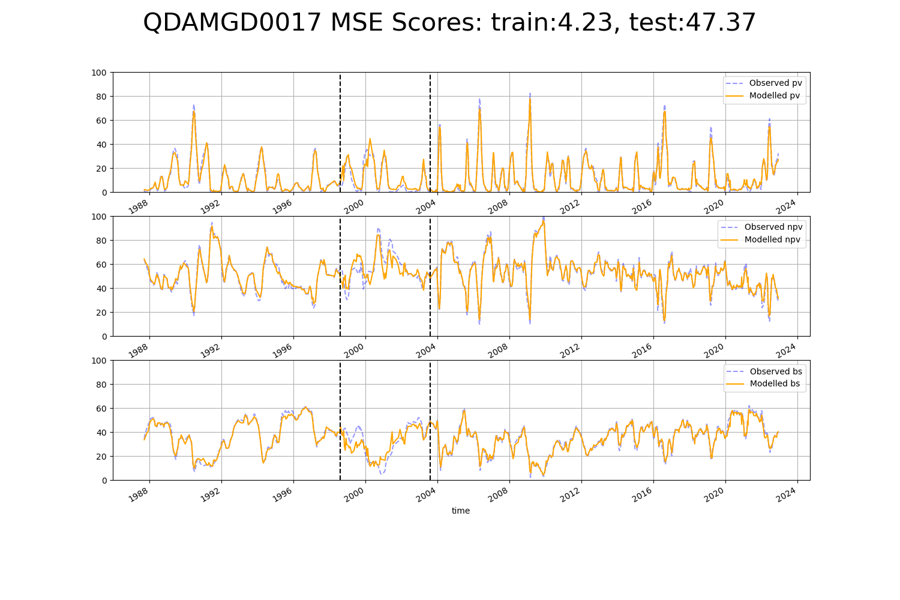

# QDAMGD0018

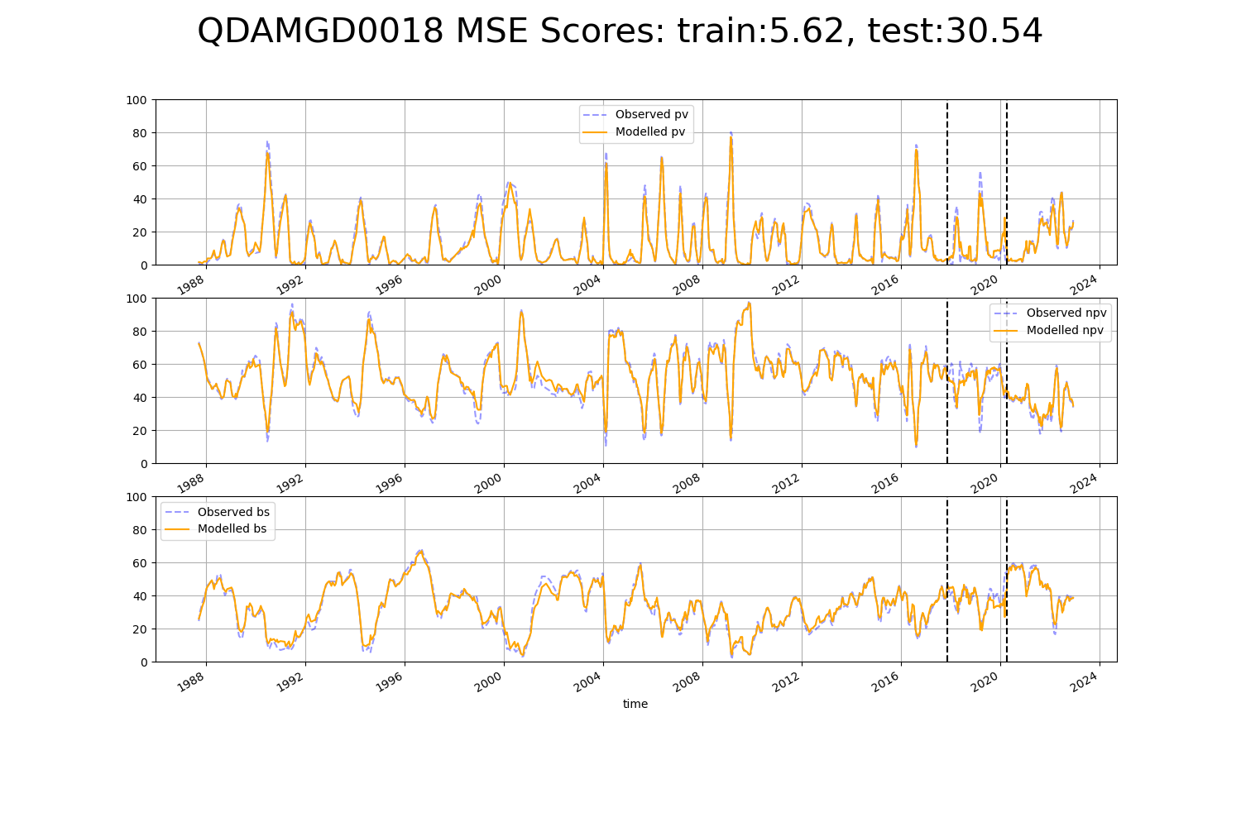

# QDAMGD0019

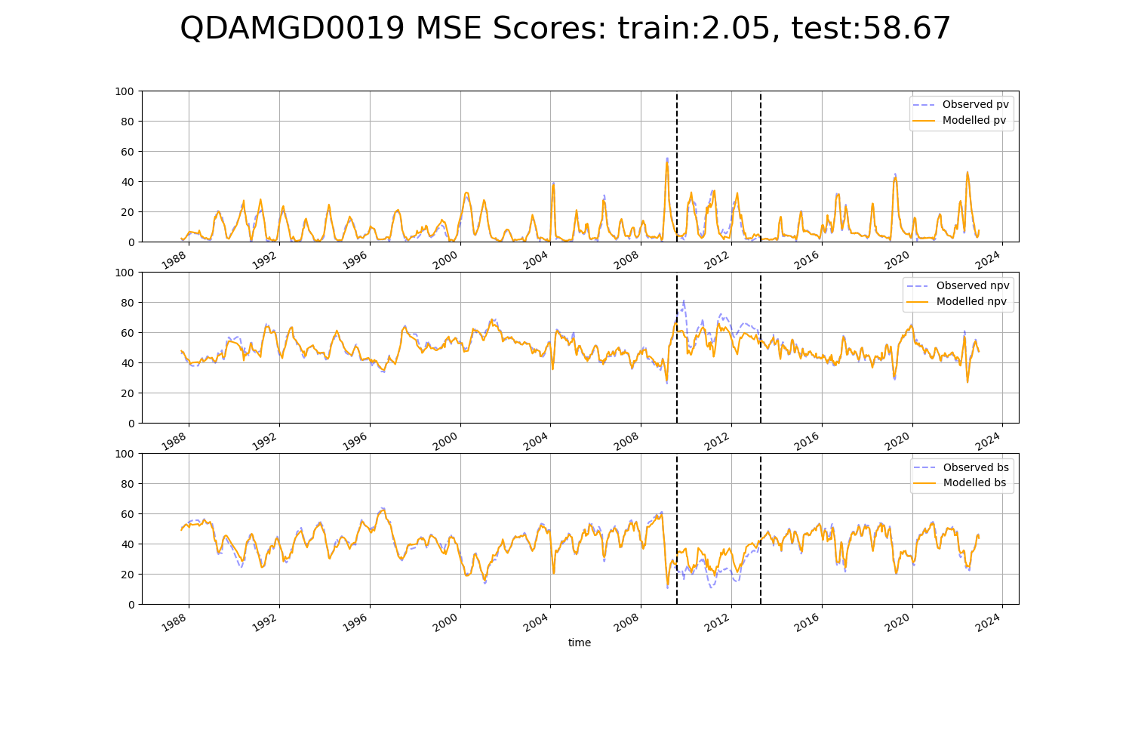

# QDAMGD0021

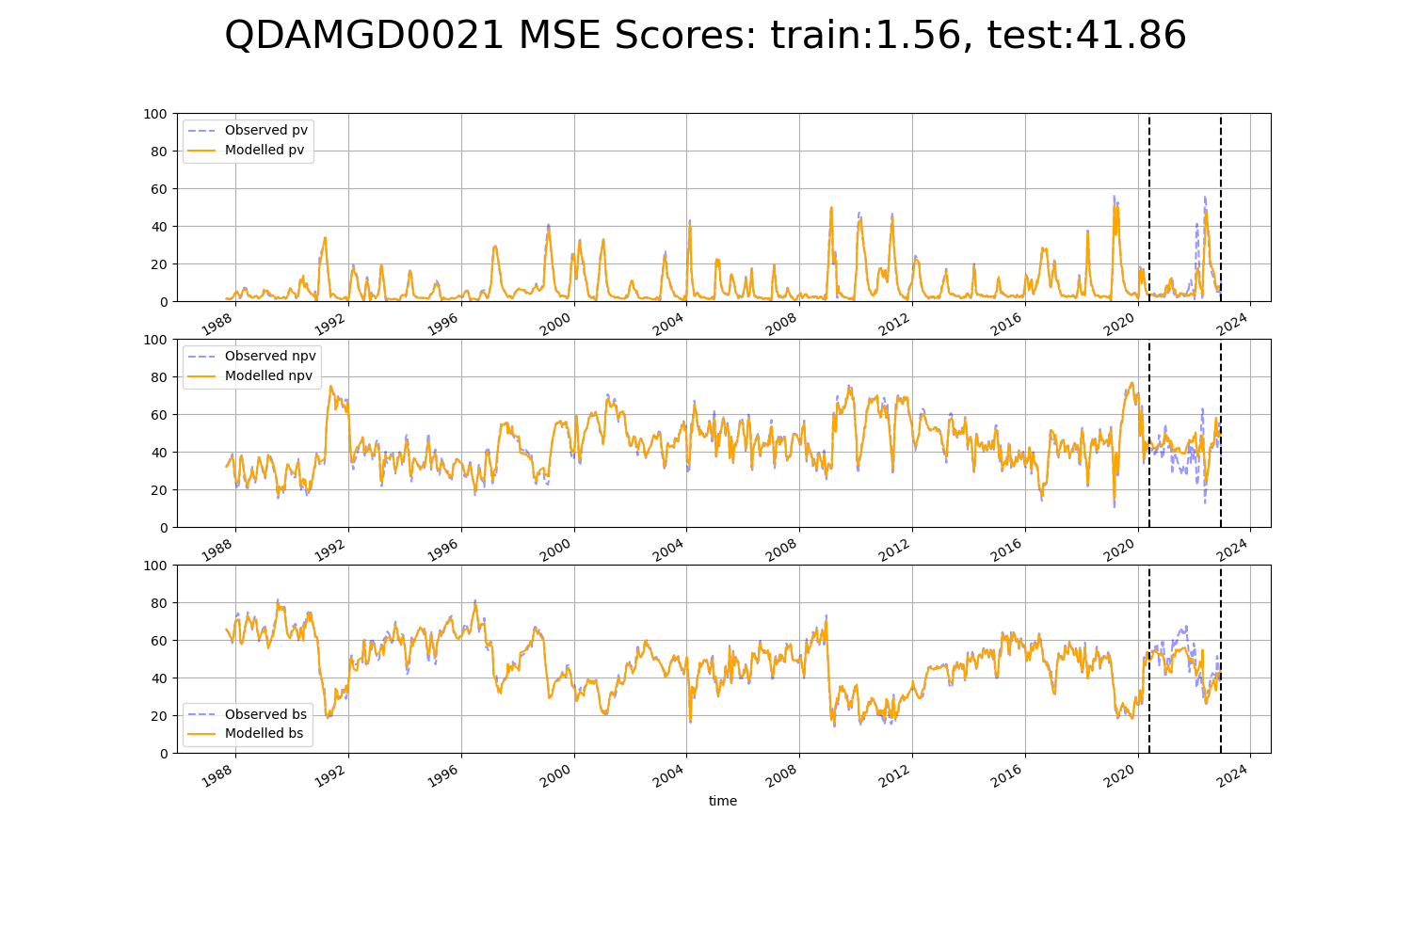

# QDAMGD0022

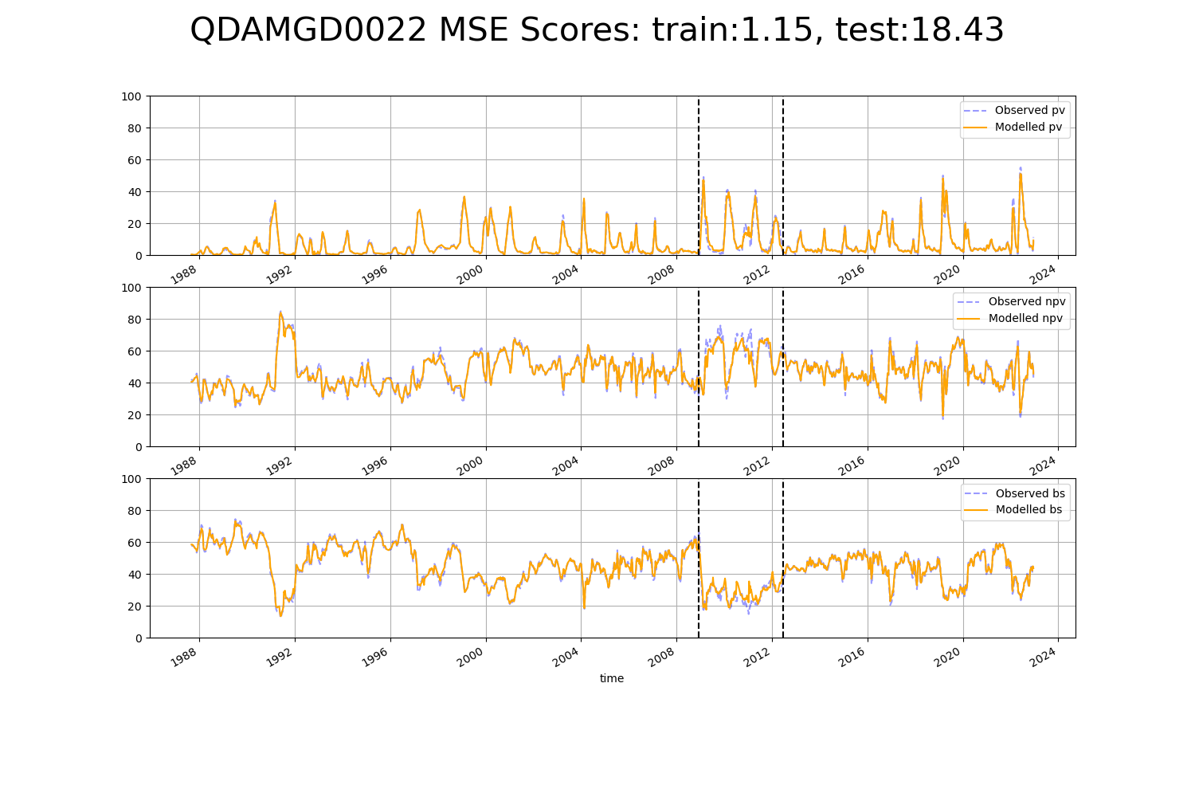

# QDAMGD0023

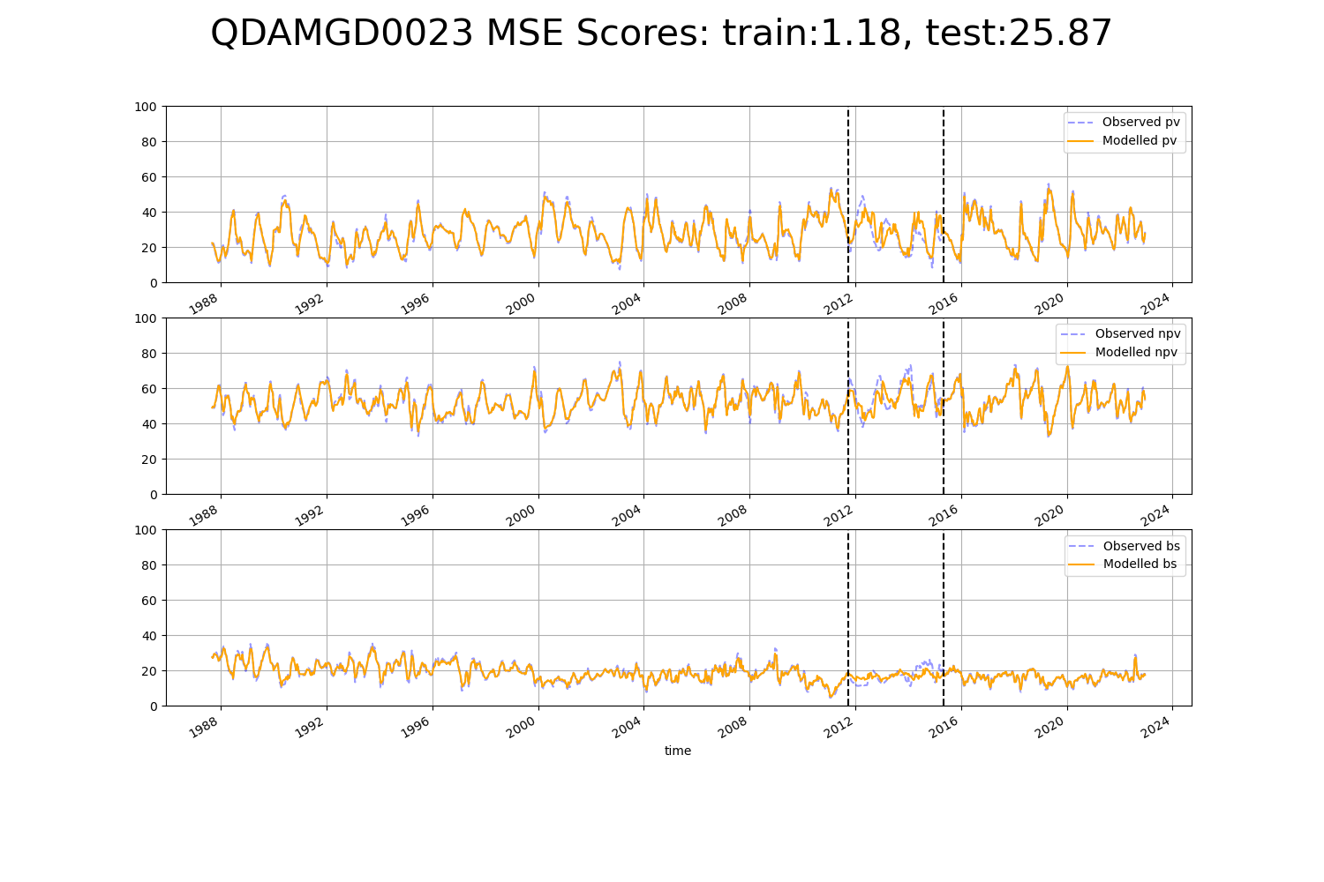

# QDAMGD0024

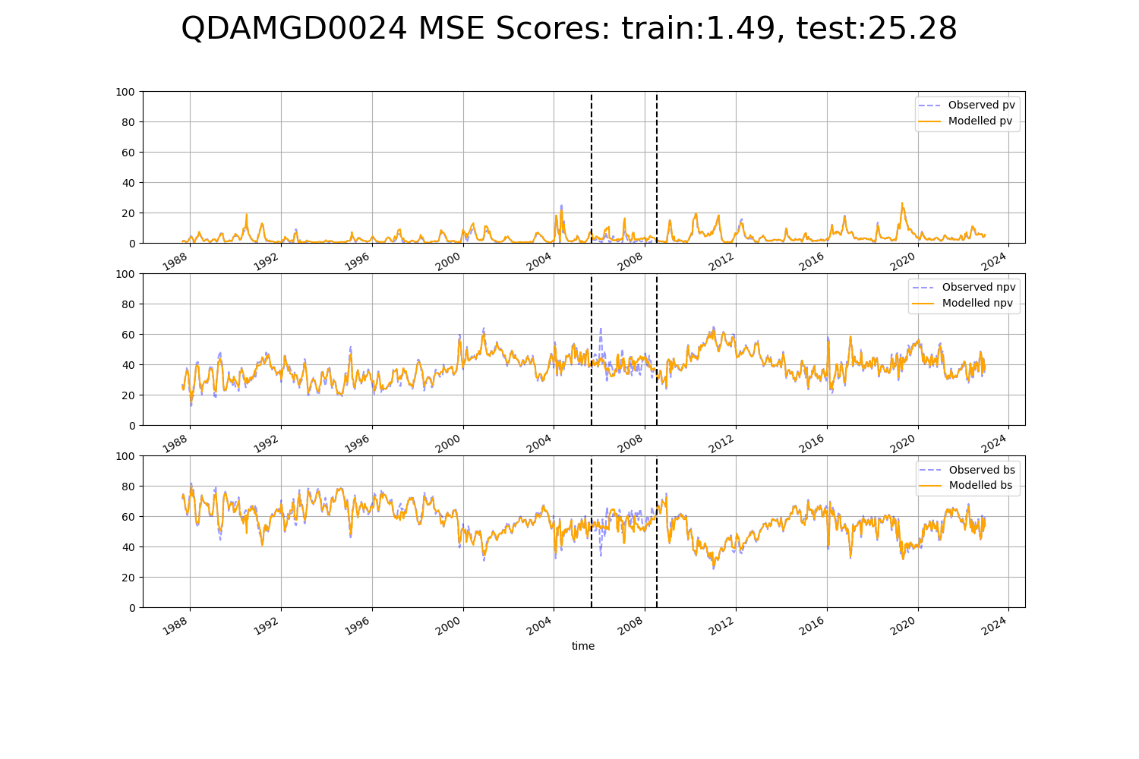

# QDASSD0003

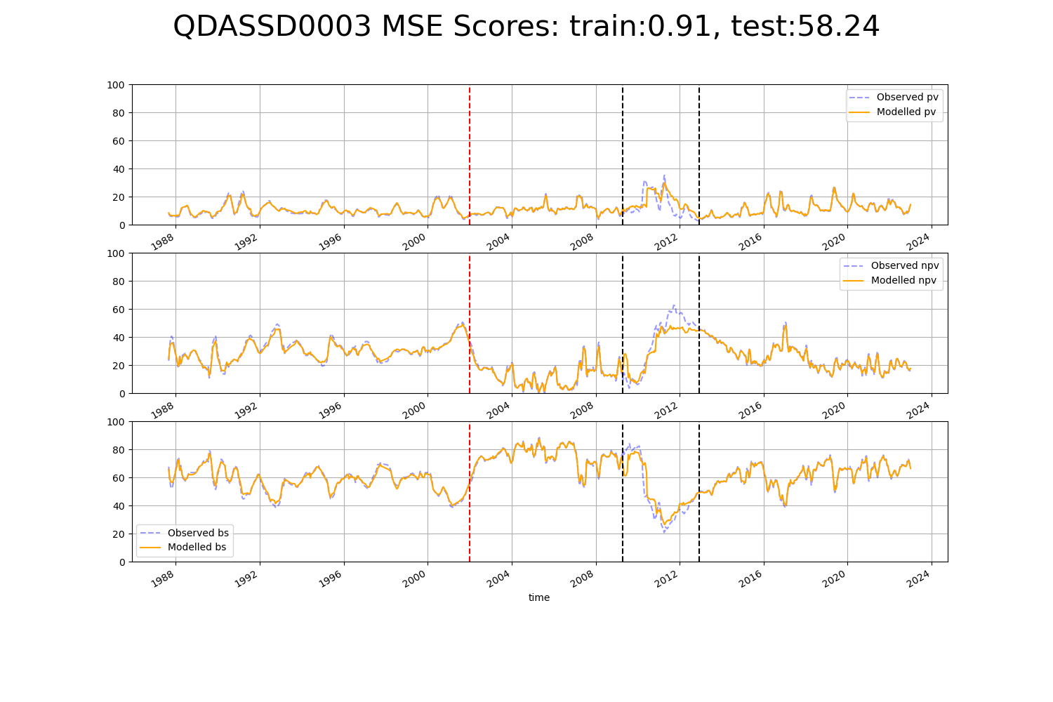

# QDASSD0006

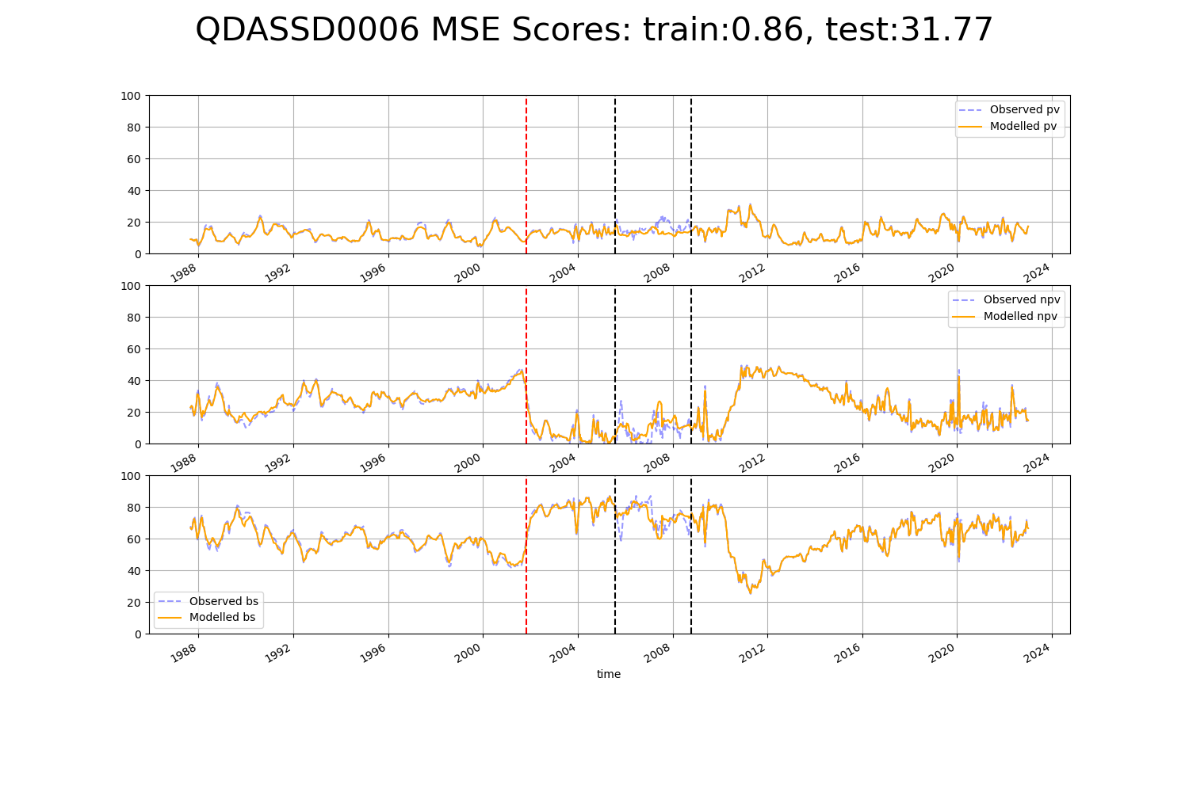

# QDASSD0007

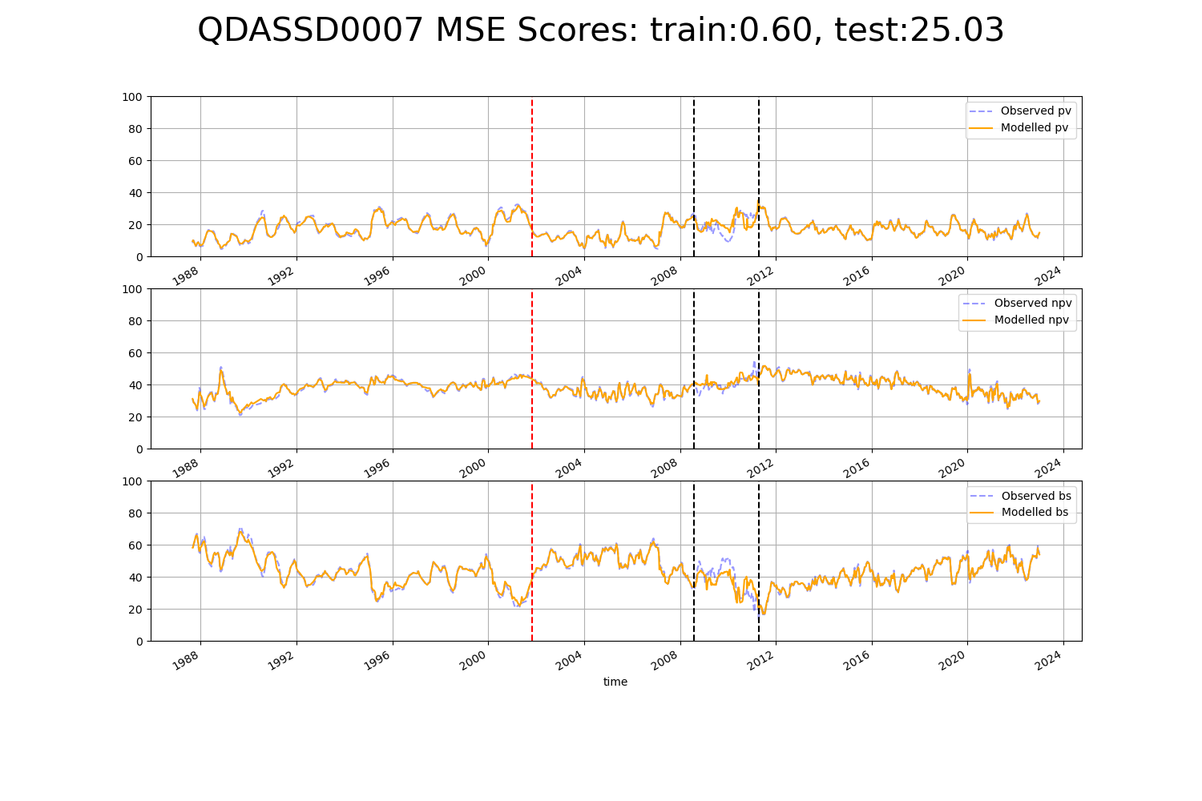

# QDASSD0009

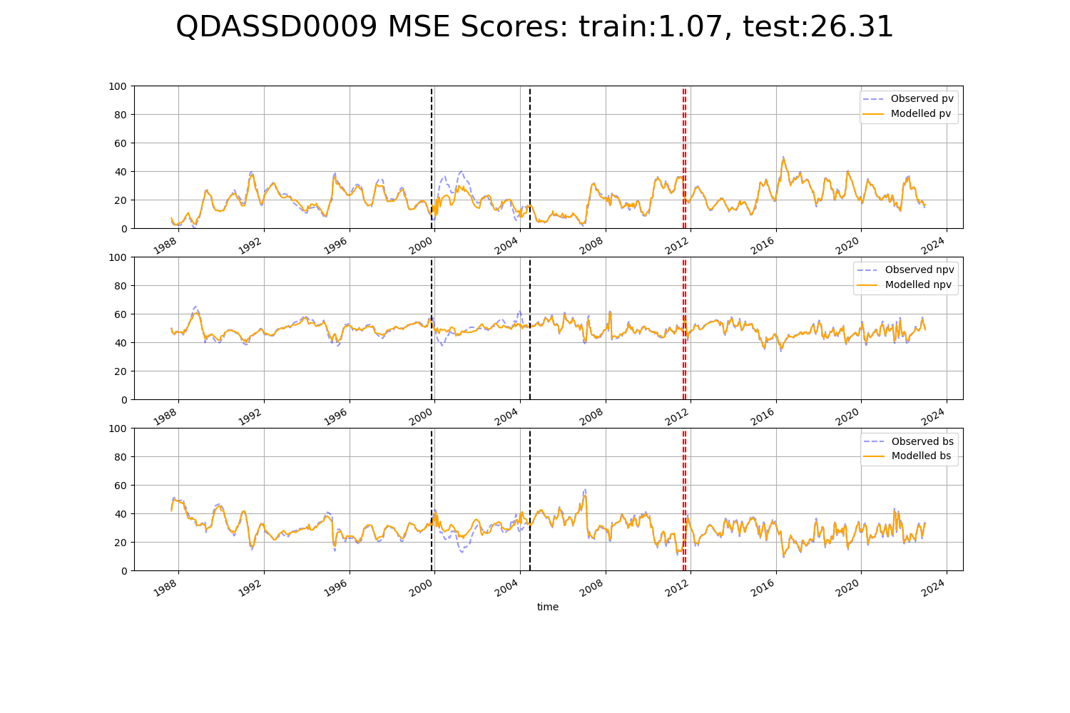

# QDASSD0010

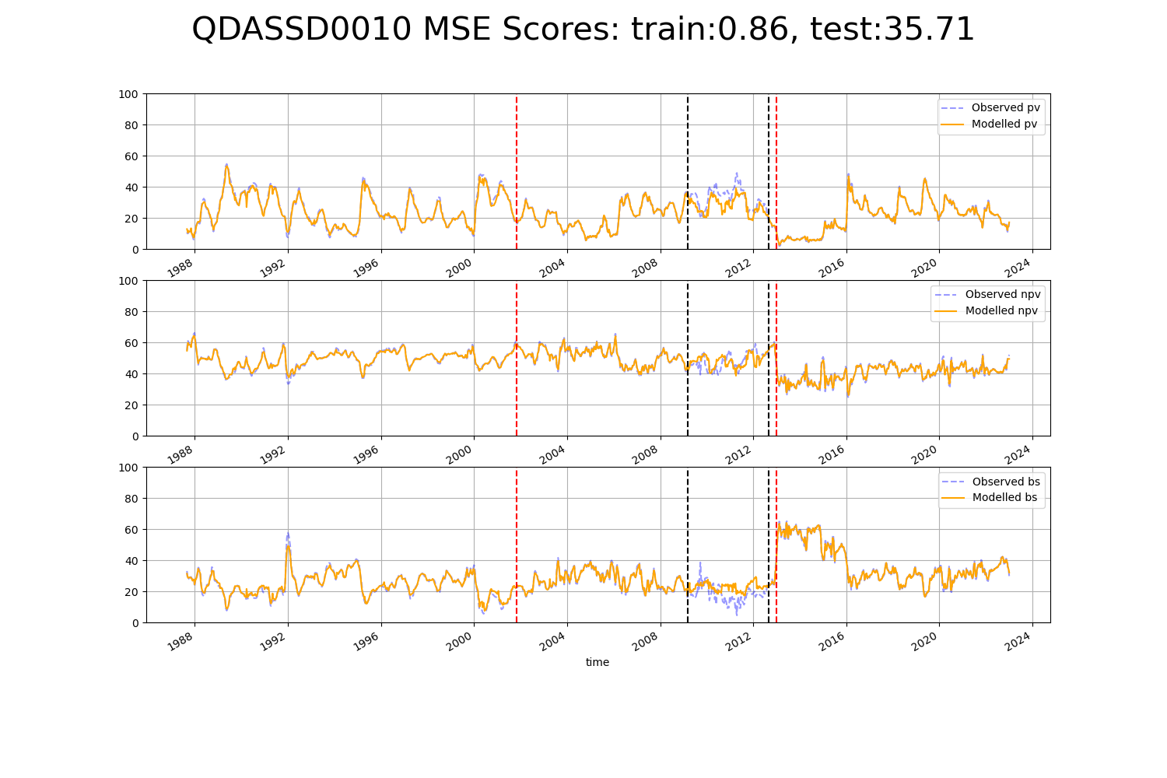

# QDASSD0013

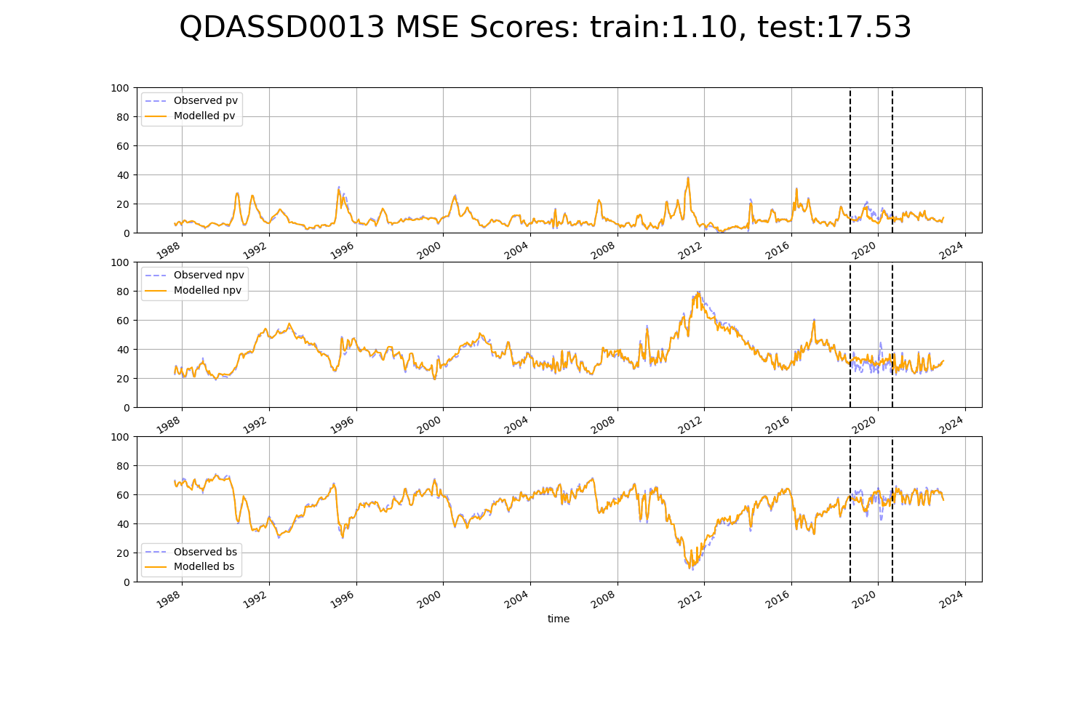

# QDASSD0014

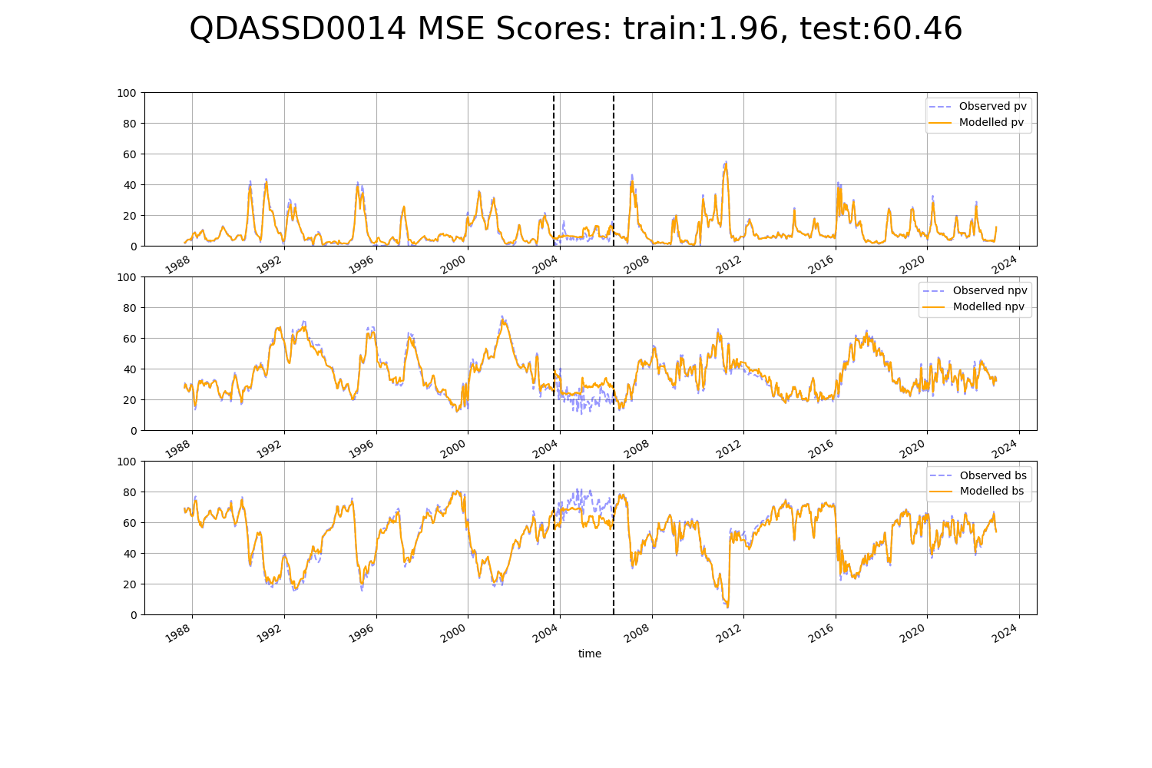

# QDASSD0015

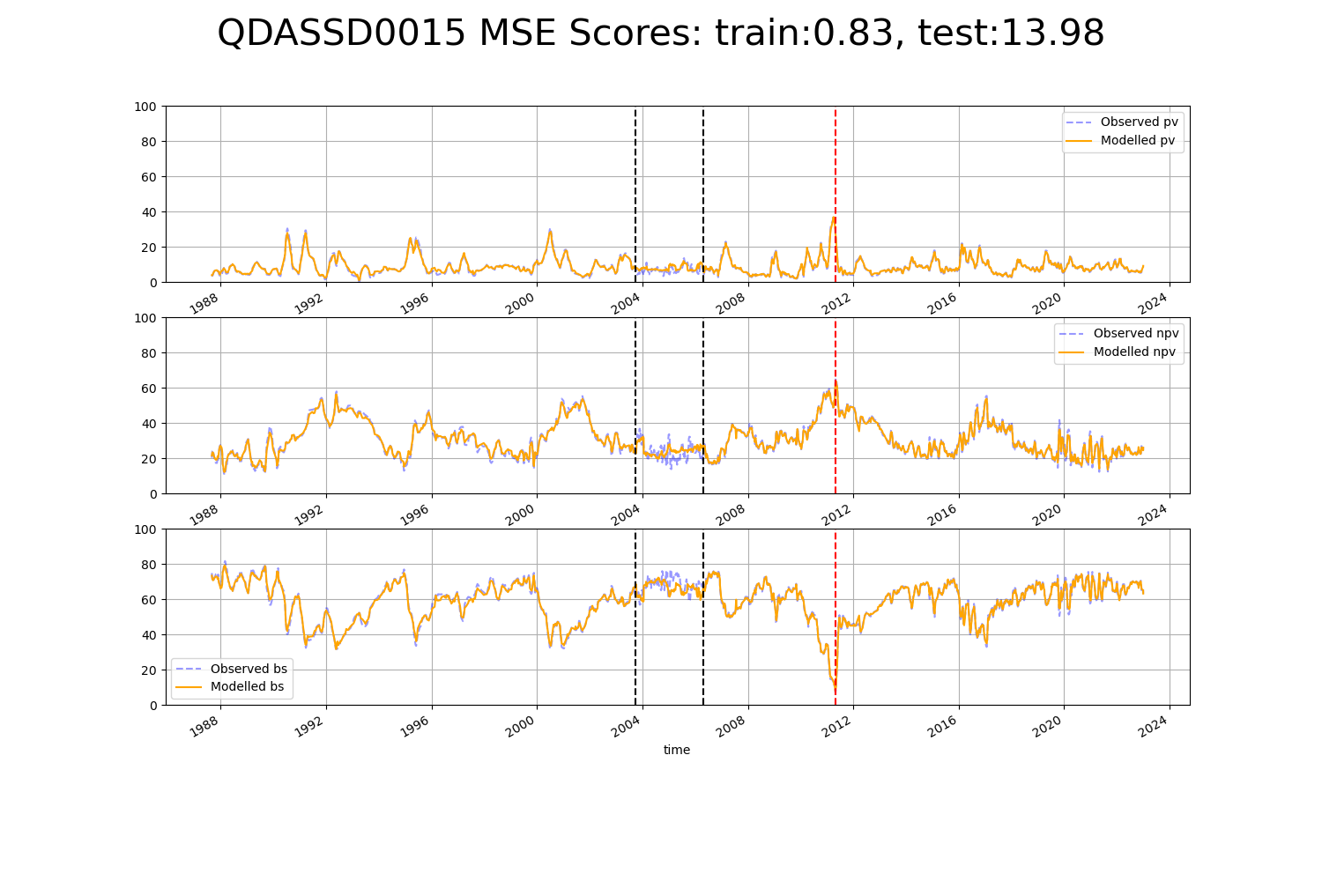

# SAAFLB0030

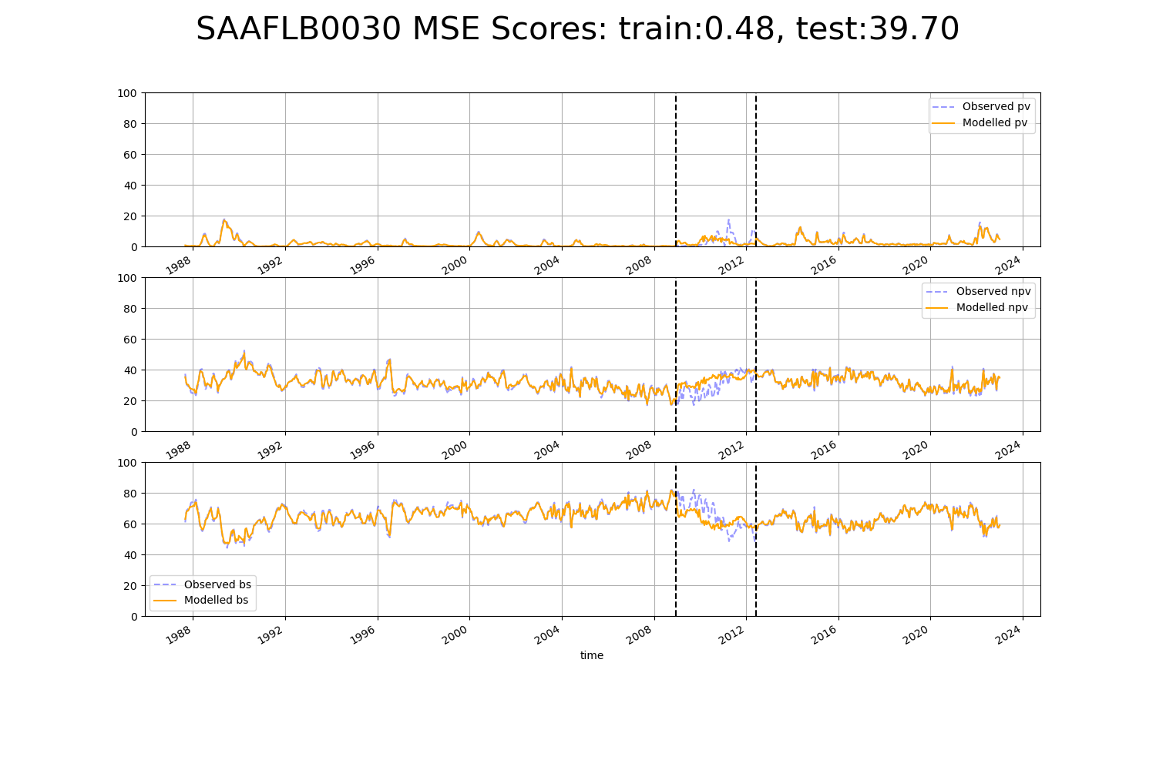

# SAAGVD0002

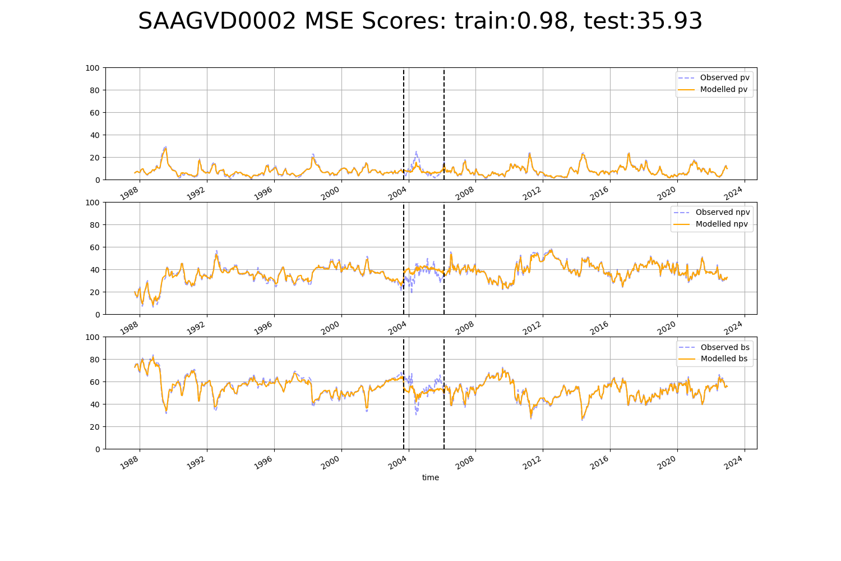

# SAAGVD0003

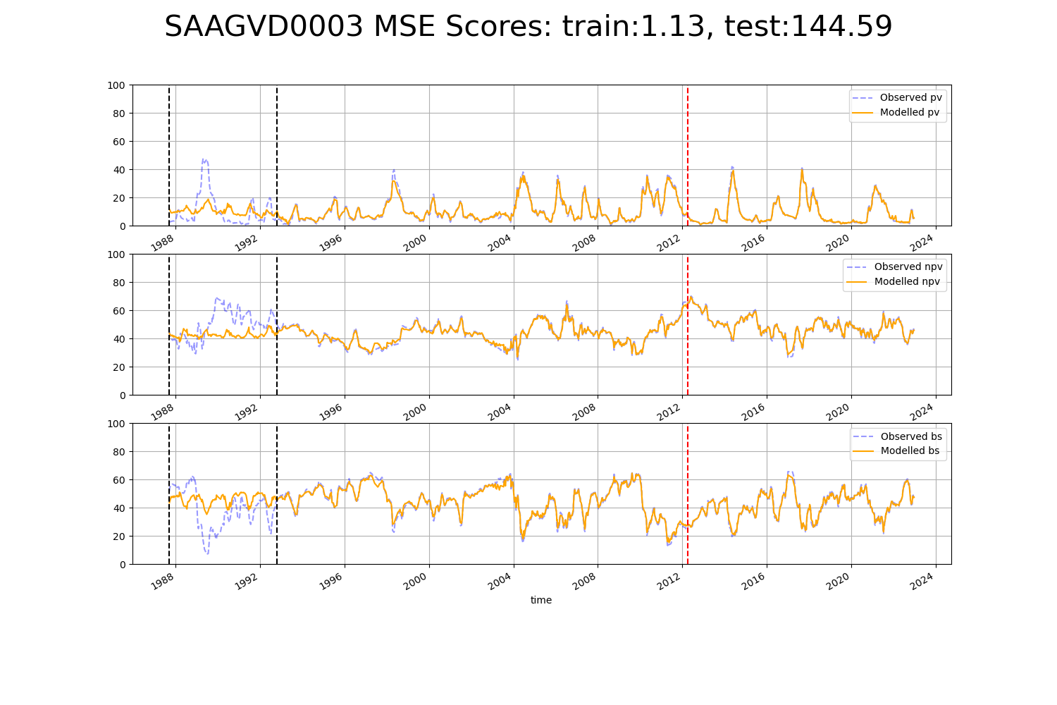

# SAANUL0003

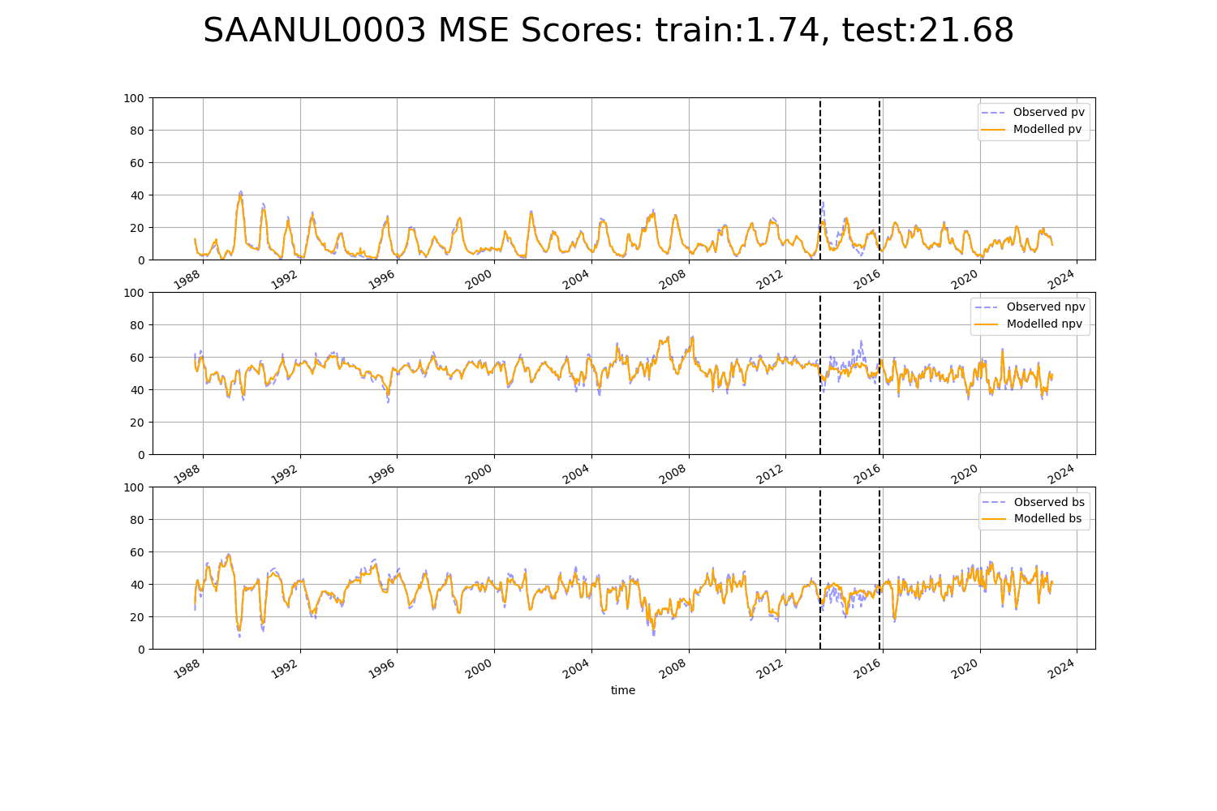

# SAASTP0002

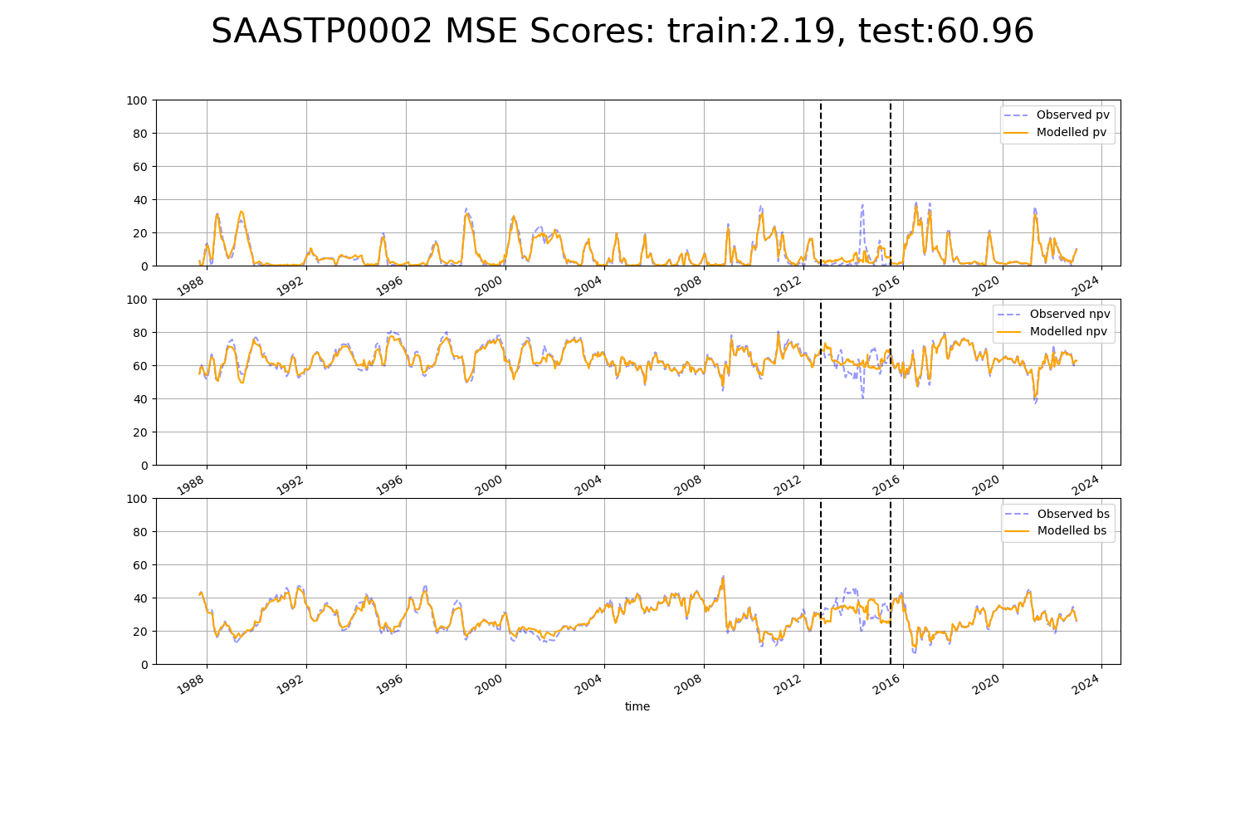

# SAASTP0011

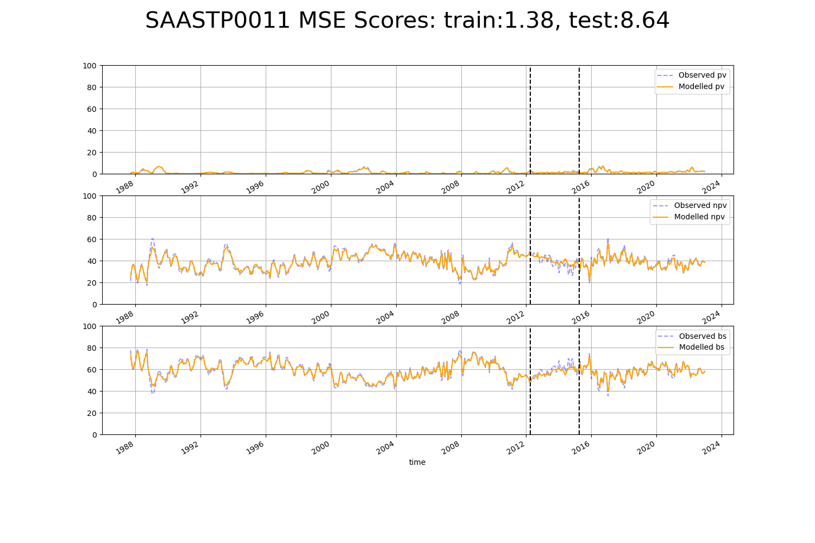

# SAASTP0012

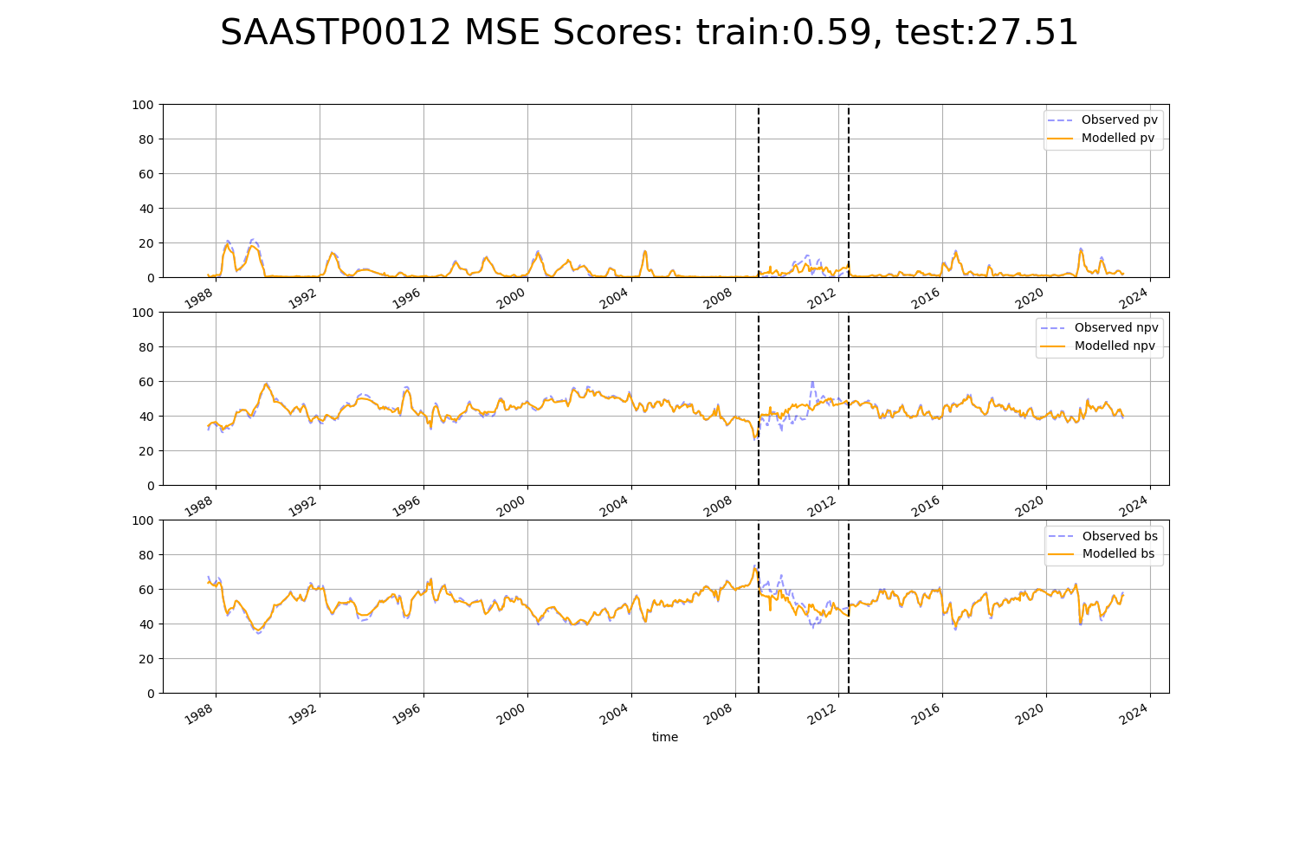

# SAASTP0013

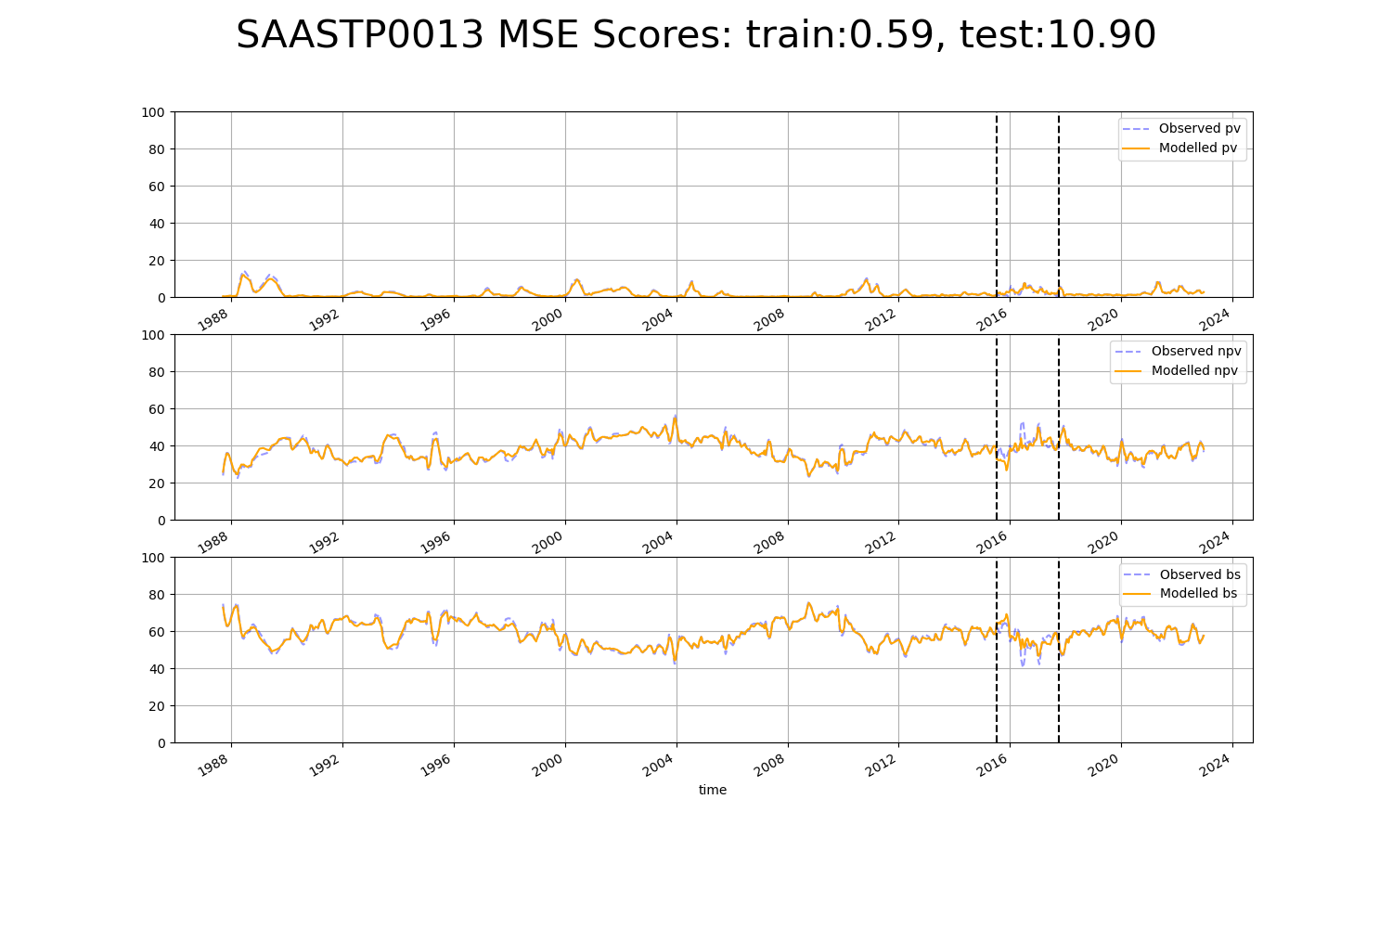

# SAASTP0015

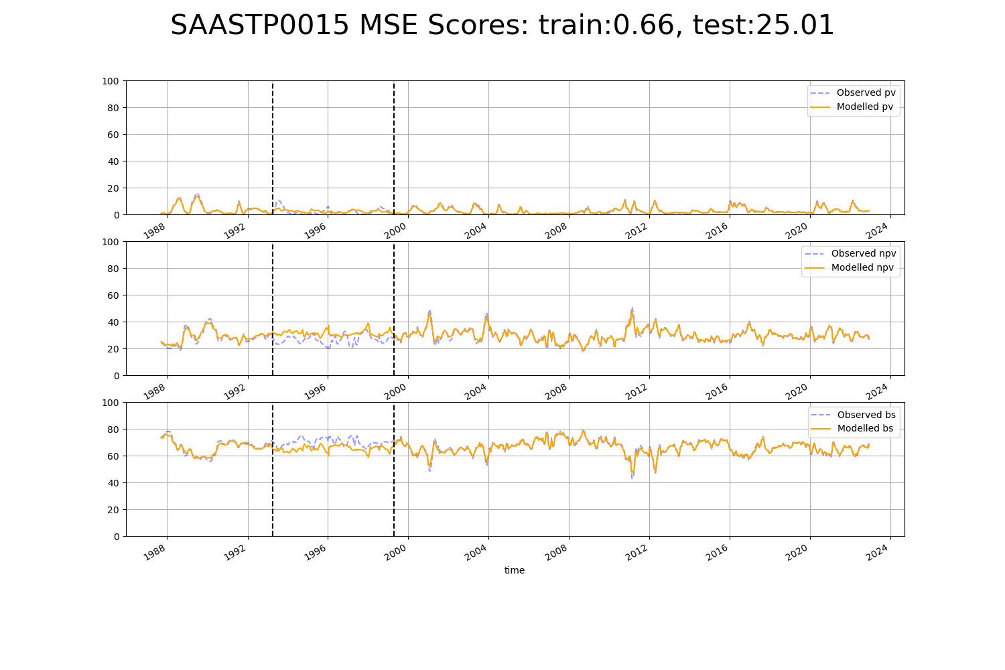

# SAASTP0018

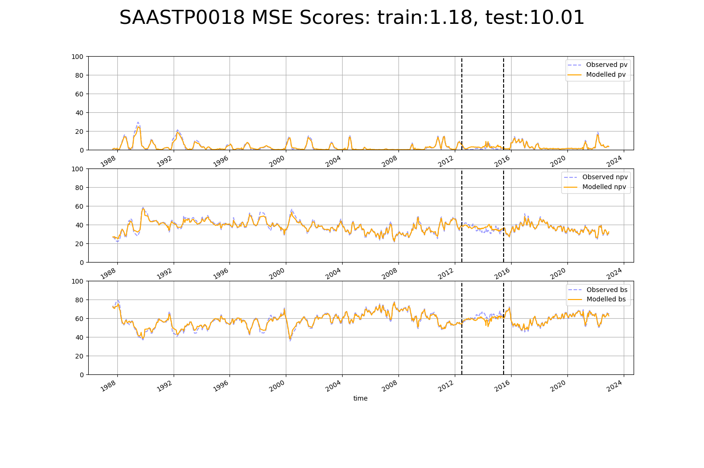

# SAASTP0020

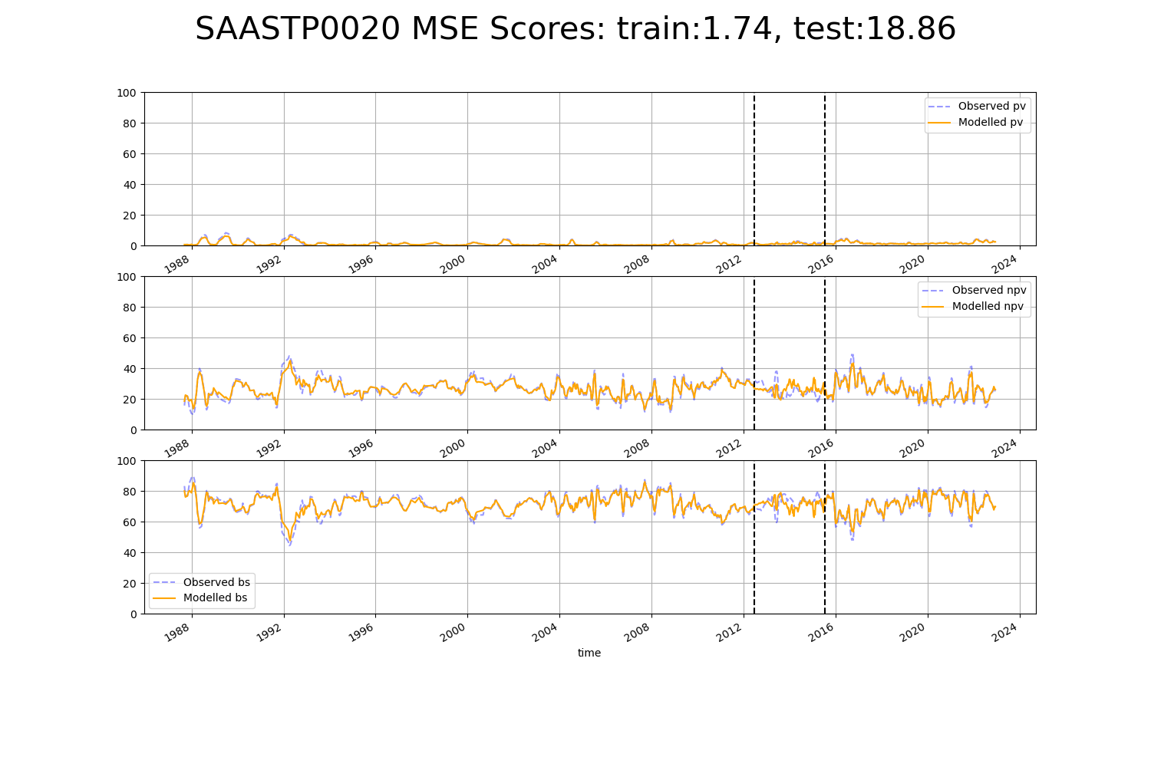

# SAASTP0030

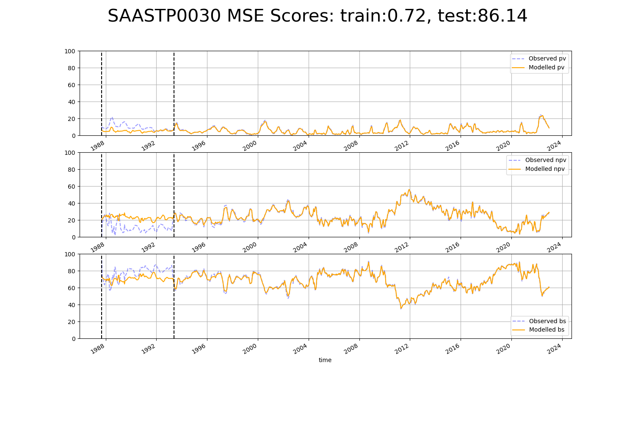

# SAASTP0031

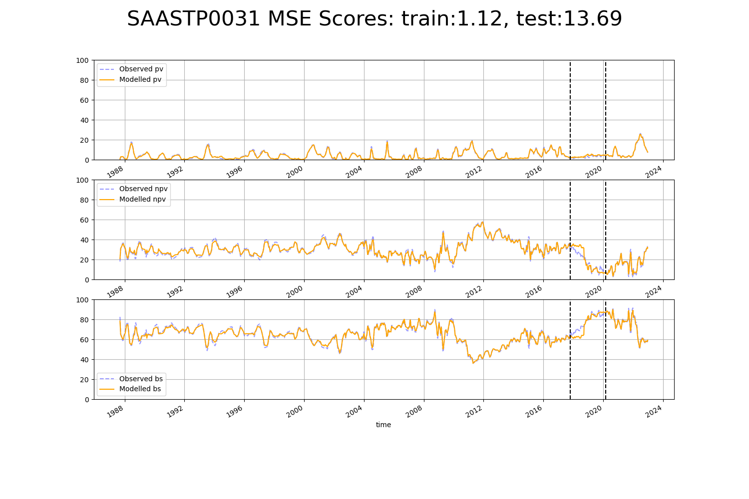

# SAASTP0032

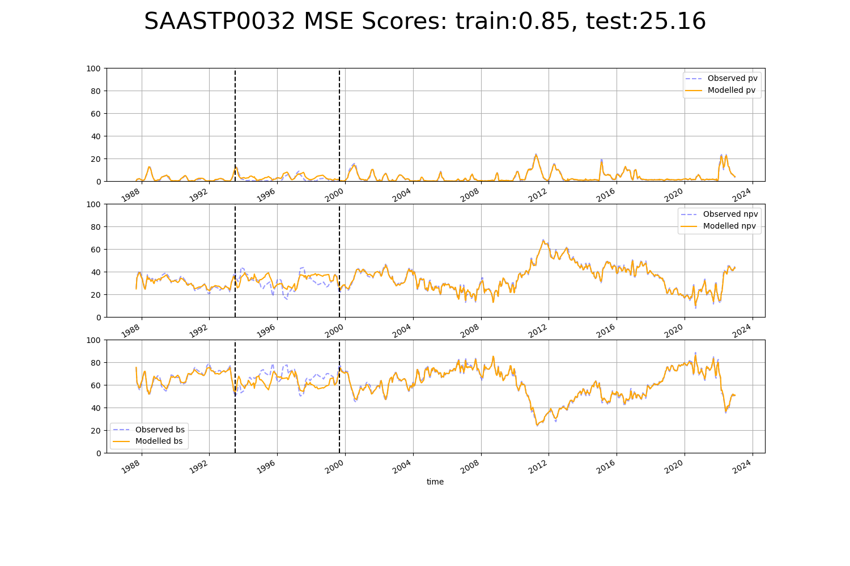

# SASMDD0003

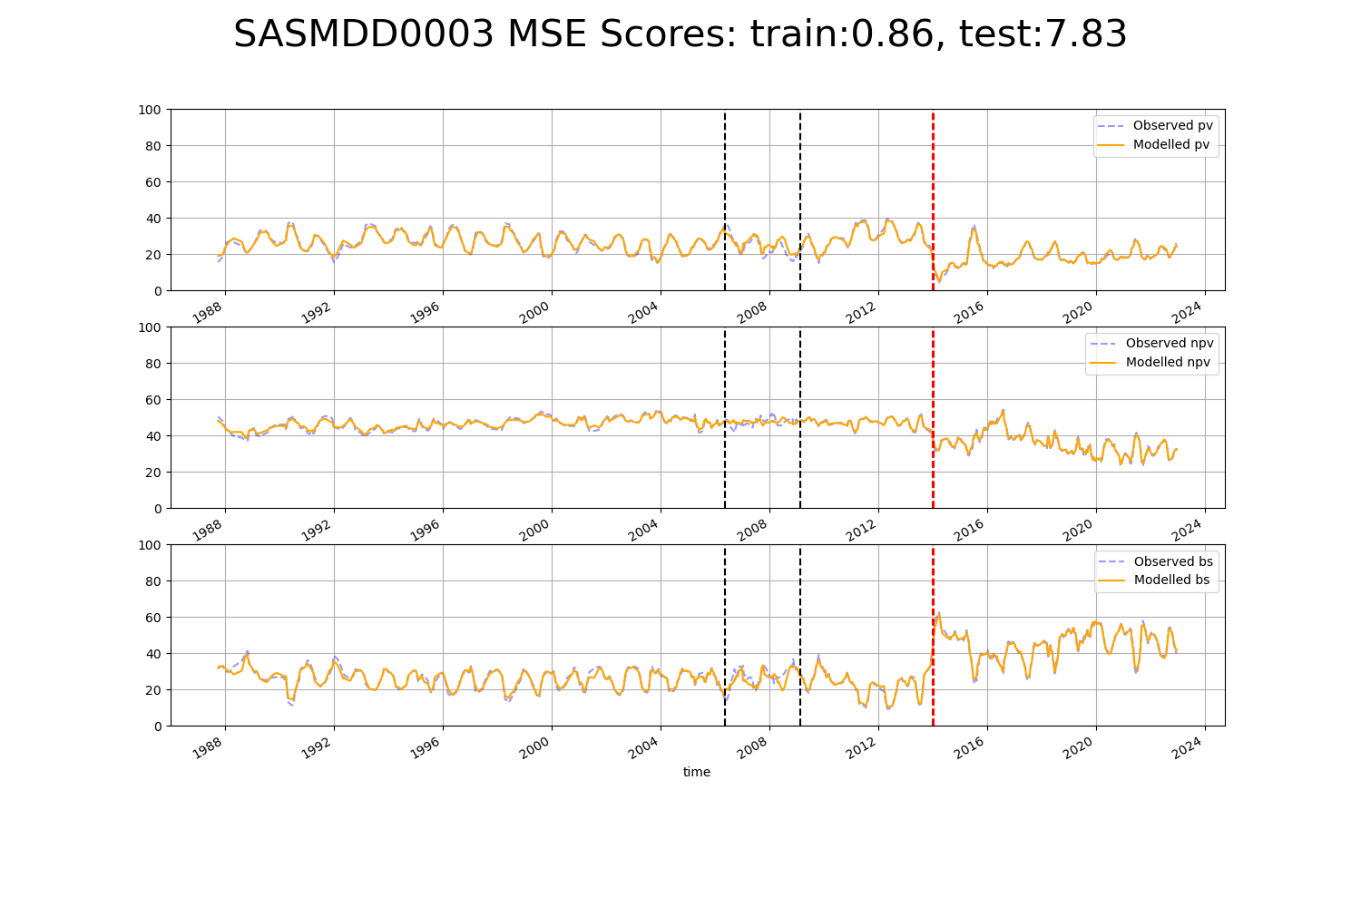

# SATSTP0001

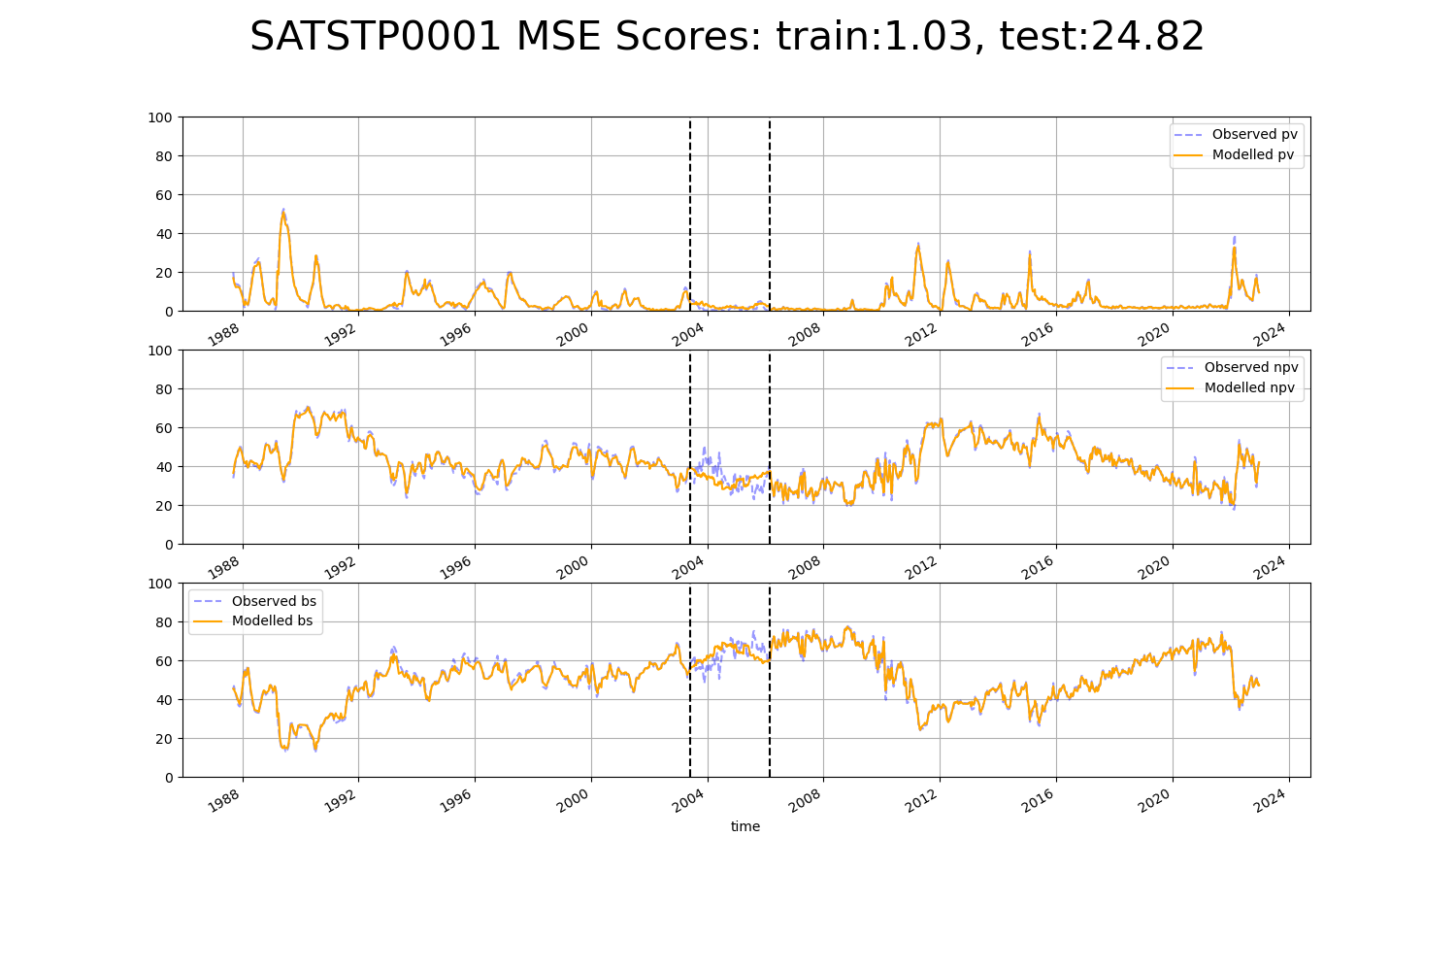

# SATSTP0003

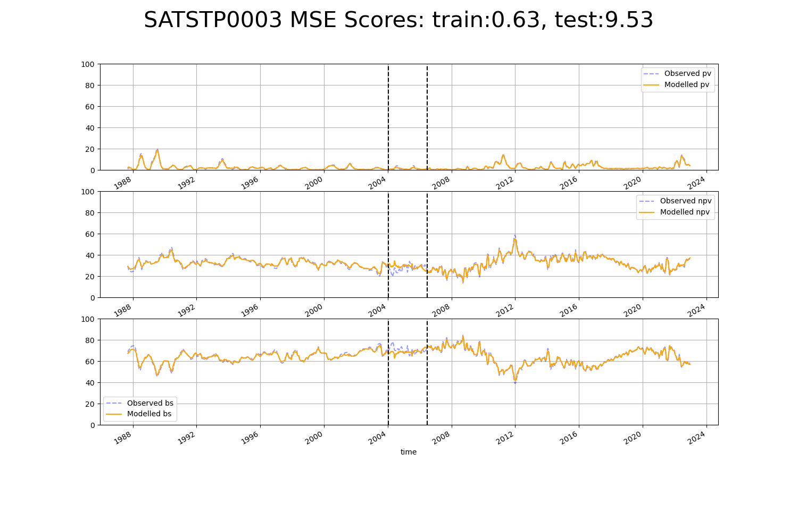

# SATSTP0008

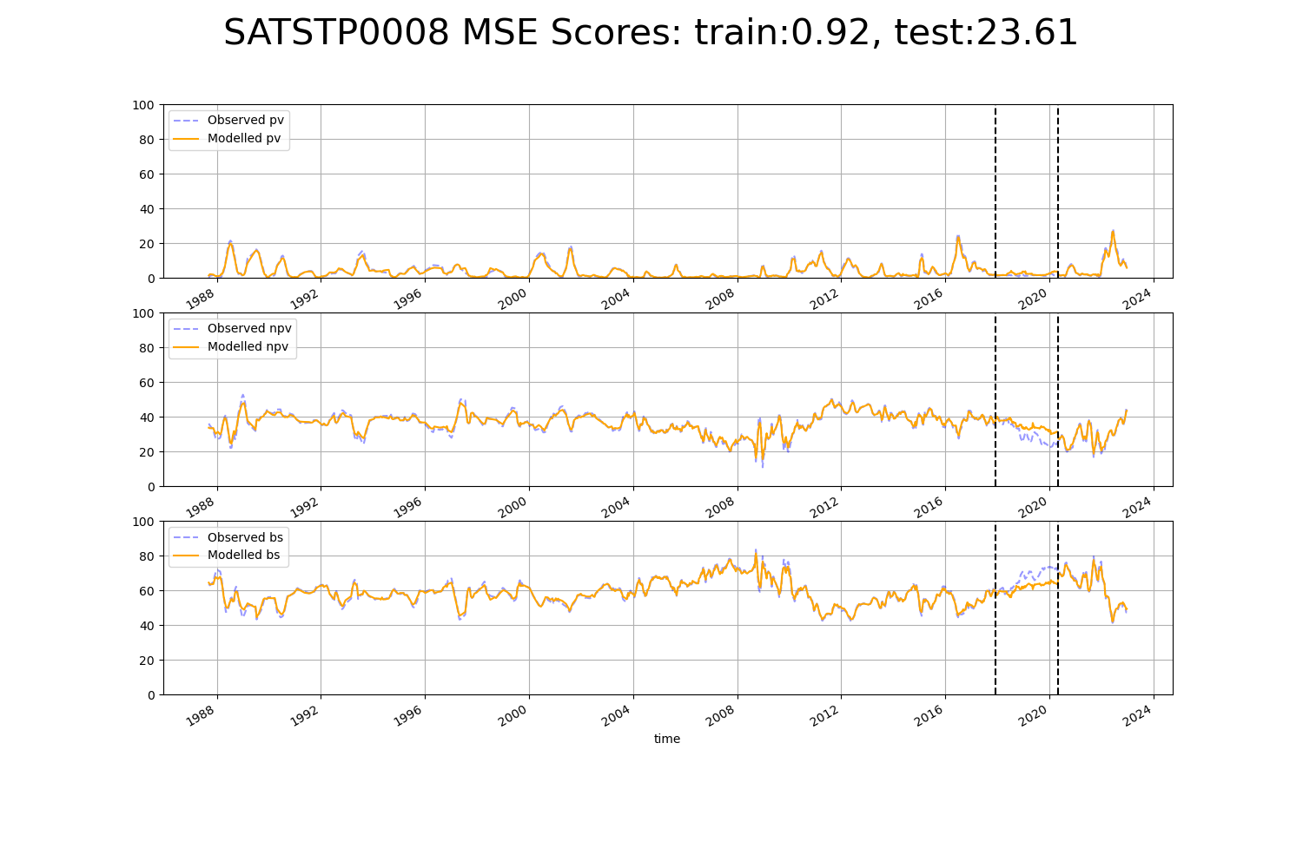

# WAACOO0010

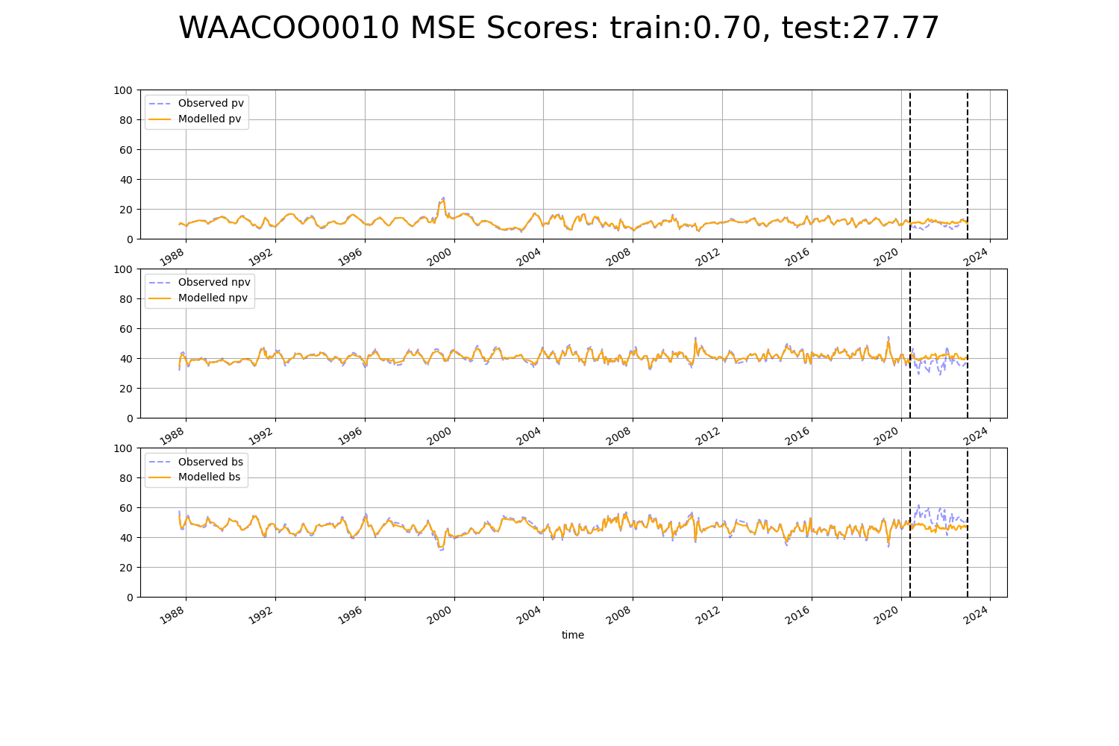

# WAAGAS0002

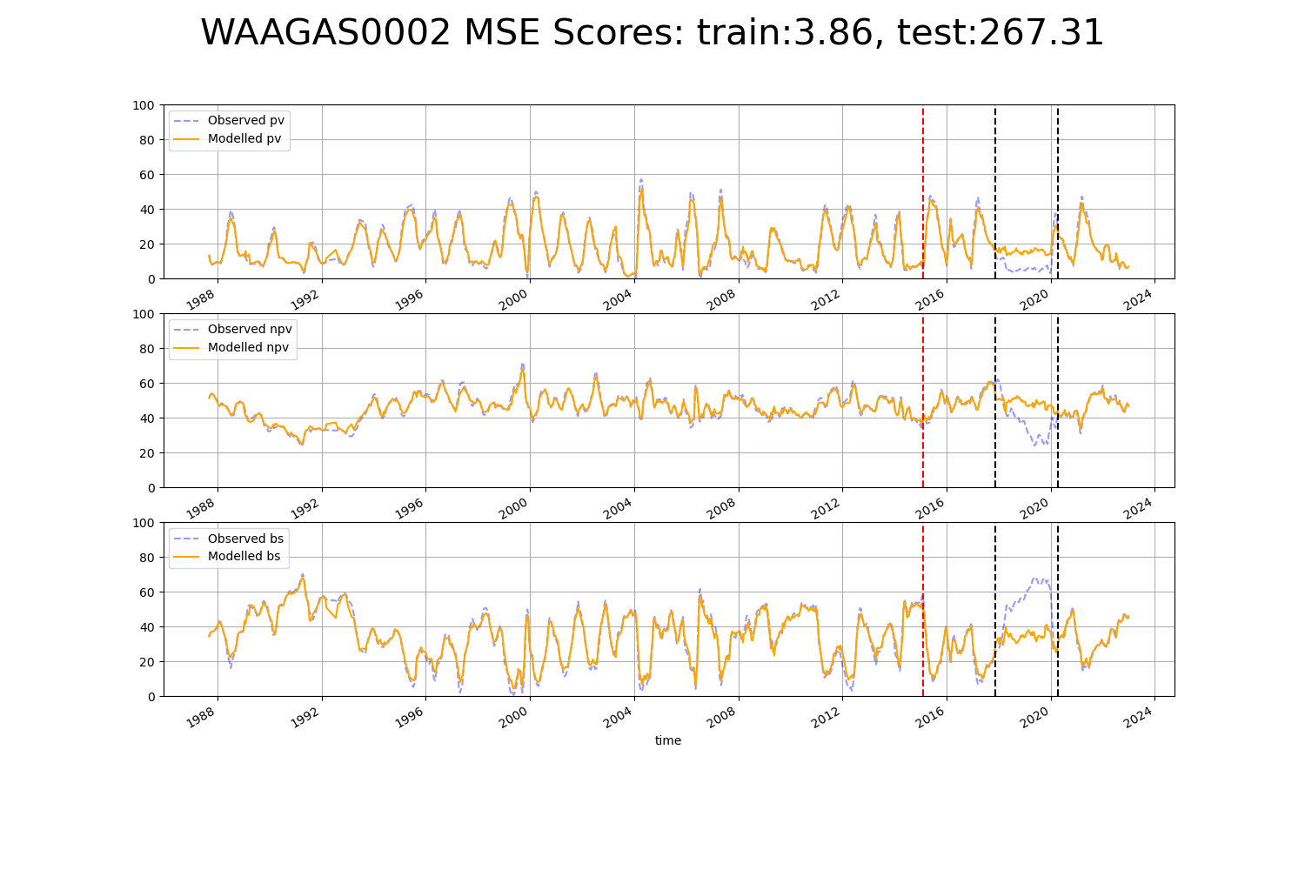

# WAAHAM0003

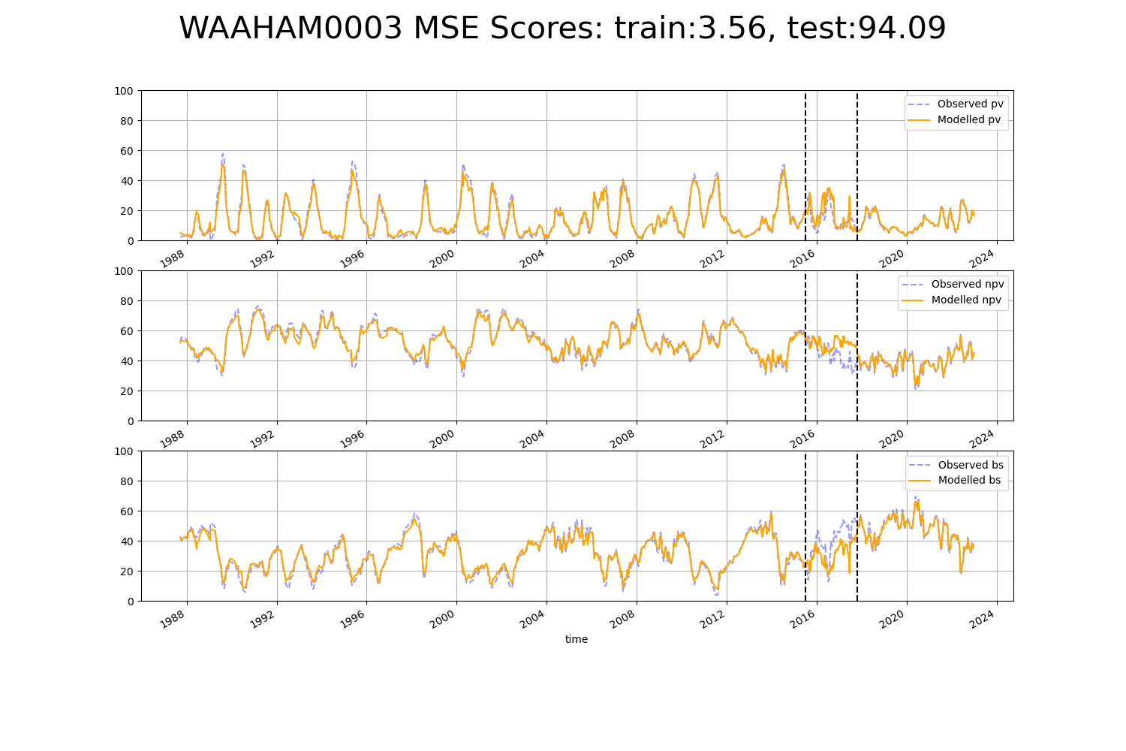

# WAALSD0001

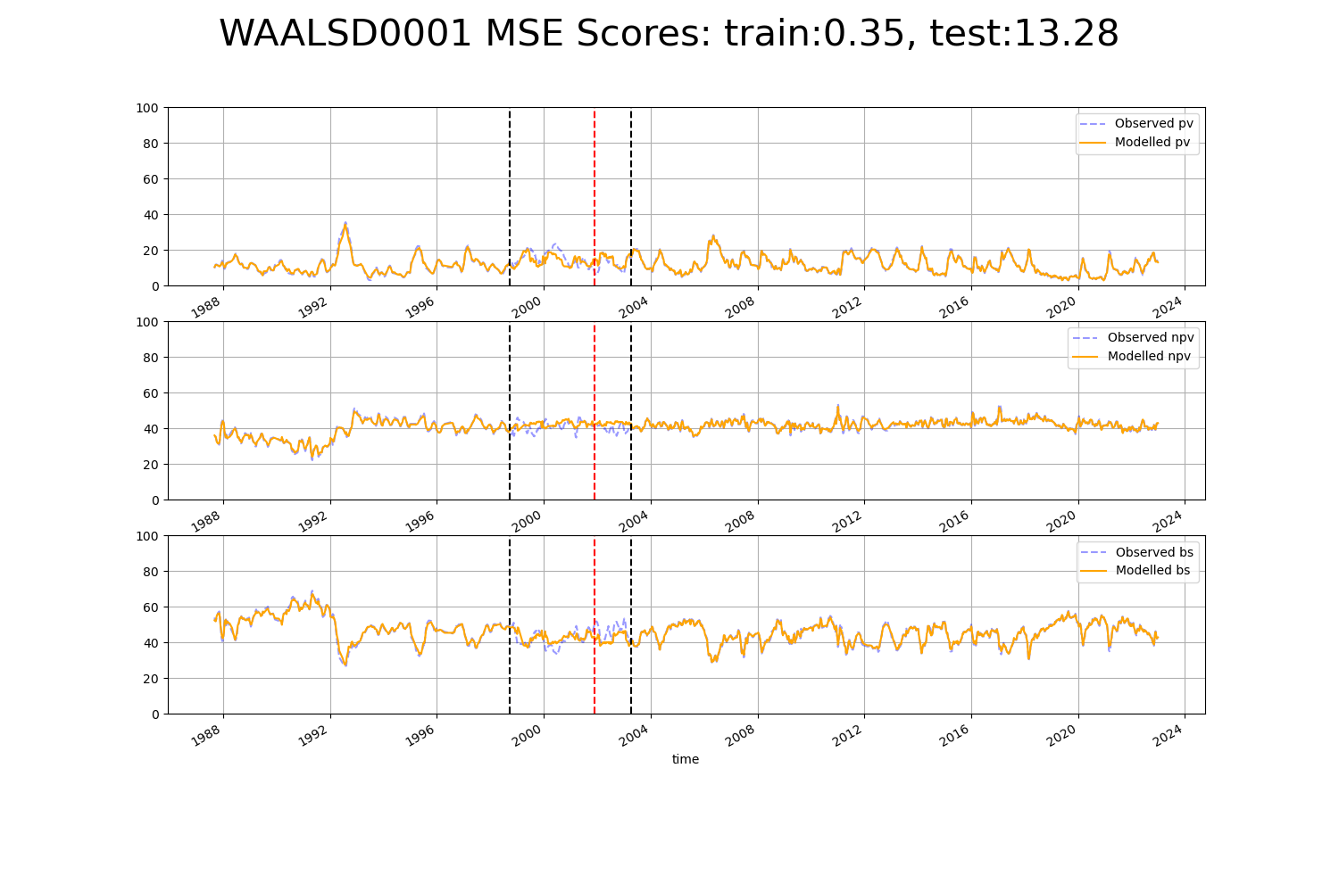

# WAAMUR0005

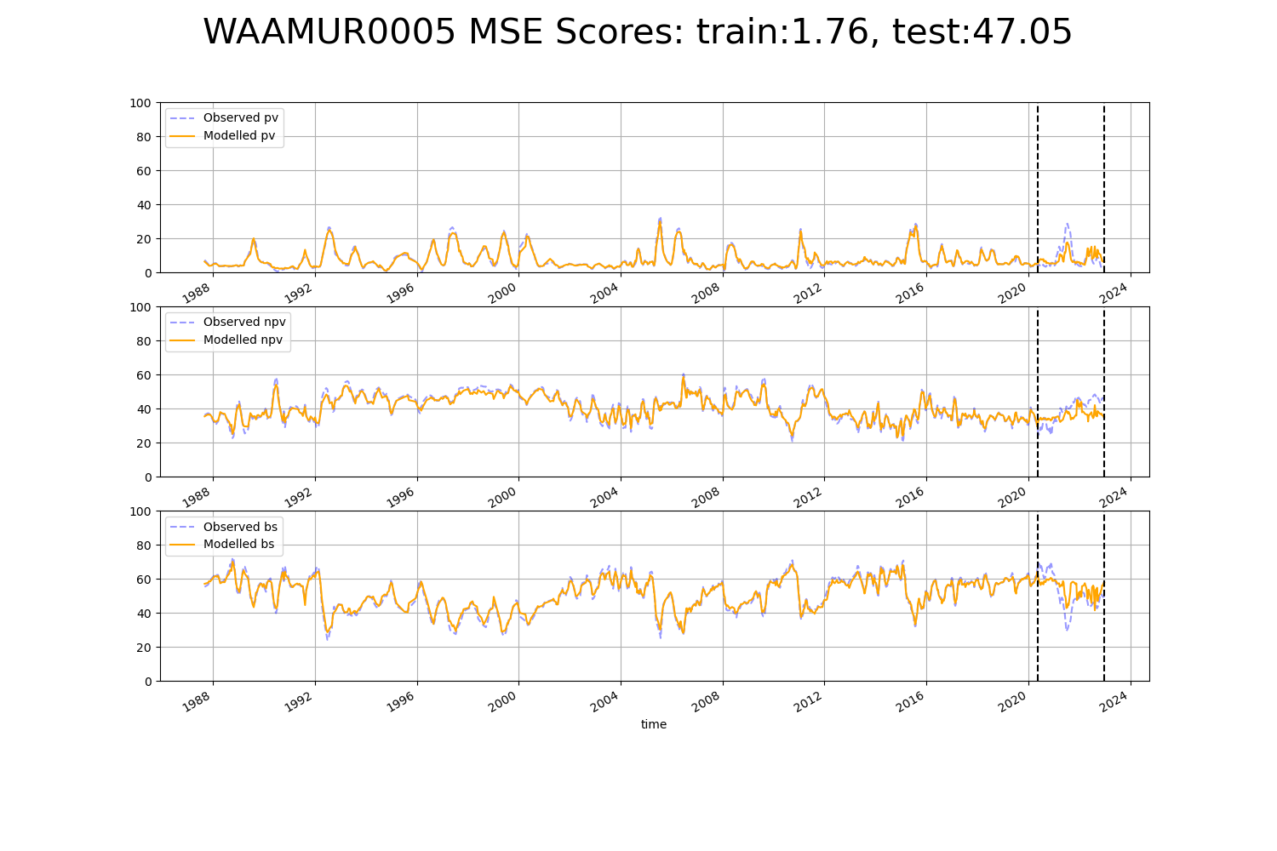

# WAAPIL0001

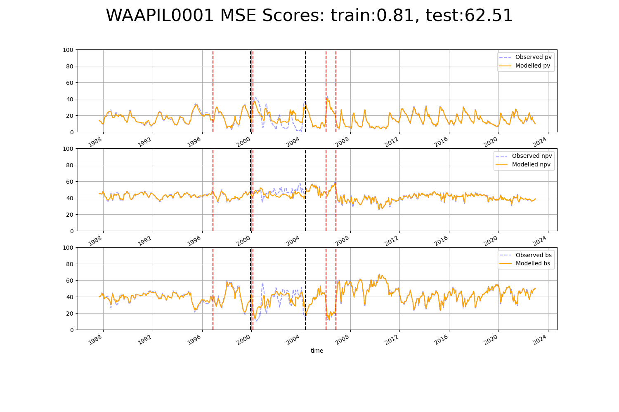

# WAAPIL0004

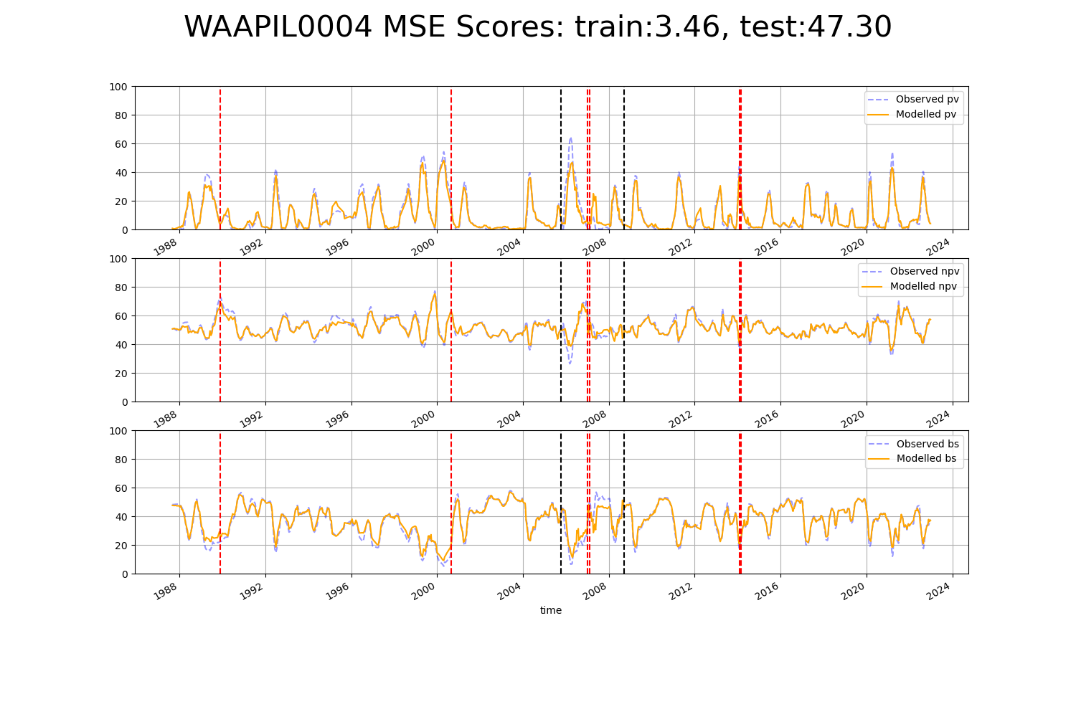

# WAAPIL0007

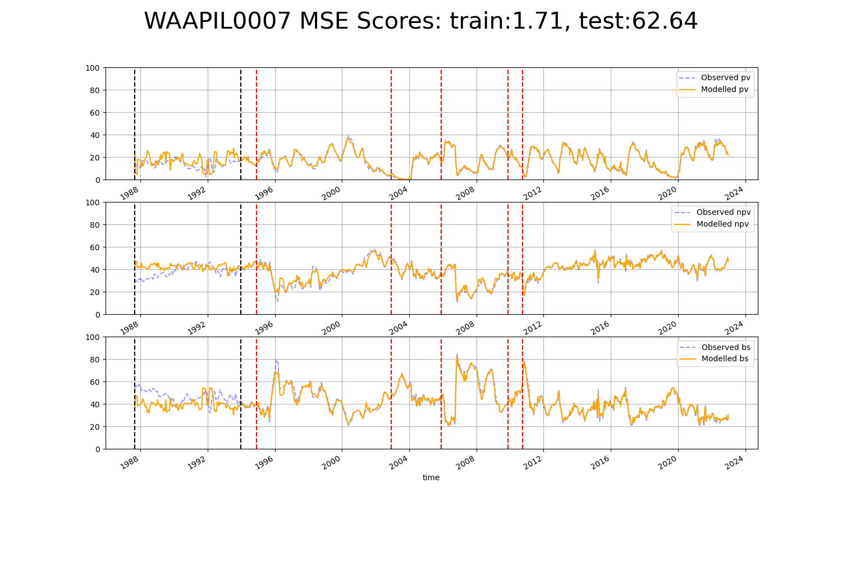

# WAAPIL0008

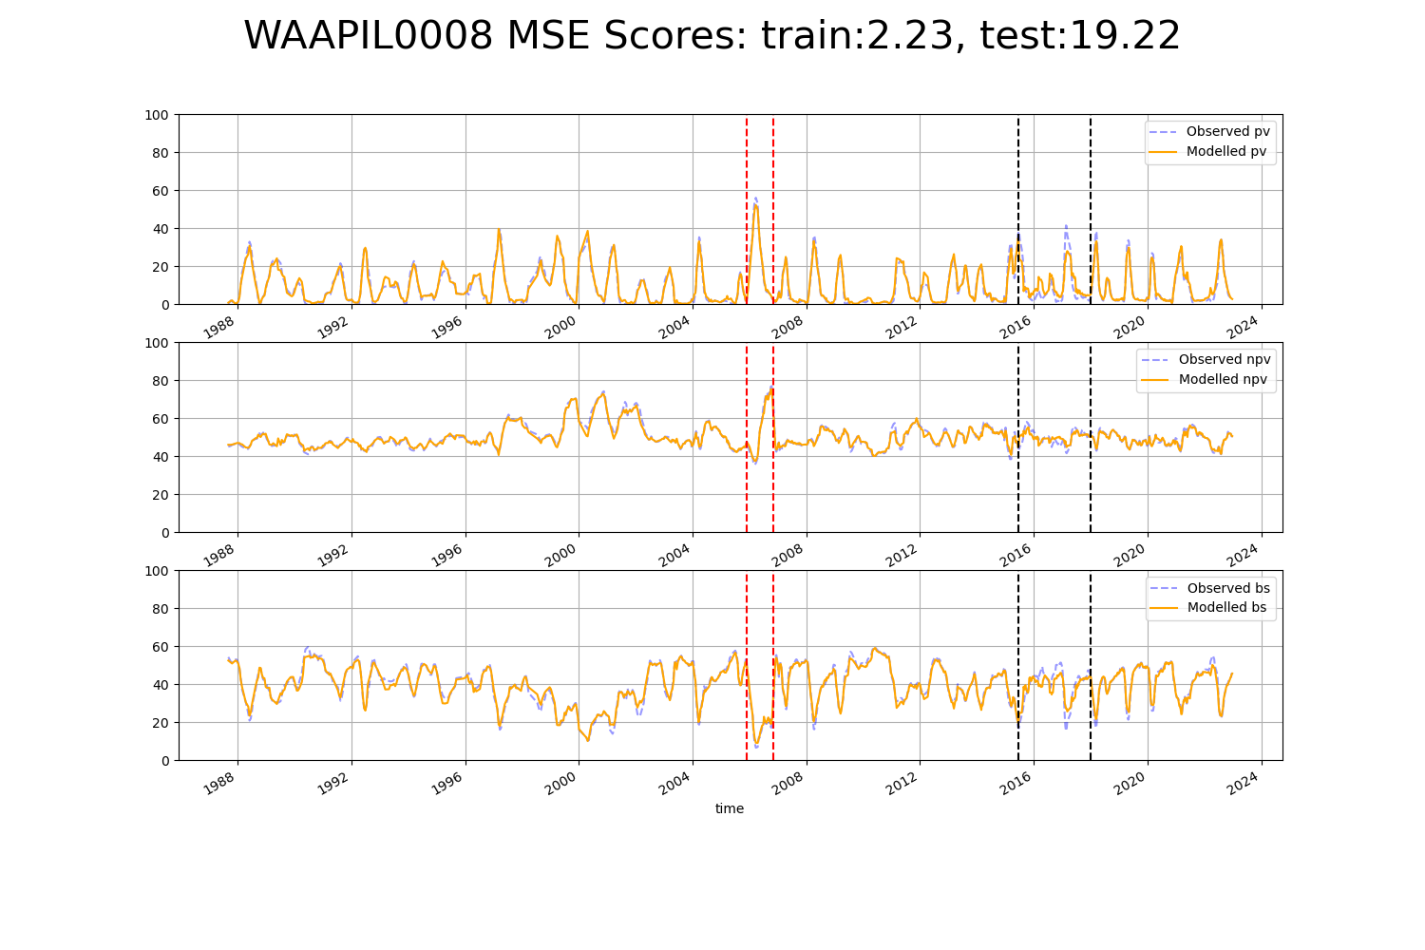

# WAAPIL0009

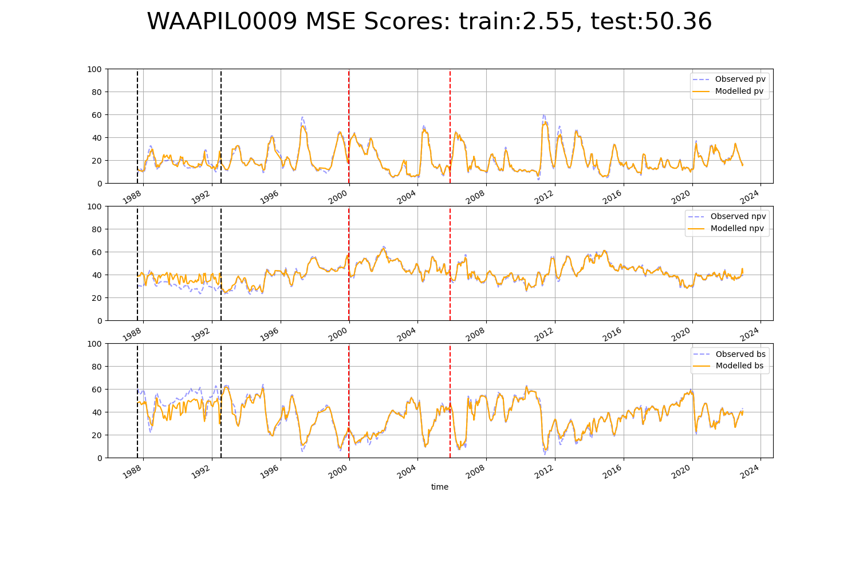

# WAAPIL0015

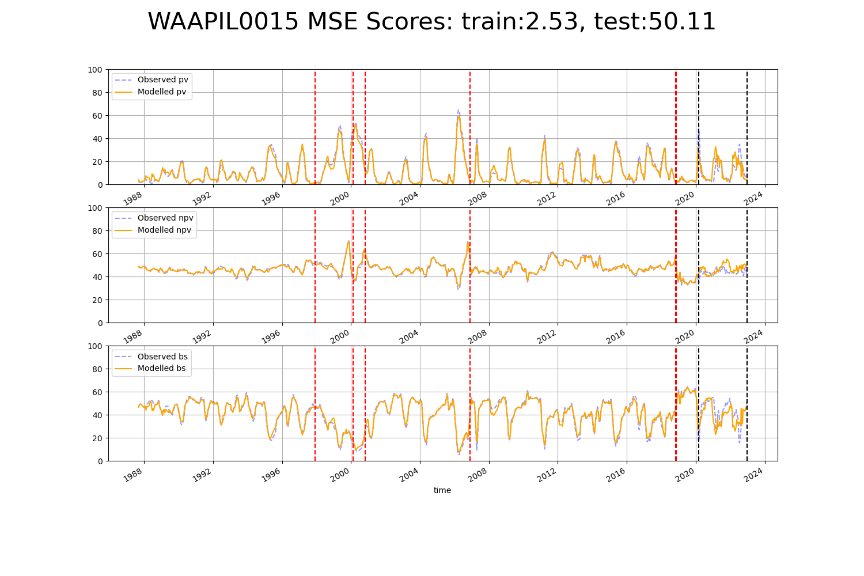

# WAAPIL0018

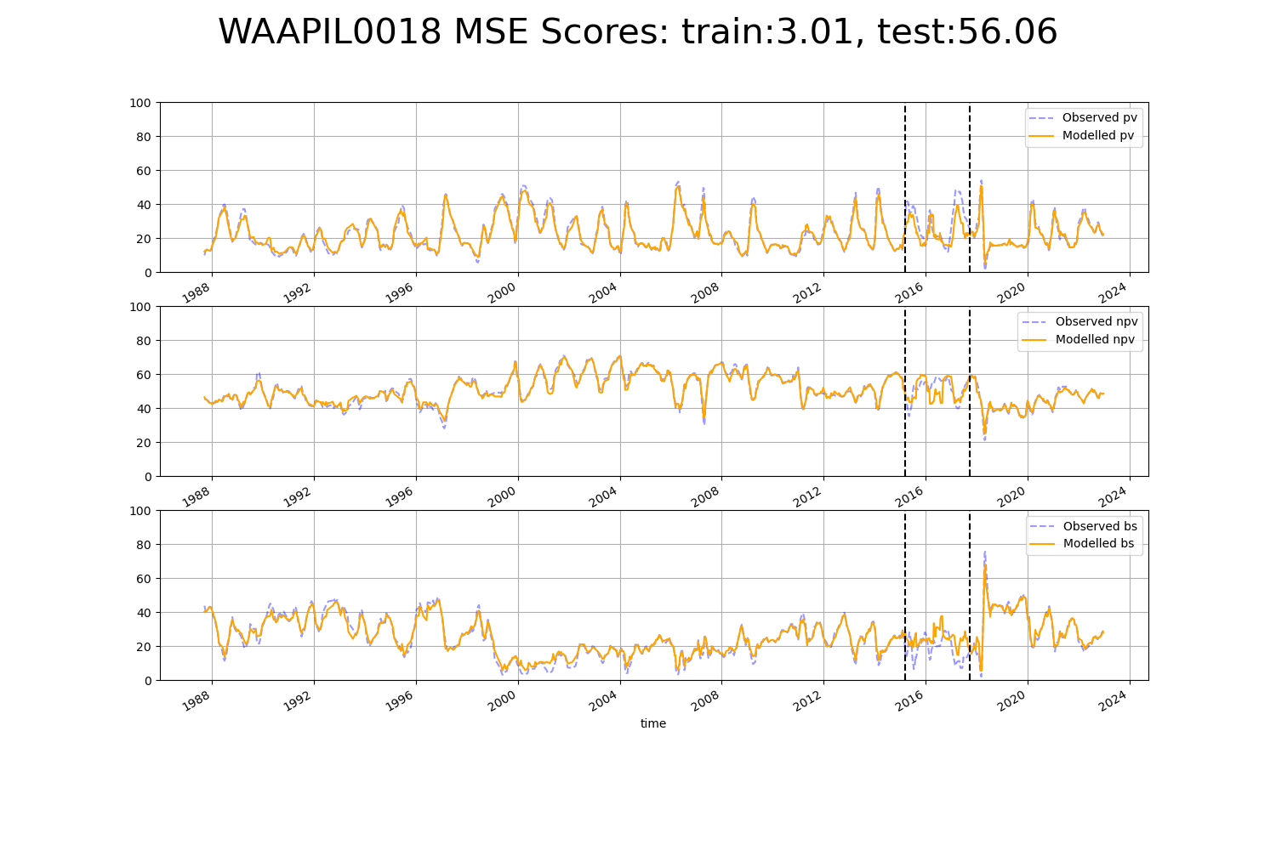

# WAAPIL0019

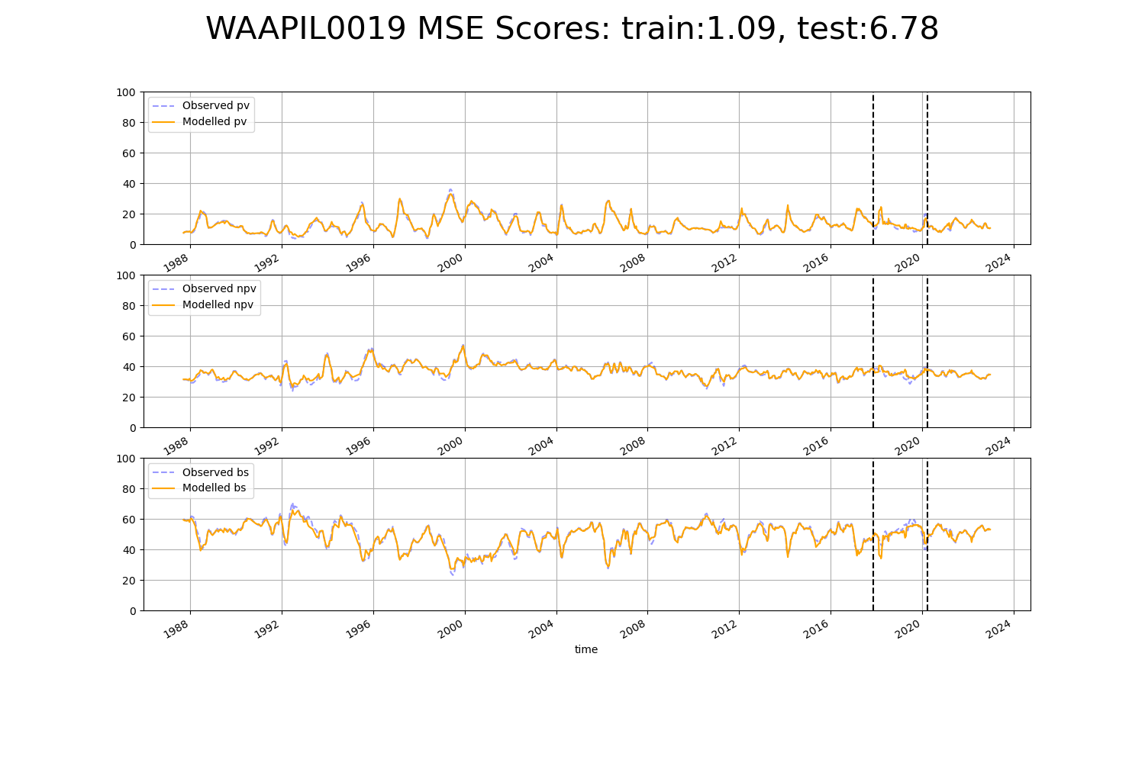

# WAAPIL0030

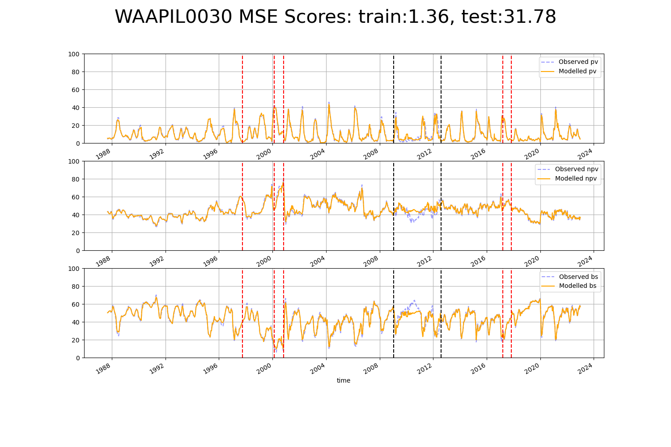

# WAAPIL0033

